**CS372 Final Study Guide:**

**What to cover:**

-Lectures 21 to 42

-Quiz 1

-Quiz 2

-Lab 3

-Lab 4

-Lab 5

-Midterm

-In class exercises week 6 to 10

*Slide Notes:*

**Lecture 21: Congestion and Congestion Control**

-As *utilization* approaches maximum, *delay* increases

**For congestion…**

-Cause: end systems send too much data too fast for the routers to handle

-Costs: delay/dropped packets

-long delays from queue

-dropped packets

-slow ACK’s

-**congestion collapse**

**Effective Delay:**

-Delay and utilization:

$$D= \frac{d_{0}}{(1-U)}$$

D = effective delay

U = network utilization

D0 = what it’s supposed to be

-Goals of congestion control:

-Optimize utilization

-Handle causes of congestion

-Detect/avoid congestion

-React to congestion

-TCP countdown timer:

-“just right” timer can improve efficiency

-not too long, not too short

-To estimate RTT, use SampleRTT equation

-DeviationRTT = (1-B)*DeviationRTTprevious + B*(SampleRTT-EstimatedRTT)

-TimeoutInterval = EstimatedRTT + 4*DeviationRTT

***PRACTICE***

**Lecture 22: Congestion Control**

-**Goals** of congestion control:

-Optimize utilization

-Handle causes of congestion

-Detect/avoid congestion

-React to congestion

-Two approaches to detecting congestion:

a. Inferred by end-to-end systems

-used by TCP

b. Network core assistance

-routers provide feedback to servers

-Avoiding congestion:

-timeouts (Lecture 21)

-**sliding windows:** receiver gives the sender a window of how much data it can handle. The sender does not exceed it unless packages in the queue are successfully processed and ACKed, creating room in the queue for more packages to be sent.

-Reacting to congestion:

-Need to find the right balance between *under-utilization* and  *over-utilization*.

-Adaptive transmission algorithm:

-Define **CongWin** (sender’s window size)

-Slowly increase **CongWin** to probe for usable bandwidth

-When congestion is detected, decrease sending rates.

-TCP uses **A**dditive-**I**ncrease, **M**ultiplicative-**D**ecrease (**AIMD)**

**-MSS (Maximum Segment Size):**

-upper limit on amount of data that can be sent on the largest link-layer frame on the sending host

-TCP congestion control: **AIMD**

-additive increase: increase CongWin by 1 MSS every RTT until loss is detected

-multiplicative decrease: cut CongWin in half after loss

-After 3 duplicate ACK’s…

-CongWin is cut in half

-window then grows linearly

-After timeout event…

-CongWin is set to 1 MSS

-window grows exponentially to a Limit, then linearly

-When CongWin < Limit = slow-start phase

-CongWin grows **exponentially**

-When CongWin > Limit = congestion-avoidance phase

-CongWin grows **linearly**

-After 3 duplicate ACK’s, **Limit** = **CongWin/2** and **CongWin = Limit**

-When timeout occurs, **Limit** = **CongWin/2** and **CongWin = 1MSS**

***PRACTICE***

**Lecture 23: TCP Segment Structure**

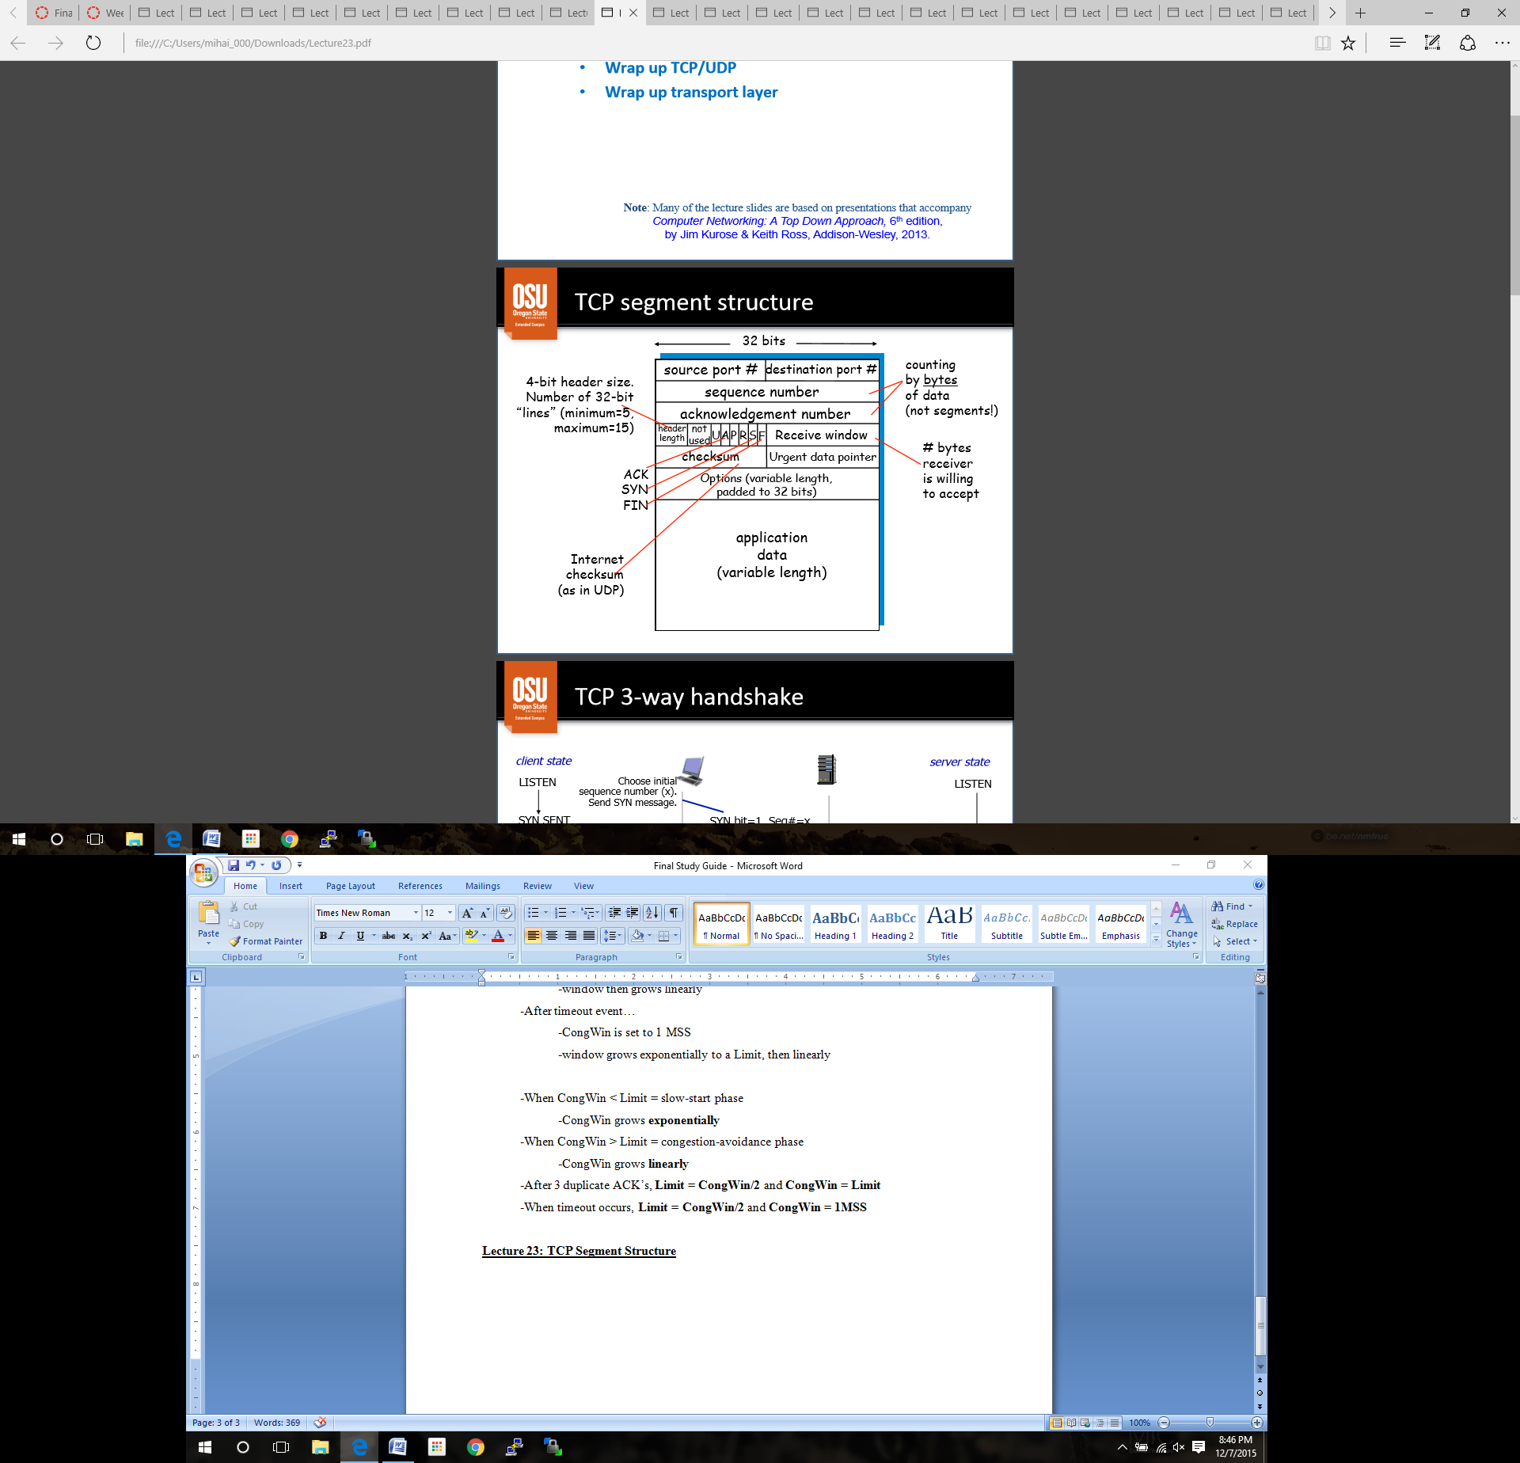

-**3-way Handshake:** ***PRACTICE***

1. SYN bit = 1, Seq# = x (set at the beginning of transmission)

2. SYN bit = 1, Seq# = y

ACK bit = 1, Seq# = x + 1

3. ACK bit = 1, ACK# = y + 1

**-To close a connection:**

1. Send FIN bit with Seq# x (set at the beginning of transmission)

2. Get ACK bit with ACK# x + 1

-now the client can no longer send

3. Receive FIN bit from server, Seq# y

4. Send ACK bit back, with ACK# y + 1

**-TCP fairness goal:**

-if n TCP users share the same bottleneck link of bandwidth R, each should have an average rate of R/n

-TCP is fair to each connection, but not necessarily each host

-a host may have multiple connections

-UDP vs TCP

-UDP provides…

-connectionless service

-end to end best effort (unreliable) delivery

-simple and fast

-8 byte header

- TCP provides…

-connection oriented service

-end to end reliable byte stream delivery

-is complicated

-20 byte header minimum

-adds a huge amount of overhead

-but it works….

-Both…

-use IP for delivery

-send to and receive from multiple applications

-de-multiplex to destination application protocol ports

**Lecture 24: Introduction to the Network Layer**

-*transport layer*: logical communications between processes

-relies on and enhances network layer services

-the transport-layer unit is called a segment

-*network layer:* logical communications between hosts

-relies on and enhances link layer services

-the network-layer unit is called a datagram

-Network layer protocols run at **routers** and **end systems**

-Sender side:

-get segments from transport layer

-encapsulate segments into datagrams

-Routers examine header fields in all IP datagrams

-Receiver side:

-delivers segments to transport layer

**Two major network layer functions:**

-*routing*: determine route taken by packets from source to destination (routing algorithms)

-*forwarding*: move packets from router’s input to appropriate router output

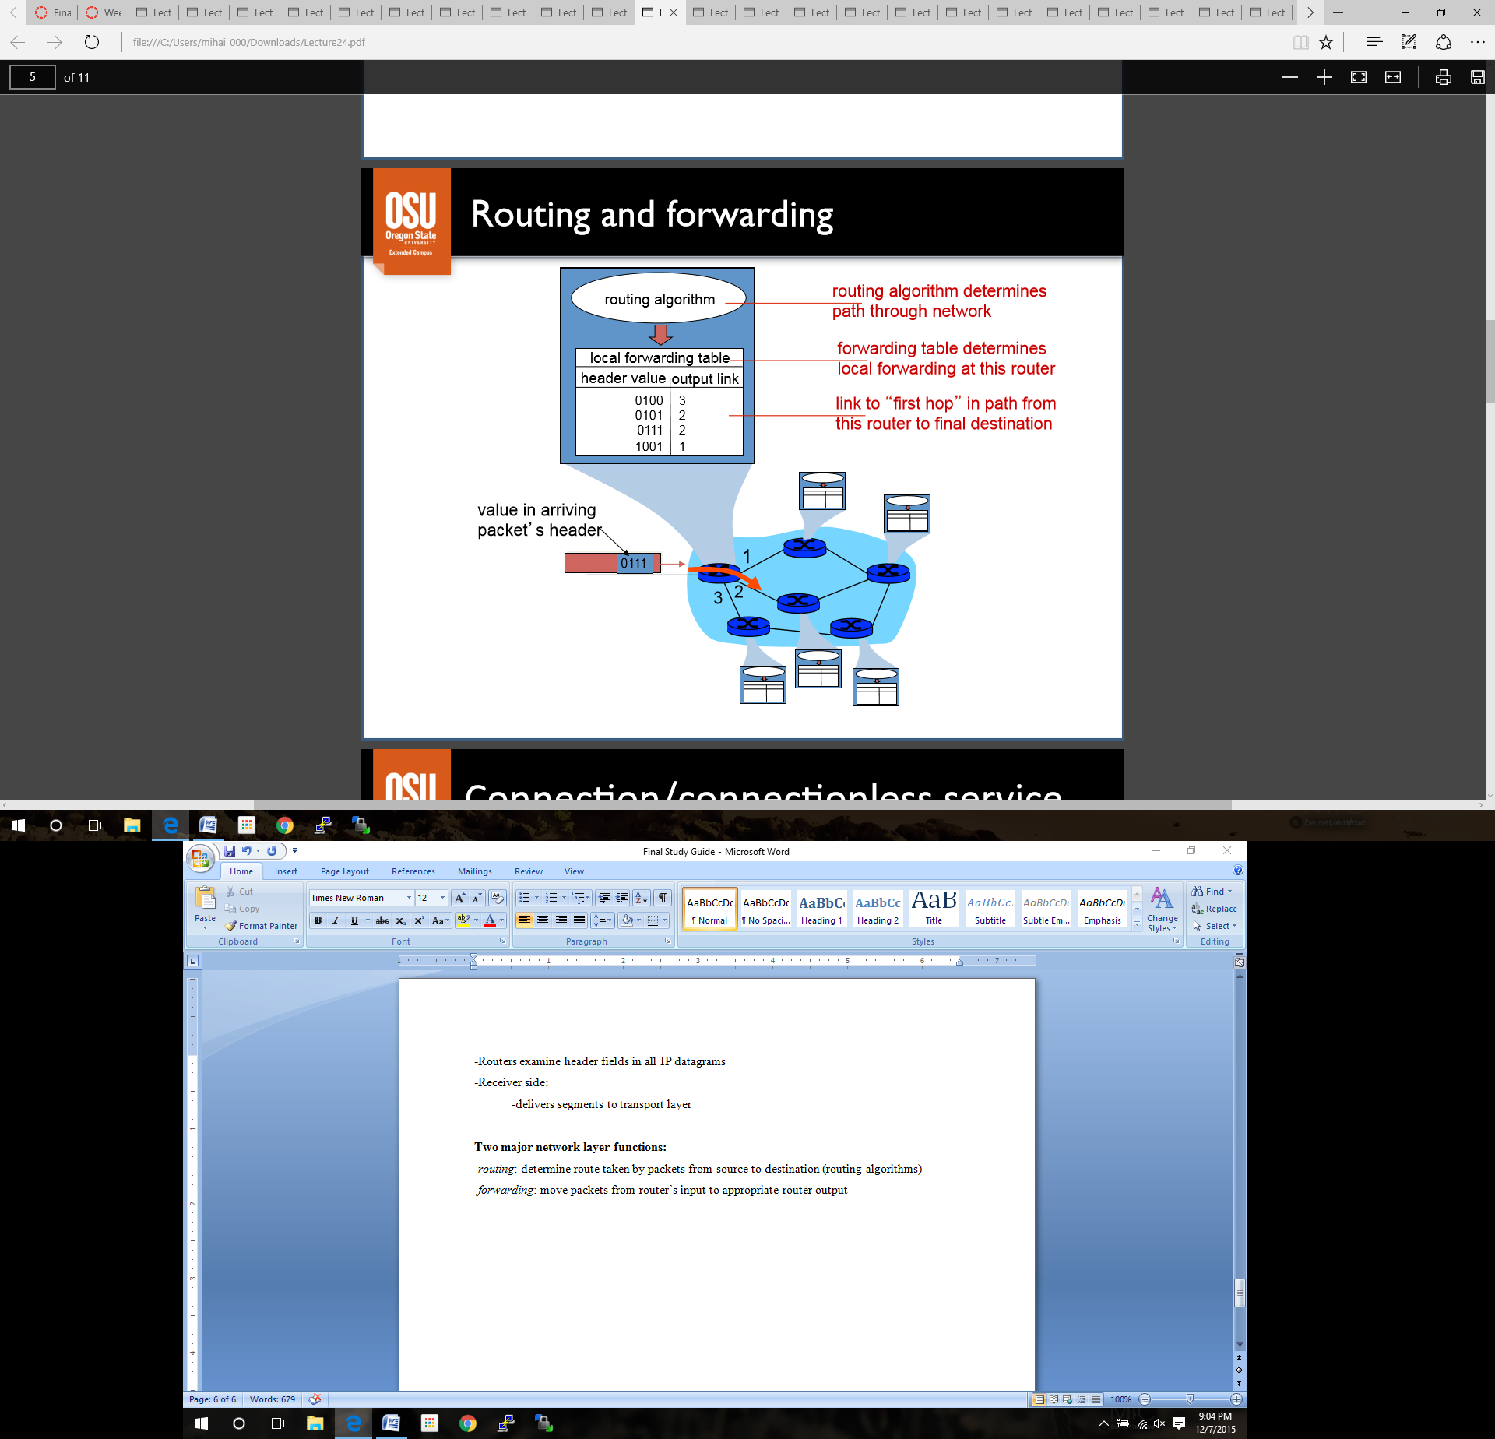

Each device will go through a different output link, dependent on its VC value.

Connection/connectionless service:

**-virtual-circuit network** provides network layer connection service

-**datagram network** provides network layer connectionless service

-Same as TCP/UDP connection / connectionless transport layer services except for…

-service: host to host

-no choice: network provides one or the other

-implementation: in network core

**Virtual Circuit (VC) (connection service)**

-behaves much like a telephone circuit

1. Call setup for each call before you can send

2. VC identified in each packet (not destination host address)

3. Maintain state for each VC on every router in path

4. Allocate resources for each in VC: bandwidth, buffers in links, routers involved

-Forwarding Table:

-pretty much what it sounds like

- each Incoming VC is paired with an Incoming interface

- each Outgoing VC is paired with an Outgoing interface

-boom, you have a table of stuff

**Datagram Networks (connectionless service)**

-no call setup at network layer

-no state of end to end connection is kept in routers

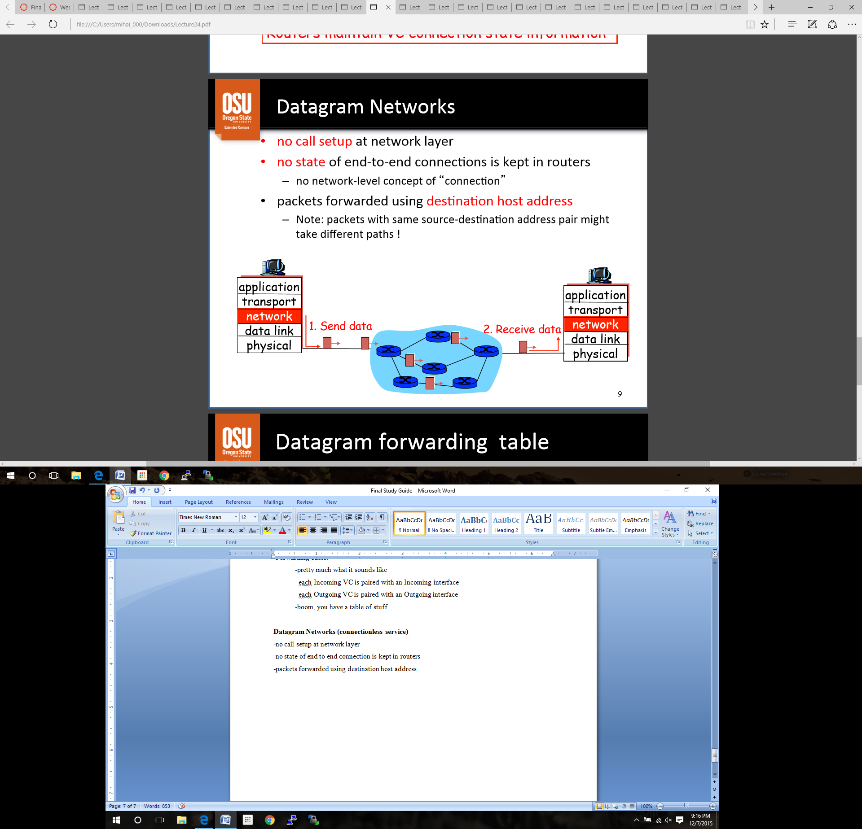-packets forwarded using destination host address

-Forwarding table is set up the same as VC, except the output link for each datagram is decided by the destination IP address saved within each.

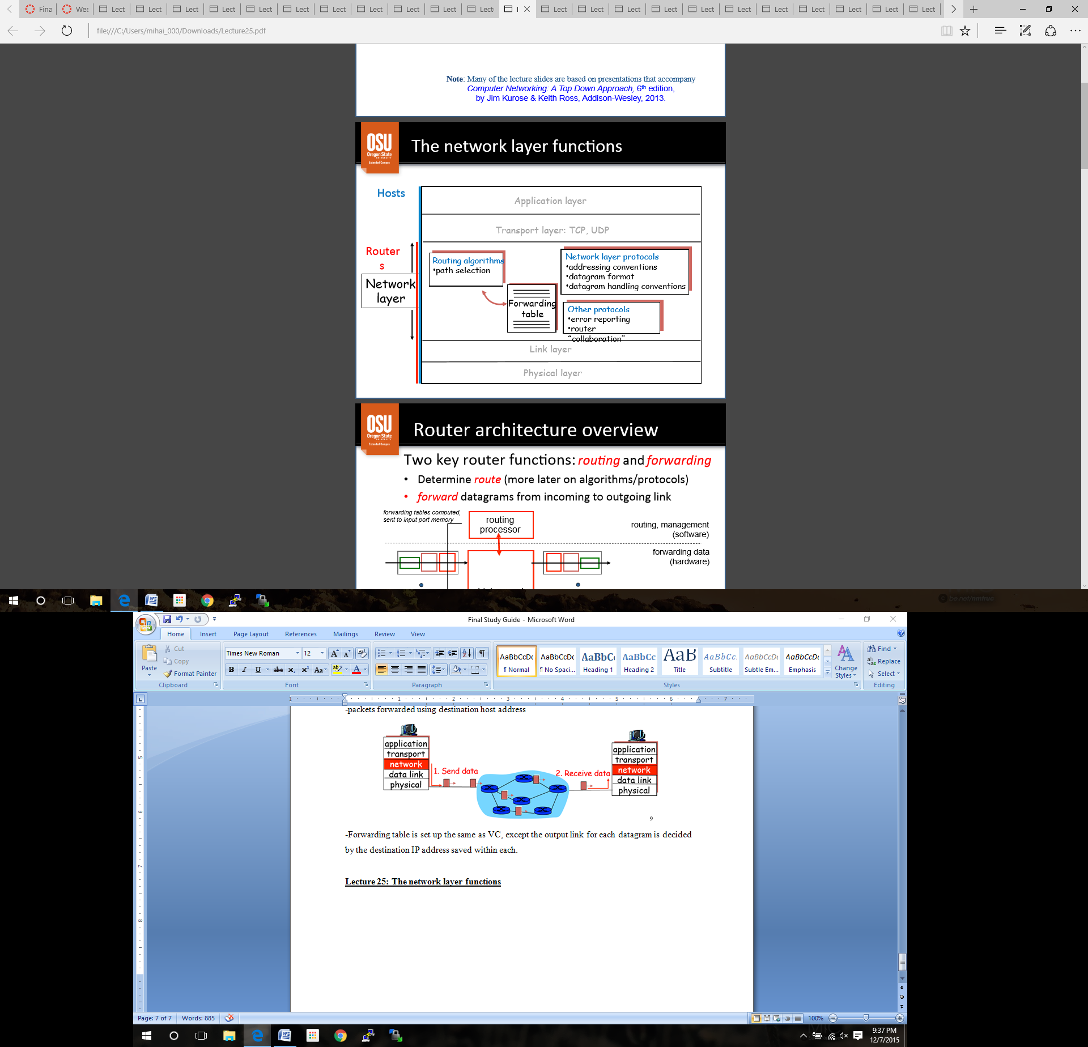**Lecture 25: The network layer functions**

*-Router Overview*:

-Determine the route (using algorithms and protocols)

-forward datagram from incoming to outgoing link using high speed switching fabric

-router processor is where the software lives in a router

-*Input Port Functions*:

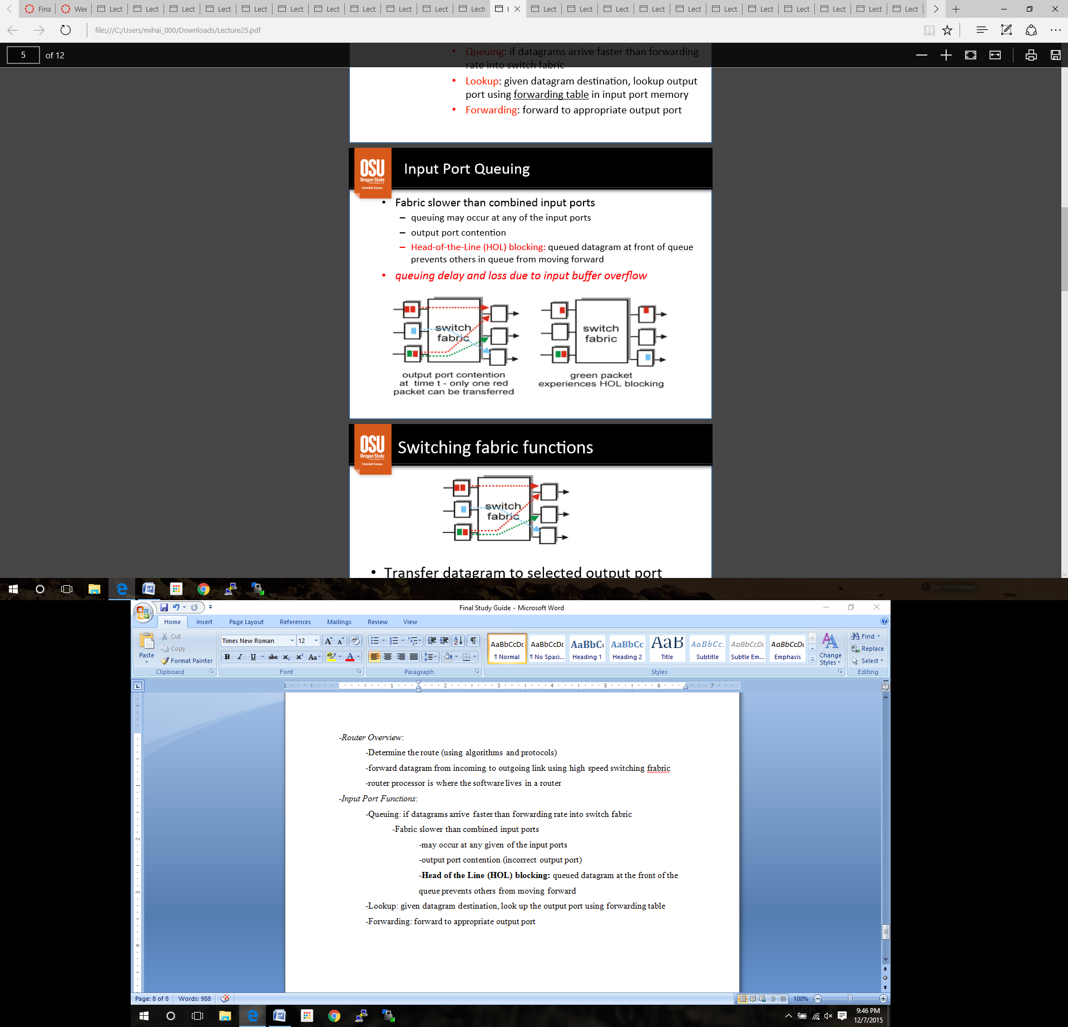 -Queuing: if datagrams arrive faster than forwarding rate into switch fabric

-Fabric slower than combined input ports

-may occur at any given of the input ports

-output port contention (incorrect output port)

-**Head of the Line (HOL) blocking:** queued datagram at the front of the queue prevents others from moving forward

-*queuing delay and loss due to input port buffer overflow*

-Lookup: given datagram destination, look up the output port using forwarding table

-Forwarding: forward to appropriate output port

-*Switching Fabric Functions:*

-transfer datagram to selected output port

-prevent collisions

-*Output Port Functions*:

-Queuing required at each output port if datagrams arrive from fabric faster than the link’s transmission rate

-Output link’s transmission rate is slower than the switching fabric

-may occur at any of the output ports

-overloading of individual ports

-*queuing delay and loss due to output port buffer overflow*

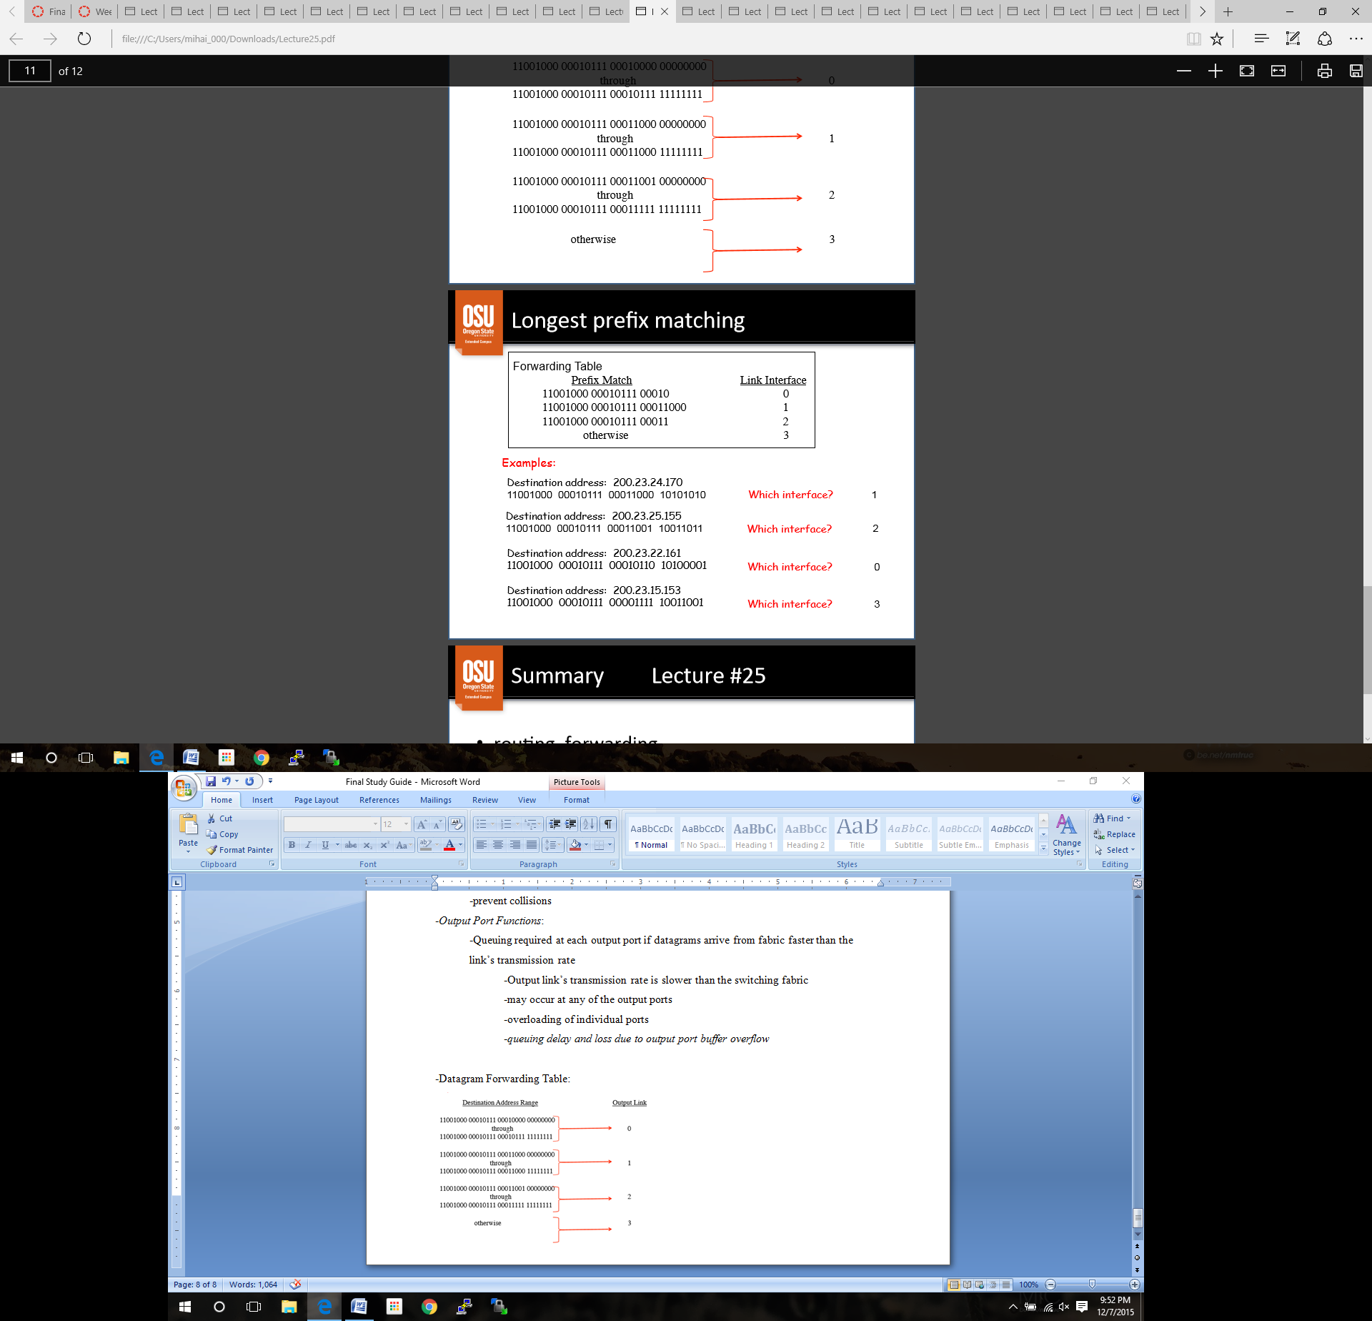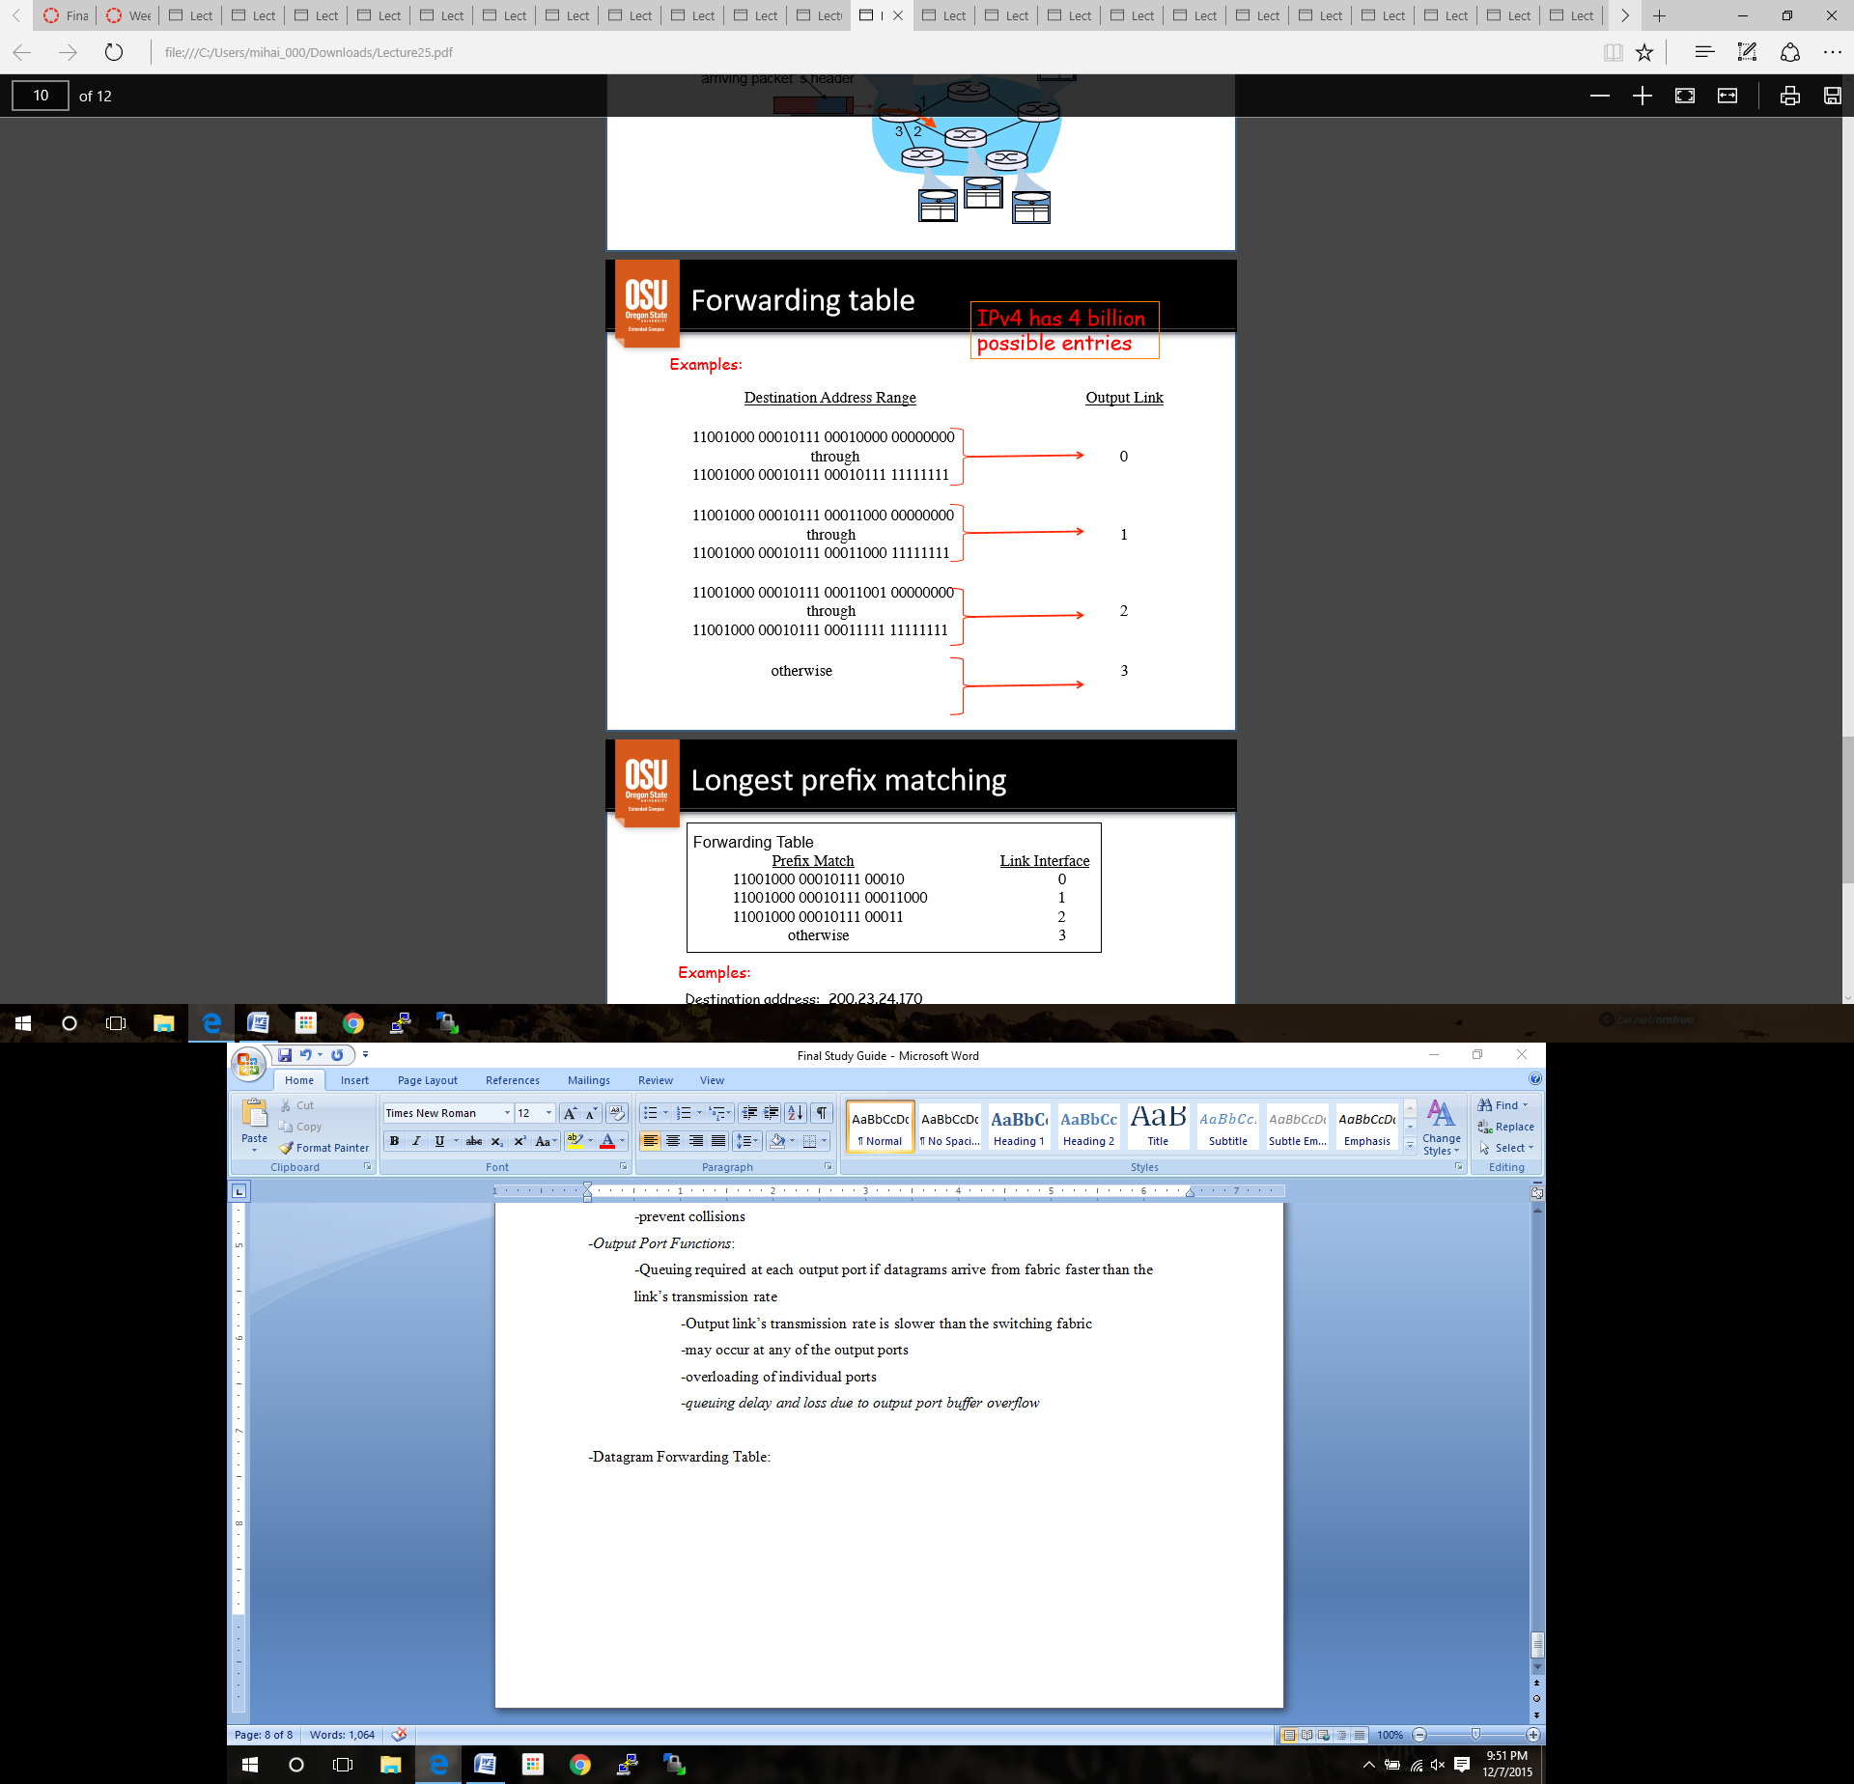-Datagram Forwarding Table: ***PRACTICE***

**Lecture 26: The Internet Protocol**

-*IP is the internet’s network layer protocol*

-not very many alternatives, and they are obscure

-accepts TCP / UDP segments, with a destination address

-encapsulates segment, source IP, destination IP, etc into **datagram**

-provides “best-effort”, host to host delivery

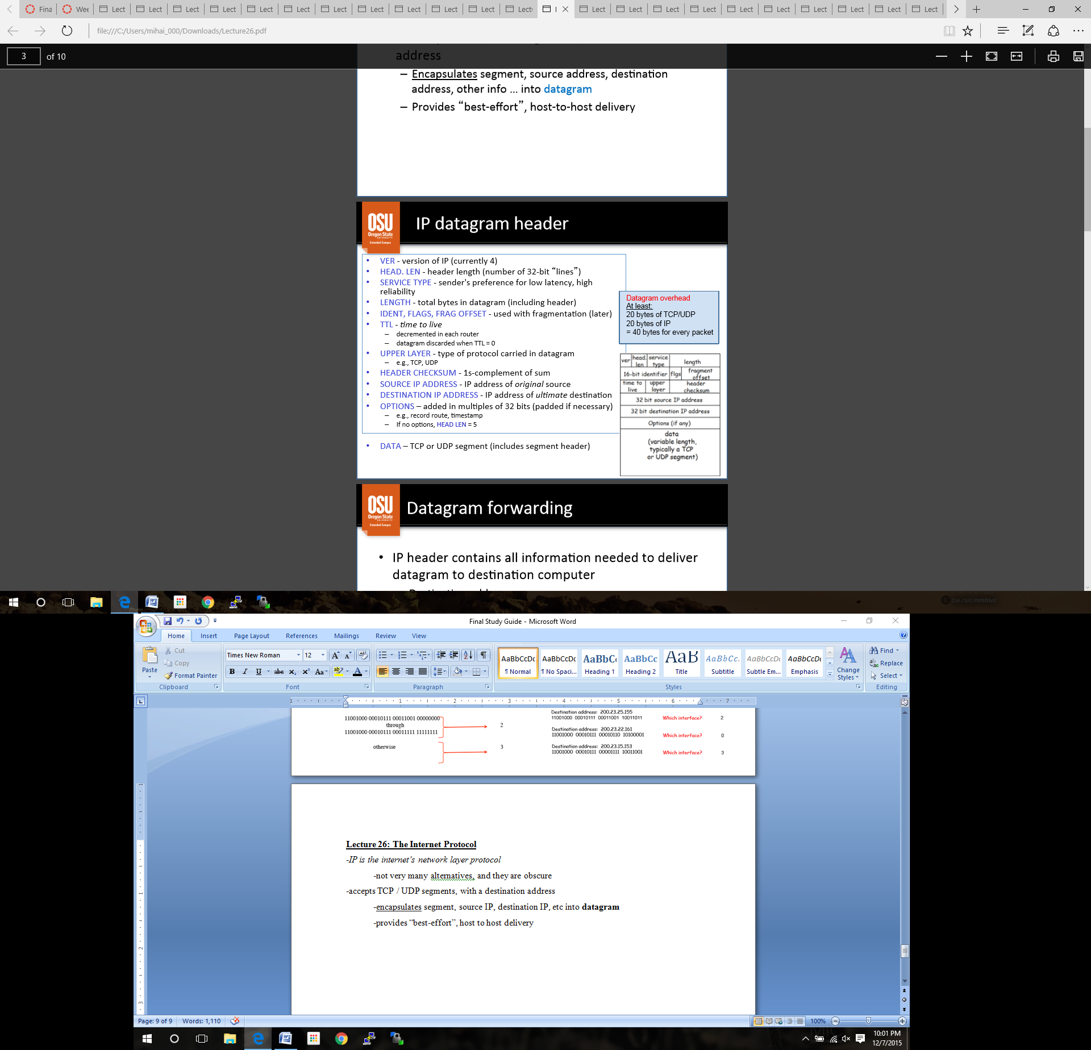-IP datagram header

Datagram overhead:

-20 bytes for TCP/UDP header

-20 bytes for the IP header

Datagram forwarding:

-IP **contains** all that is needed to deliver to destination computer

*-Destination IP address*

*-Source IP address*

*-Identifier (session, sequence)*

*-Other delivery info*

-Each router examines the header of each datagram and forwards it along its path to the destination

**Internet Address:**

-Address must be independent of any particular hardware address

-different devices have different types of hardware addresses

-Cannot use local addresses because other networks may use same address internally

-IPv4

-each host is given a 32 bit number, called IP address

IP address notation:

-Dotted decimal is the common form

-ex 128.253.40.28

- ranges from 0.0.0.0 to 255.255.255.255

-it is just a 32 bit number, it can be represented in binary and hexadecimal

IP address hierarchy:

-every ISP network in the internet is given a *network address* that is unique within the internet

-includes the **indicator** for number of bits used for network identification

-may be divided into subnets

-ex 128.193.35.0 / **24**

-every host within a network is assigned a *host number* that is unique within the network

-ex 0.0.0.123

-Host’s *IP address* is the combination of the network address and host address

-ex 128.193.35.123 / 24

-ISP network addresses are unique

-assigned by ICANN (Internet Corporation for Assigned Names and Numbers)

-host address may be duplicated on different networks

-assigned by network admin

-the combination of **network address** and **host number** is unique in the internet

-network address assigned globally

-host address assigned within each network locally

**Lecture 27: IP classless addressing**

***PRACTICE***

**IP address assignment:**

-ISP gets a “block” of addresses from ICANN

-ex. 200.23.16.0/20

-/20 means that the first 20 bits specify the *network address*

-the remaining 12 bits are for the *host number*

-network address + host number = IP address

-200.23.16.0 is the network address

-200.23.31.255 is the broadcast address

**Subnets:**

- ISP gets a “block” of addresses from ICANN

-ISP can create subnets

-“block” from ICANN is 200.23.16.0/**20**

-example of ISP subnet division

1. 200.23.16.0/**24**

2. 200.23.18.0/**24**

3. 200.23.20.0/**24** …

7. 200.23.30.0/**24**

-in this example, each subnet gets 256 IP addresses (2 are reserved)

-16 possible subnets can be created out of the above example

-4 bits of freedom [0000 … 1111]

-each subnet controls 254 host addresses

Extracting the network address:

-the first /x bits of any IP address is often called the *prefix*

-a **netmask** is all 1’s in the first x bits, and all zeroes in the rest of the bits

Extracting the host number:

-the last (32 – x) bits of any IP address is often called the *suffix*

-a **hostmask** is all zeroes in the first x bits, and all 1’s in the rest of the bits

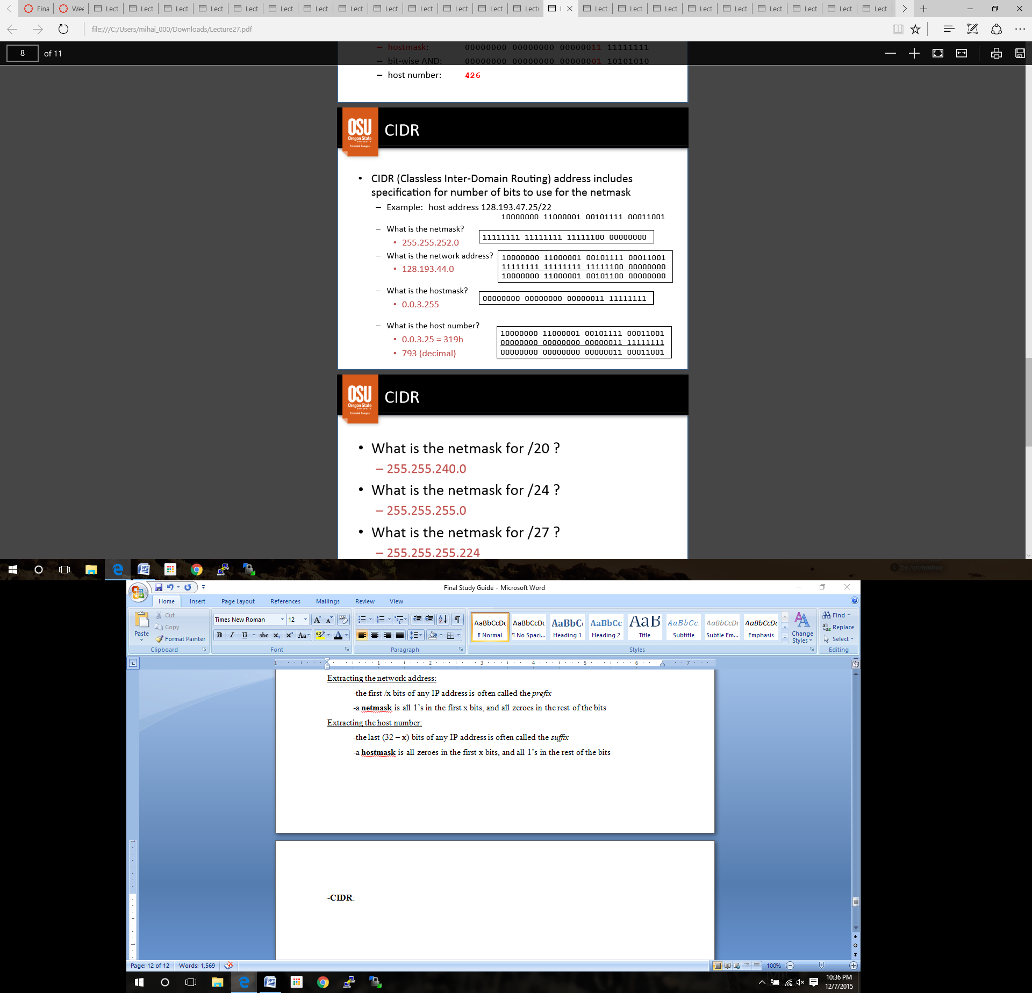**-CIDR**:

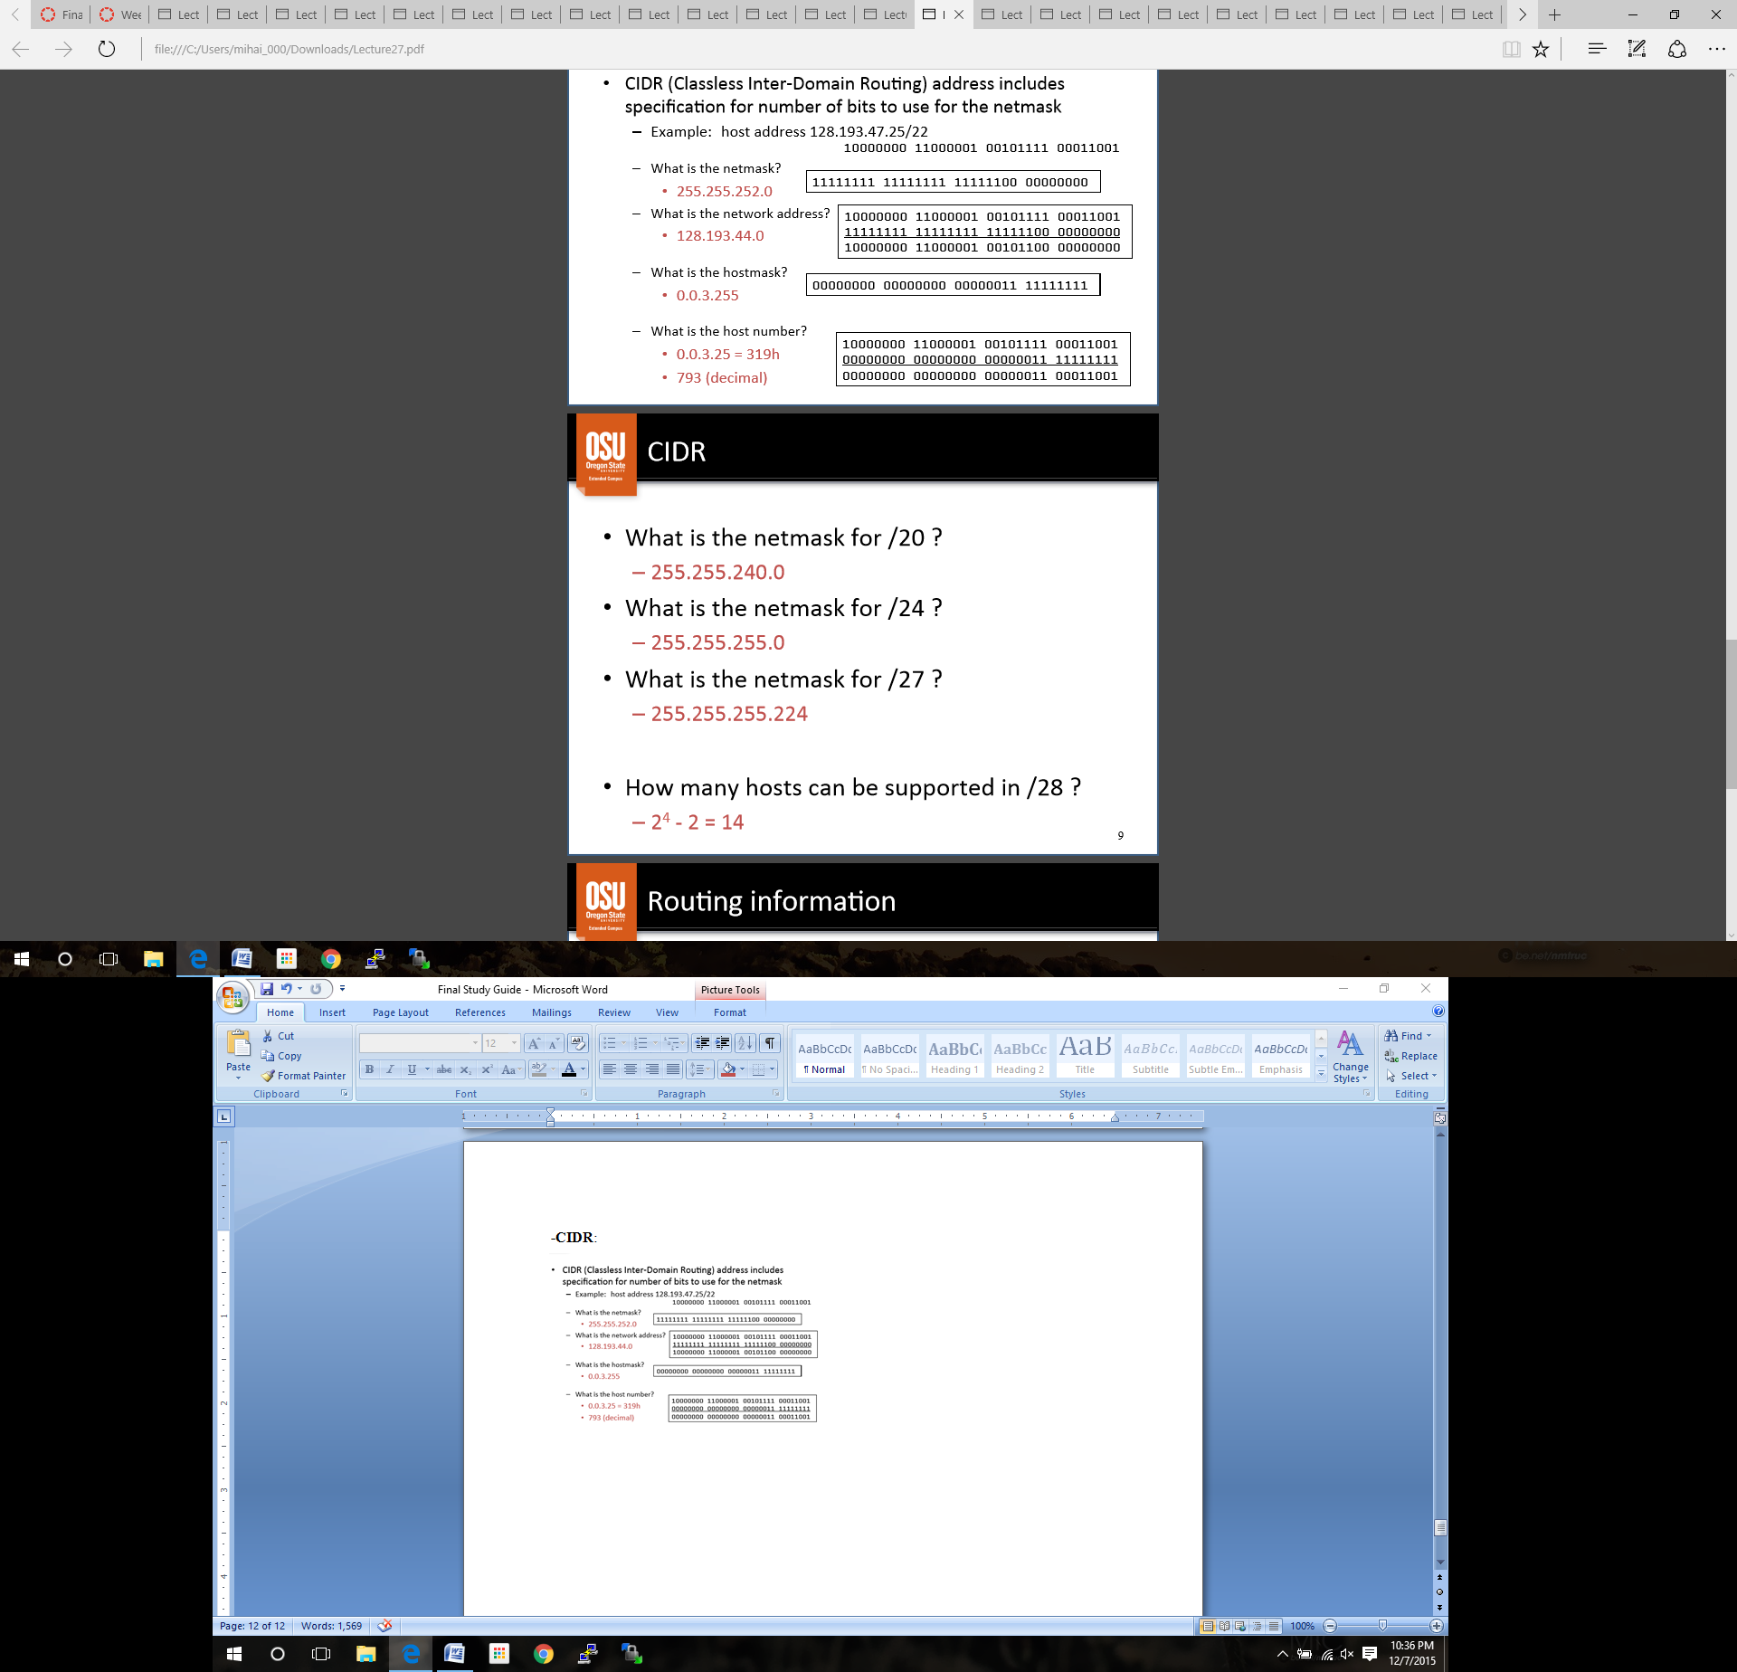

Routing information:

-sending host puts destination IP address into datagram

-*destination address* in an IP datagram is always the ultimate destination

-*address mask* defines how many bits are in prefix

-**/x** defines how many bits are given to the prefix

-router applies mask to destination address to obtain the **network address**

-routing table releases network address to next hop address

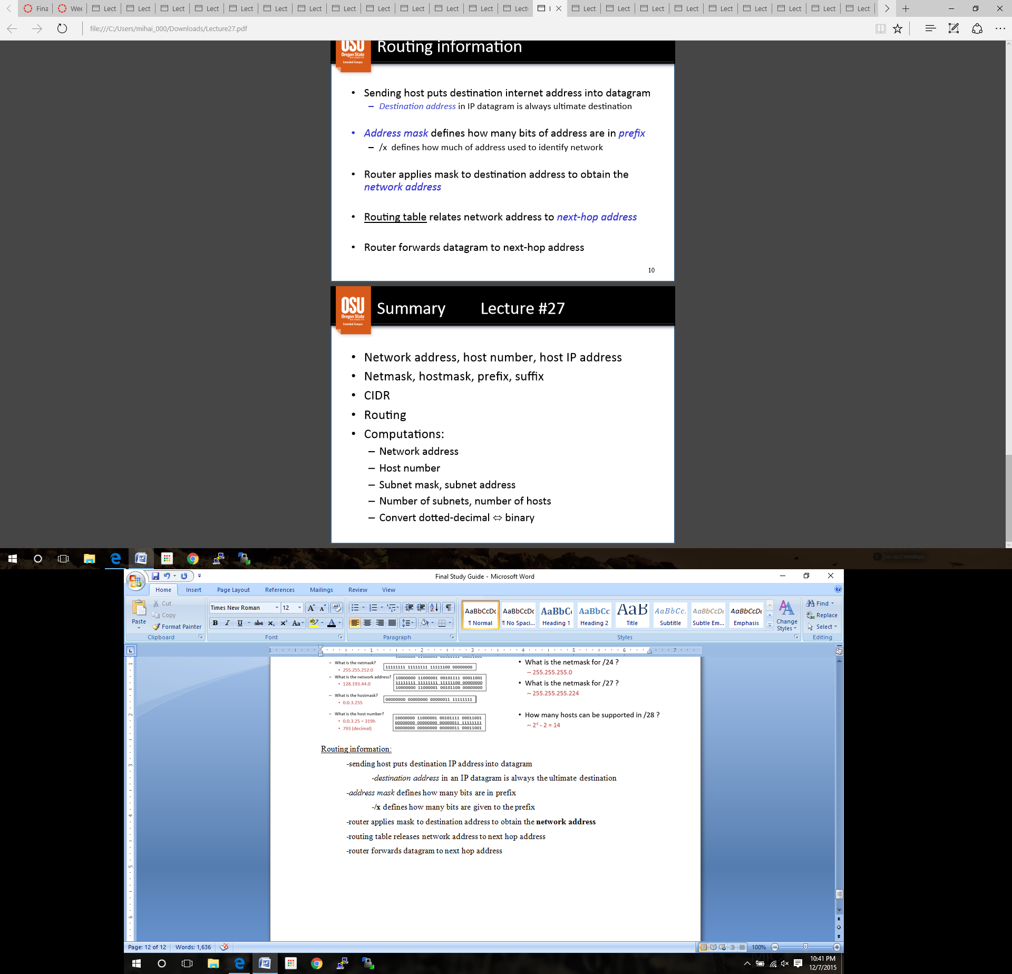 -router forwards datagram to next hop address

***PRACTICE***

**Lecture 28: Assigning IP Addresses**

-Host IP address assignment

-system admin can hard code IP addresses for each host

-**DCHP**: Dynamic Host Configuration Protocol:

-application layer protocol, DHCP client-server

-dynamically “lease” IP addresses from a server when joining

-IP addresses can be reused by other hosts if they are released

-IP lease can renew while still connected to the network

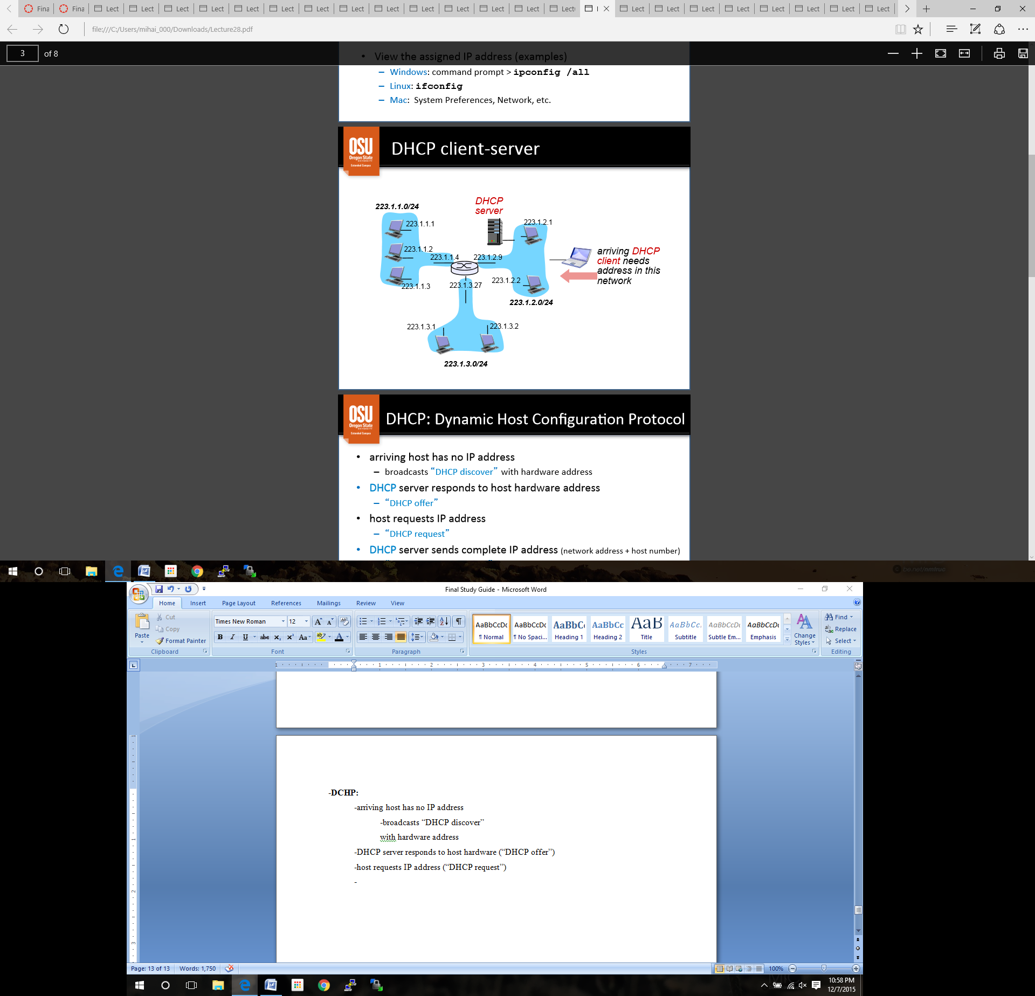-**DCHP:**

-arriving host has no IP address

-broadcasts “DHCP discover”

with hardware address

-DHCP server responds to host hardware (“DHCP offer”)

-host requests IP address (“DHCP request”)

-DHCP server sends complete IP address (*network address* + *host number*)

-“DHCP acknowledgement”

-records IP/hardware address in local server IP table

-DHCP also returns…

-address of first-hop router for client

-name and IP address of DNS server

-*netmask*

-Possible Solutions to IPv4 address exhaustion:

-IP address sharing

-Use one IP address for multiple hosts (**N**etwork **A**ddress **T**ranslation – NAT)

-IPv6

**Lecture 29: Routing**

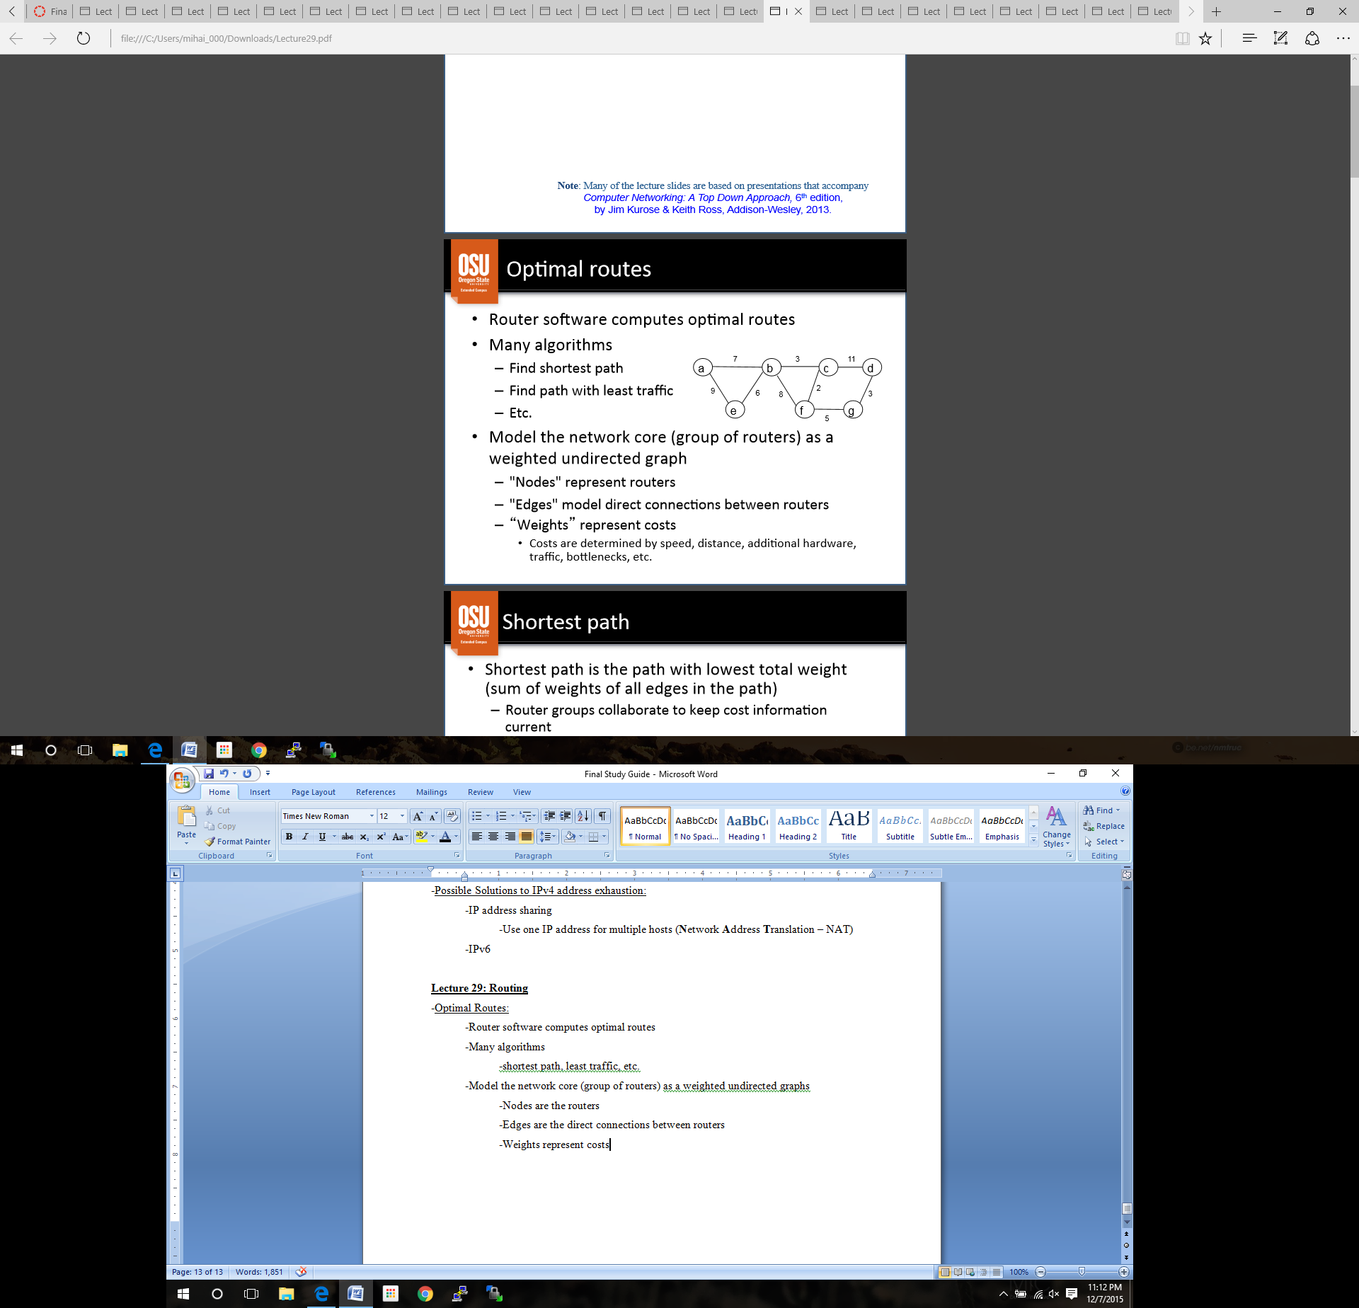-Optimal Routes:

-Router software computes optimal routes

-Many algorithms

-shortest path, least traffic, etc.

-Model the network core (group of routers) as a weighted undirected graphs

-Nodes are the routers

-Edges are the direct connections between routers

-Weights represent costs

-**Shortest Path**:

-path with the lowest total weight (sum of all edge weights)

-routers collaborate to keep cost information current

-shortest path is *not necessarily fewest edges or fewest hops*

-First node in shortest path is the “next hop”

-put next-hop information into routing table

-Djikstra’s Algorithm

**Djikstra’s Algorithm:**

Data structures:

-choose *source* node and *destination* node

-S = {all nodes expect the *source*}

-variables **u**, **v** represent nodes

-D is an array of weights of edges

-D[**v**] = edge weight, if edge from *source* to **v** exists

-use ∞ to represent a cost if it has not been computed

-R is an array of nodes

-R[**v**] = **v** if edge from *source* to **v** exists, or zero otherwise

-P is an array of nodes

-P[**v**] = *source* if edge from *source* to **v** exists, or zero otherwise

***PRACTICE***

**Lecture 30: IP Datagram Fragmentation**

Encapsulation across multiple hops:

-when a datagram transits a physical networks, it is encapsulated in a *frame* appropriate for that*network*

-*link layer* deals with hardware frame un-/encapsulation

-each router on the path from *source* to  *destination*

-**un-encapsulates** incoming datagram from frame (*link layer*)

-**processes** datagram – determines next hop (*network layer*)

-**re-encapsulates** datagram in outgoing frame (*link layer*)

-Datagram itself is unchanged unless it is fragmented

MTU:

-Every hardware technology specification includes the maximum size of the frame data area

-*maximum transmission unit* (**MTU**)

-Any datagram encapsulated in the hardware frame must be than smaller than the MTU

-Different MTU’s can cause annoyances (problems):

-source doesn’t know path MTU beforehand (*smallest* MTU for complete route)

-easy for source to limit IP datagram size to local MTU, but what happens once we got outside of this local network?

-MTU might be smaller downstream

-Choosing datagram size:

-Know your MTU, IP datagrams cannot be larger

-IPv4 uses *fragmentation*

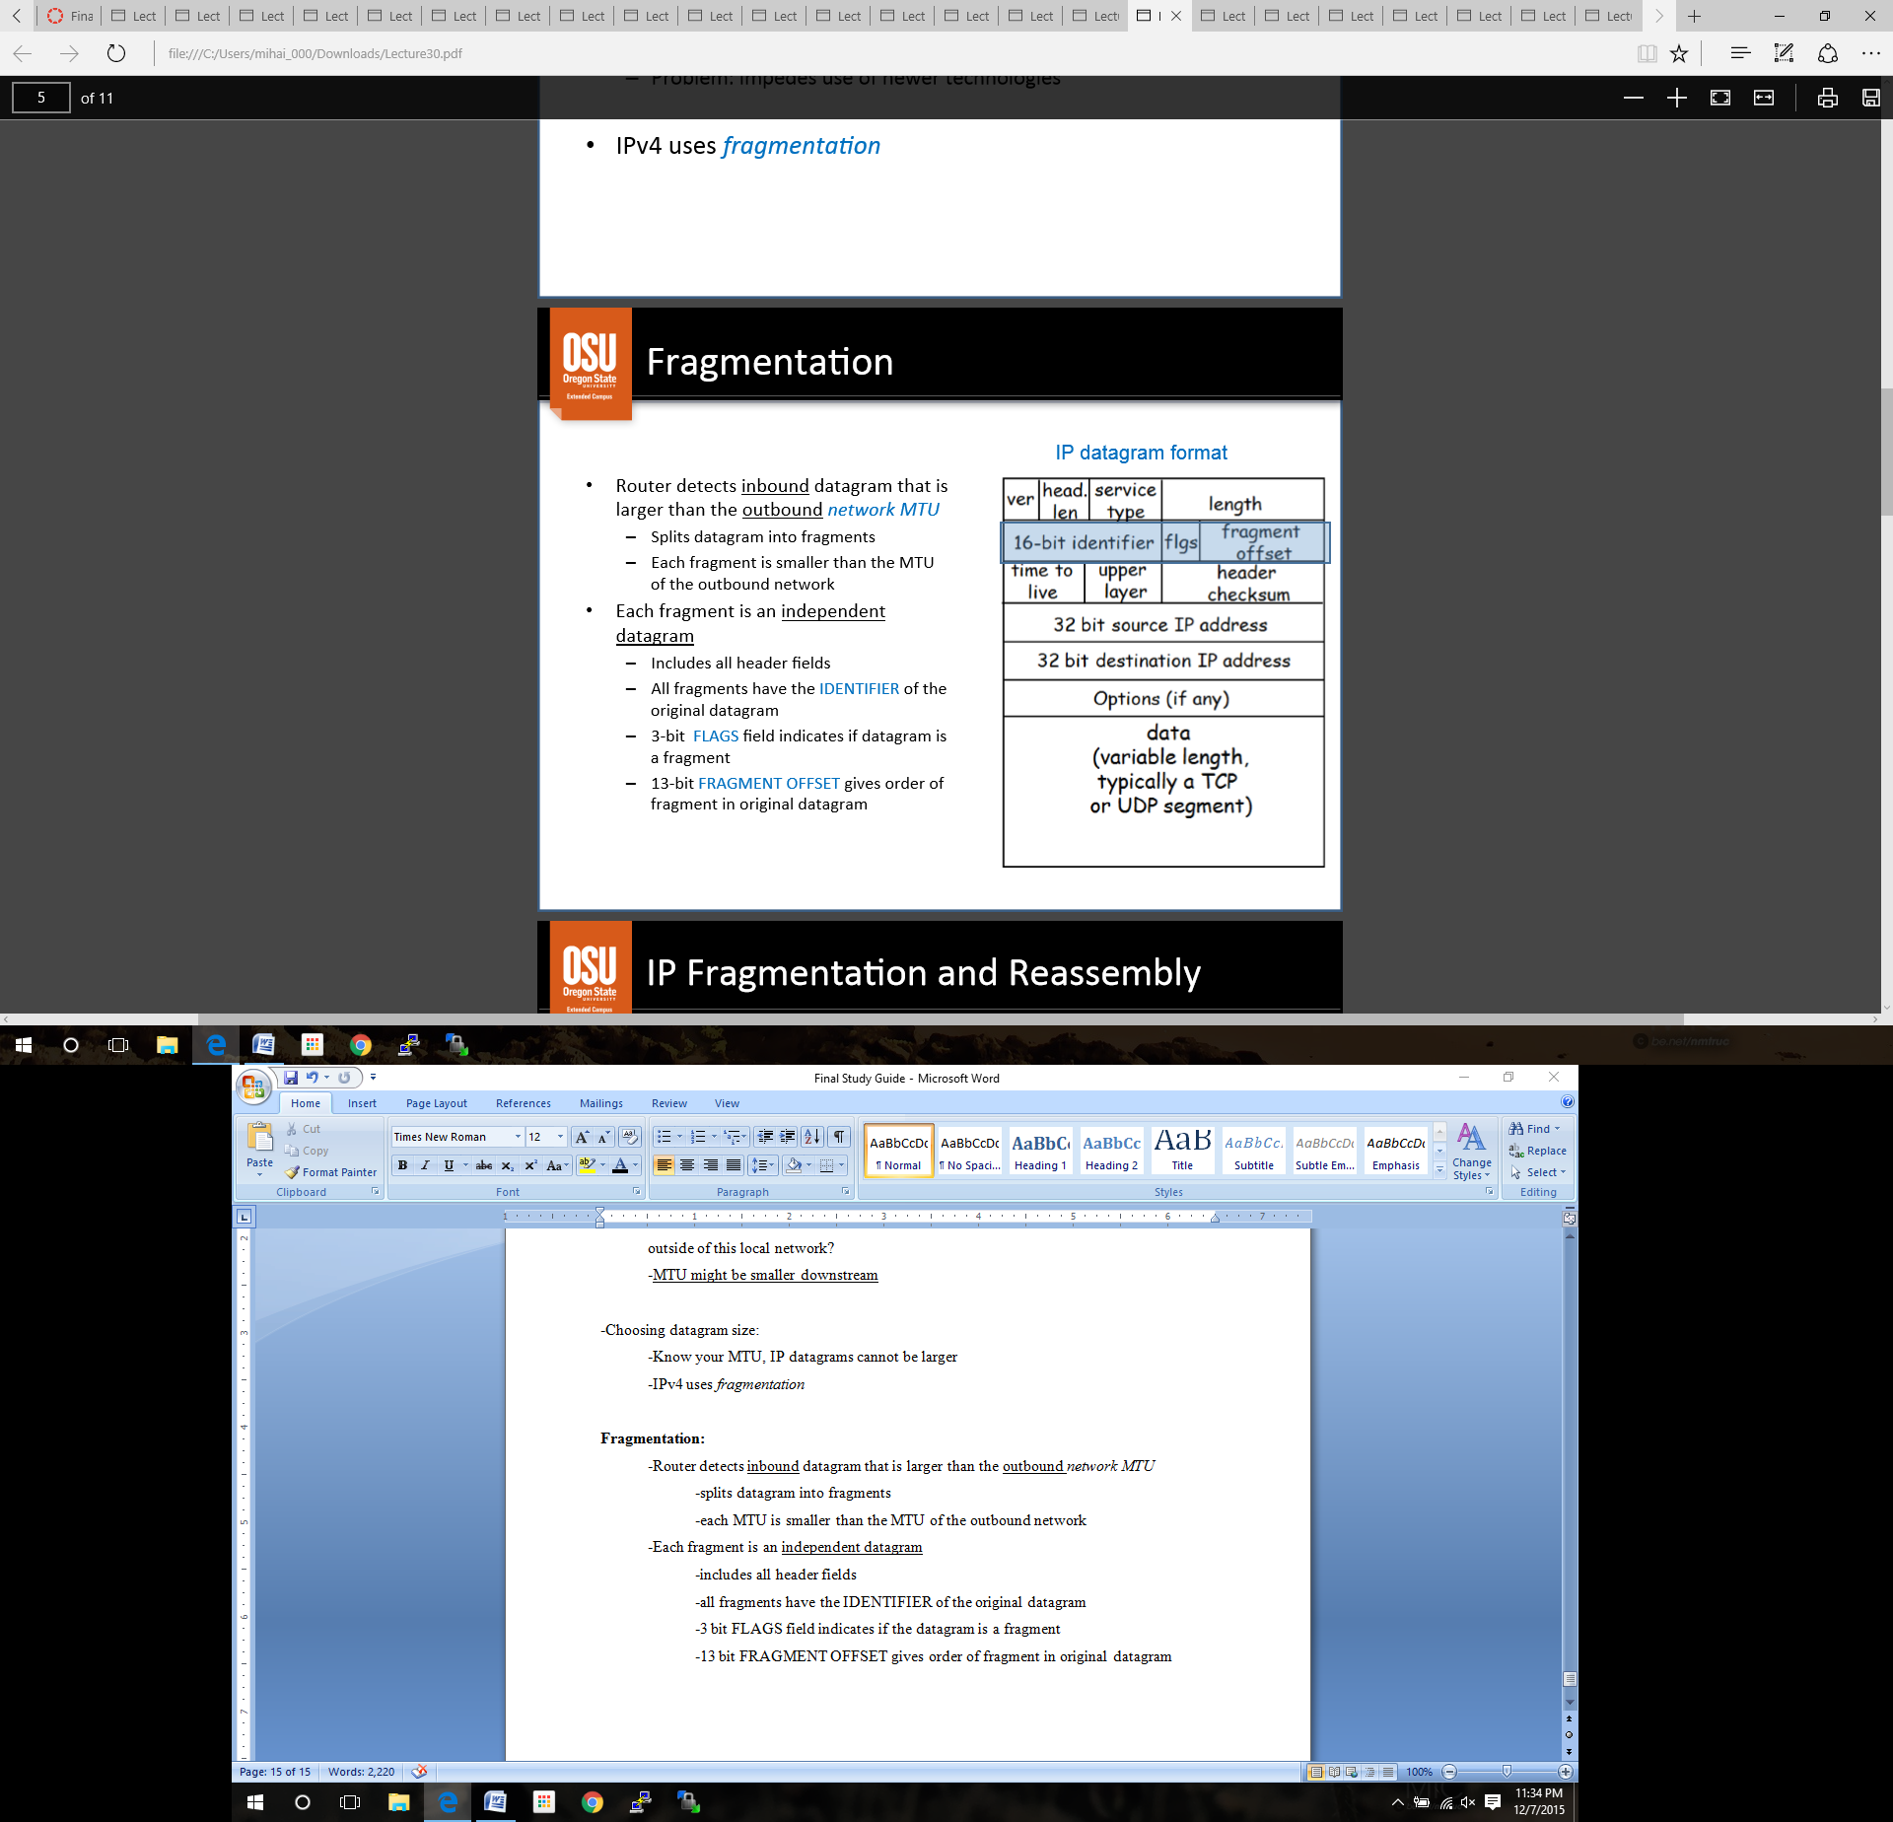

**Fragmentation:**

-Router detects inbound datagram that is larger than the outbound *network MTU*

-splits datagram into fragments

-each MTU is smaller than the MTU of the outbound network

-Each fragment is an independent datagram

-includes all header fields

-all fragments have the IDENTIFIER of the original datagram

-3 bit FLAGS field indicates if the datagram is a fragment

-13 bit FRAGMENT OFFSET gives order of fragment in original datagram

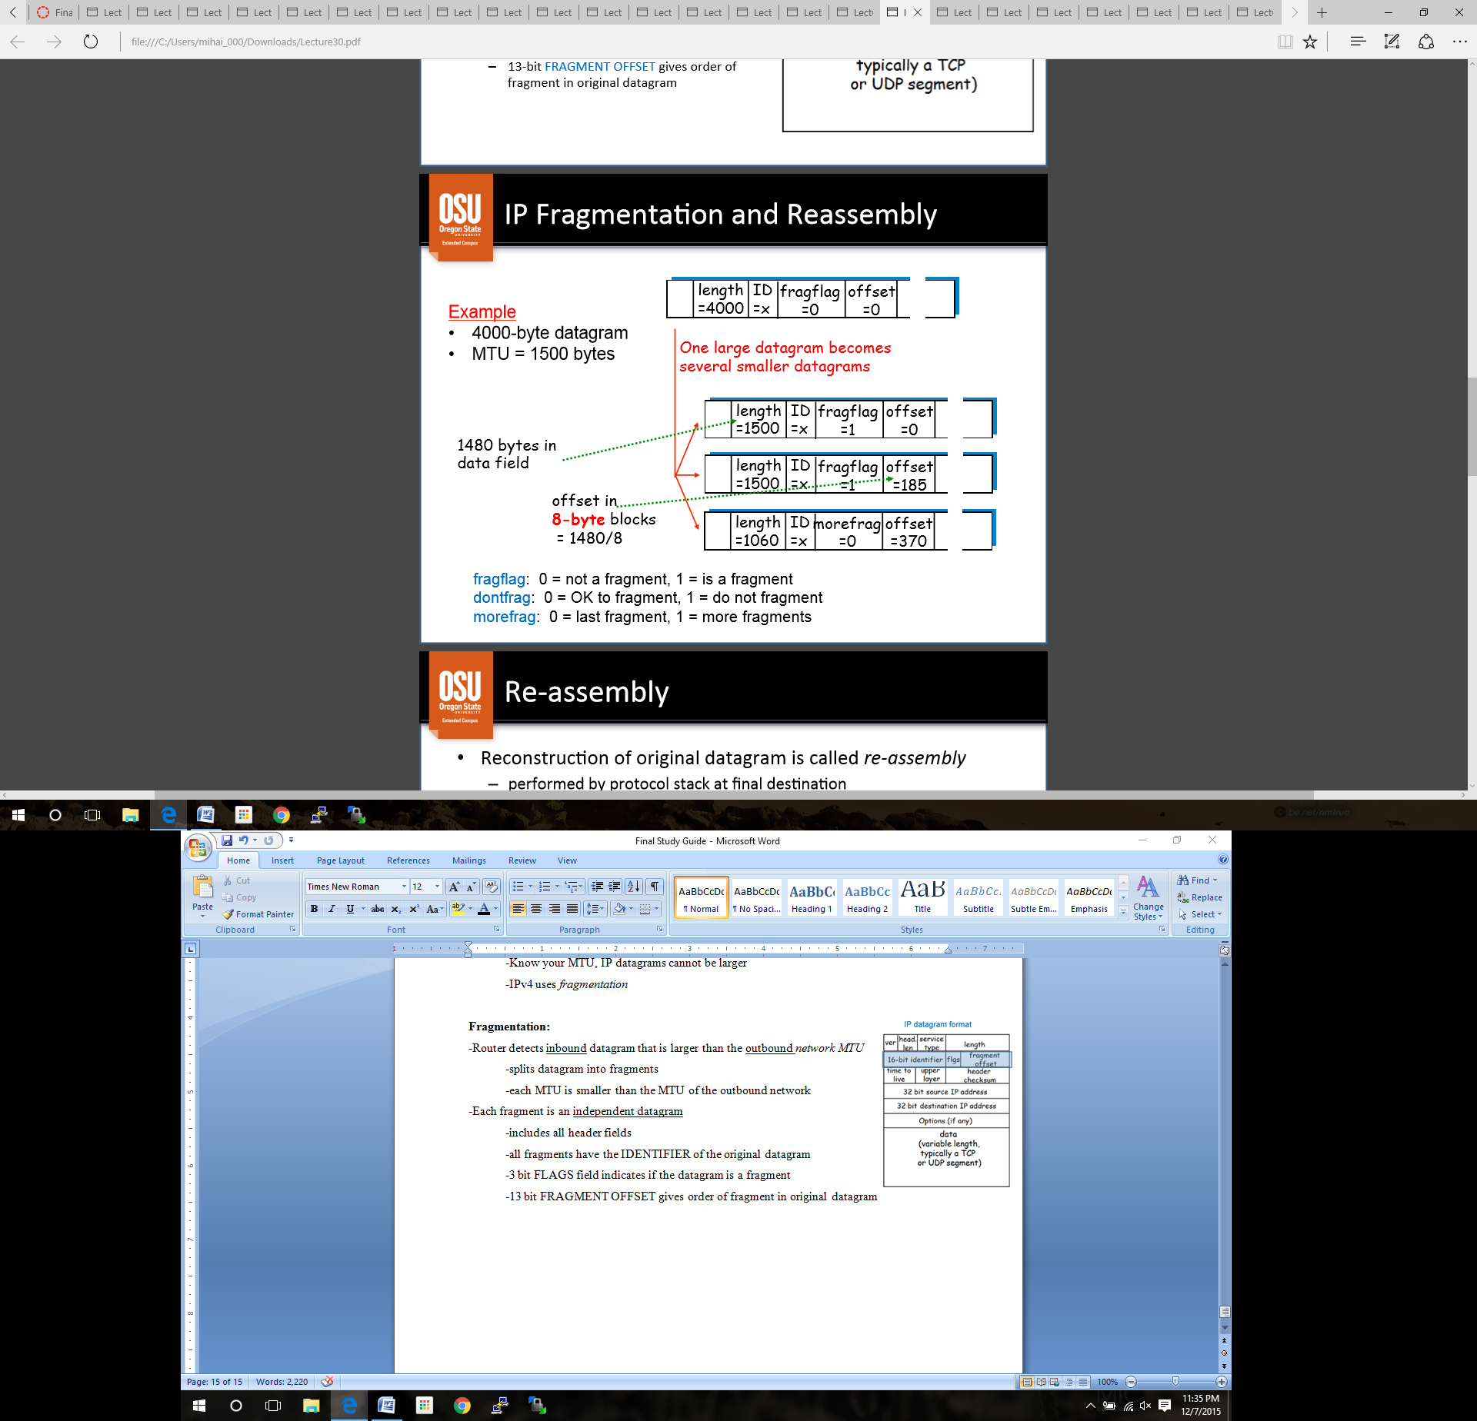

***PRACTICE***

Re-assembly:

-reconstruction of original datagram

-performed by protocol stack at final destination

-IDENTIFICATION field in each fragment matches the original datagram

-fragments can arrive out of order and be sorted out

-FLAGS field bit identifies fragment containing the end of data from original datastream

-FRAGMENT OFFSET specifies re-assembly order

-counted in 8 byte blocks

-Once datagram is fragmented, it stays fragmented until destination

-Final destination performs reassembly, **never** done along the way

-Reduces the amount of information needed by routes

-Allows routers to change dynamically

-Avoids re-fragmenting

Fragment Loss:

-Fragments may be lost…

-*Destination*

-sets timer with first fragment

-if timer expires before fragments arrive…

-one or more fragments may be assumed **lost**

-destination drops **entire** original datagram

-*source* is assumed to retransmit whole original datagram

-Why all or nothing?

-Can’t tell what fragments were lost.

-Sender doesn’t know what happens to fragments along the way.

-If sender could retransmit a single fragment, it might take a different route and be fragmented differently.

Fragmenting a Fragment:

-Fragment may encounter a network with smaller MTU

-Routers need to fragment to fit local MTU

-(sub)fragments look like original datagrams (except for size)

-no need to reassemble hierarchically

-IP does not distinguish between original fragments and subsequent fragments

-reassembly is entirely the responsibility of the host

**Lecture 31: Internet Control Message Protocol (ICMP)**

Error Detection:

-IP provides “best effort” delivery

-detects variety of errors such as checksum, TTL expires, no route to destination

-discards datagrams with certain types of problems

-some error types can be reported (RFC 792)

-router sends control messages back to the source

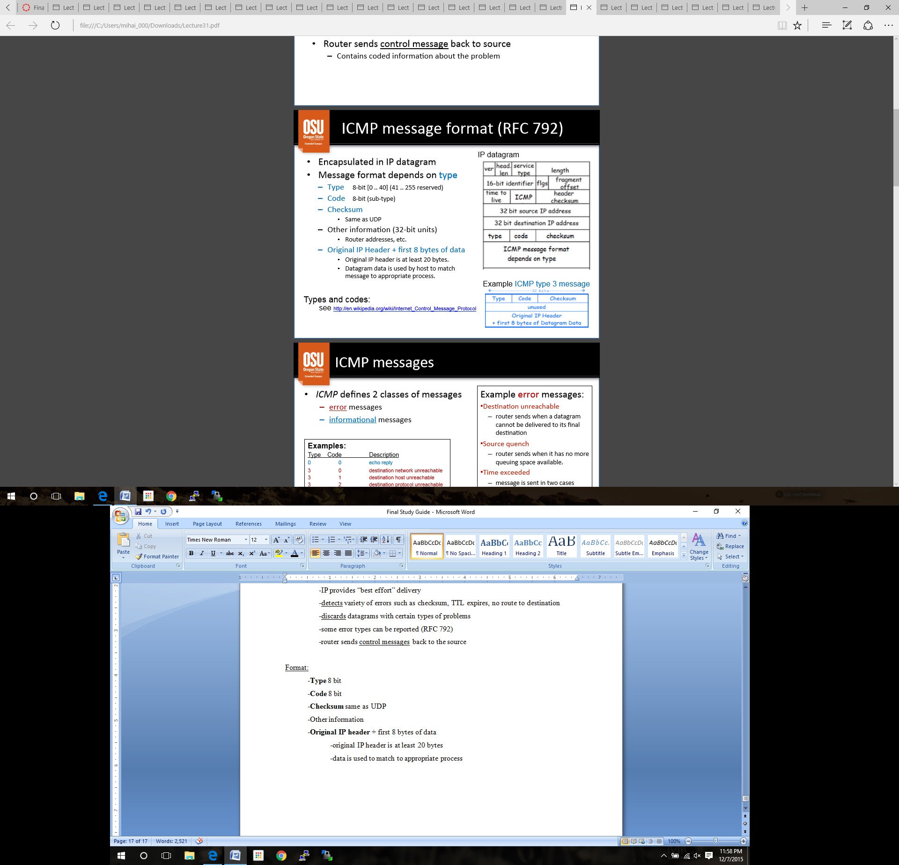

Format:

-**Type** 8 bit

-**Code** 8 bit

-**Checksum** same as UDP

-Other information

-**Original IP header** + first 8 bytes of data

-original IP header is at least 20 bytes

-data is used to match to appropriate process

Defines **two** classes of messages:

-**error** messages: destination unreachable, time exceeded, fragmentation required

-**information** messages: echo request/reply, router path MTU discovery

Applications:

-implemented at the network layer

-only *user interface* goes to the application layer

-***ping, echo, traceroute,***etc

-Discovery and router collaboration

-optimal path, MTU, etc

-infra system routing (ex Router Information Protocol, Open Shortest Path First Protocol)

-inter system routing (ex Border Gateway Protocol)

Reachability and *ping*:

-A is reachable to B if A can send datagrams to B

-***ping*** program tests reachability by sending datagram from B to A and A *echoes* it back to B

-uses ECMP “echo request” and “echo reply”

*traceroute:*

-list all routers on computed path from A to B is called the route

-***traceroute*** uses UDP with TTL field set and sends to an unlikely port

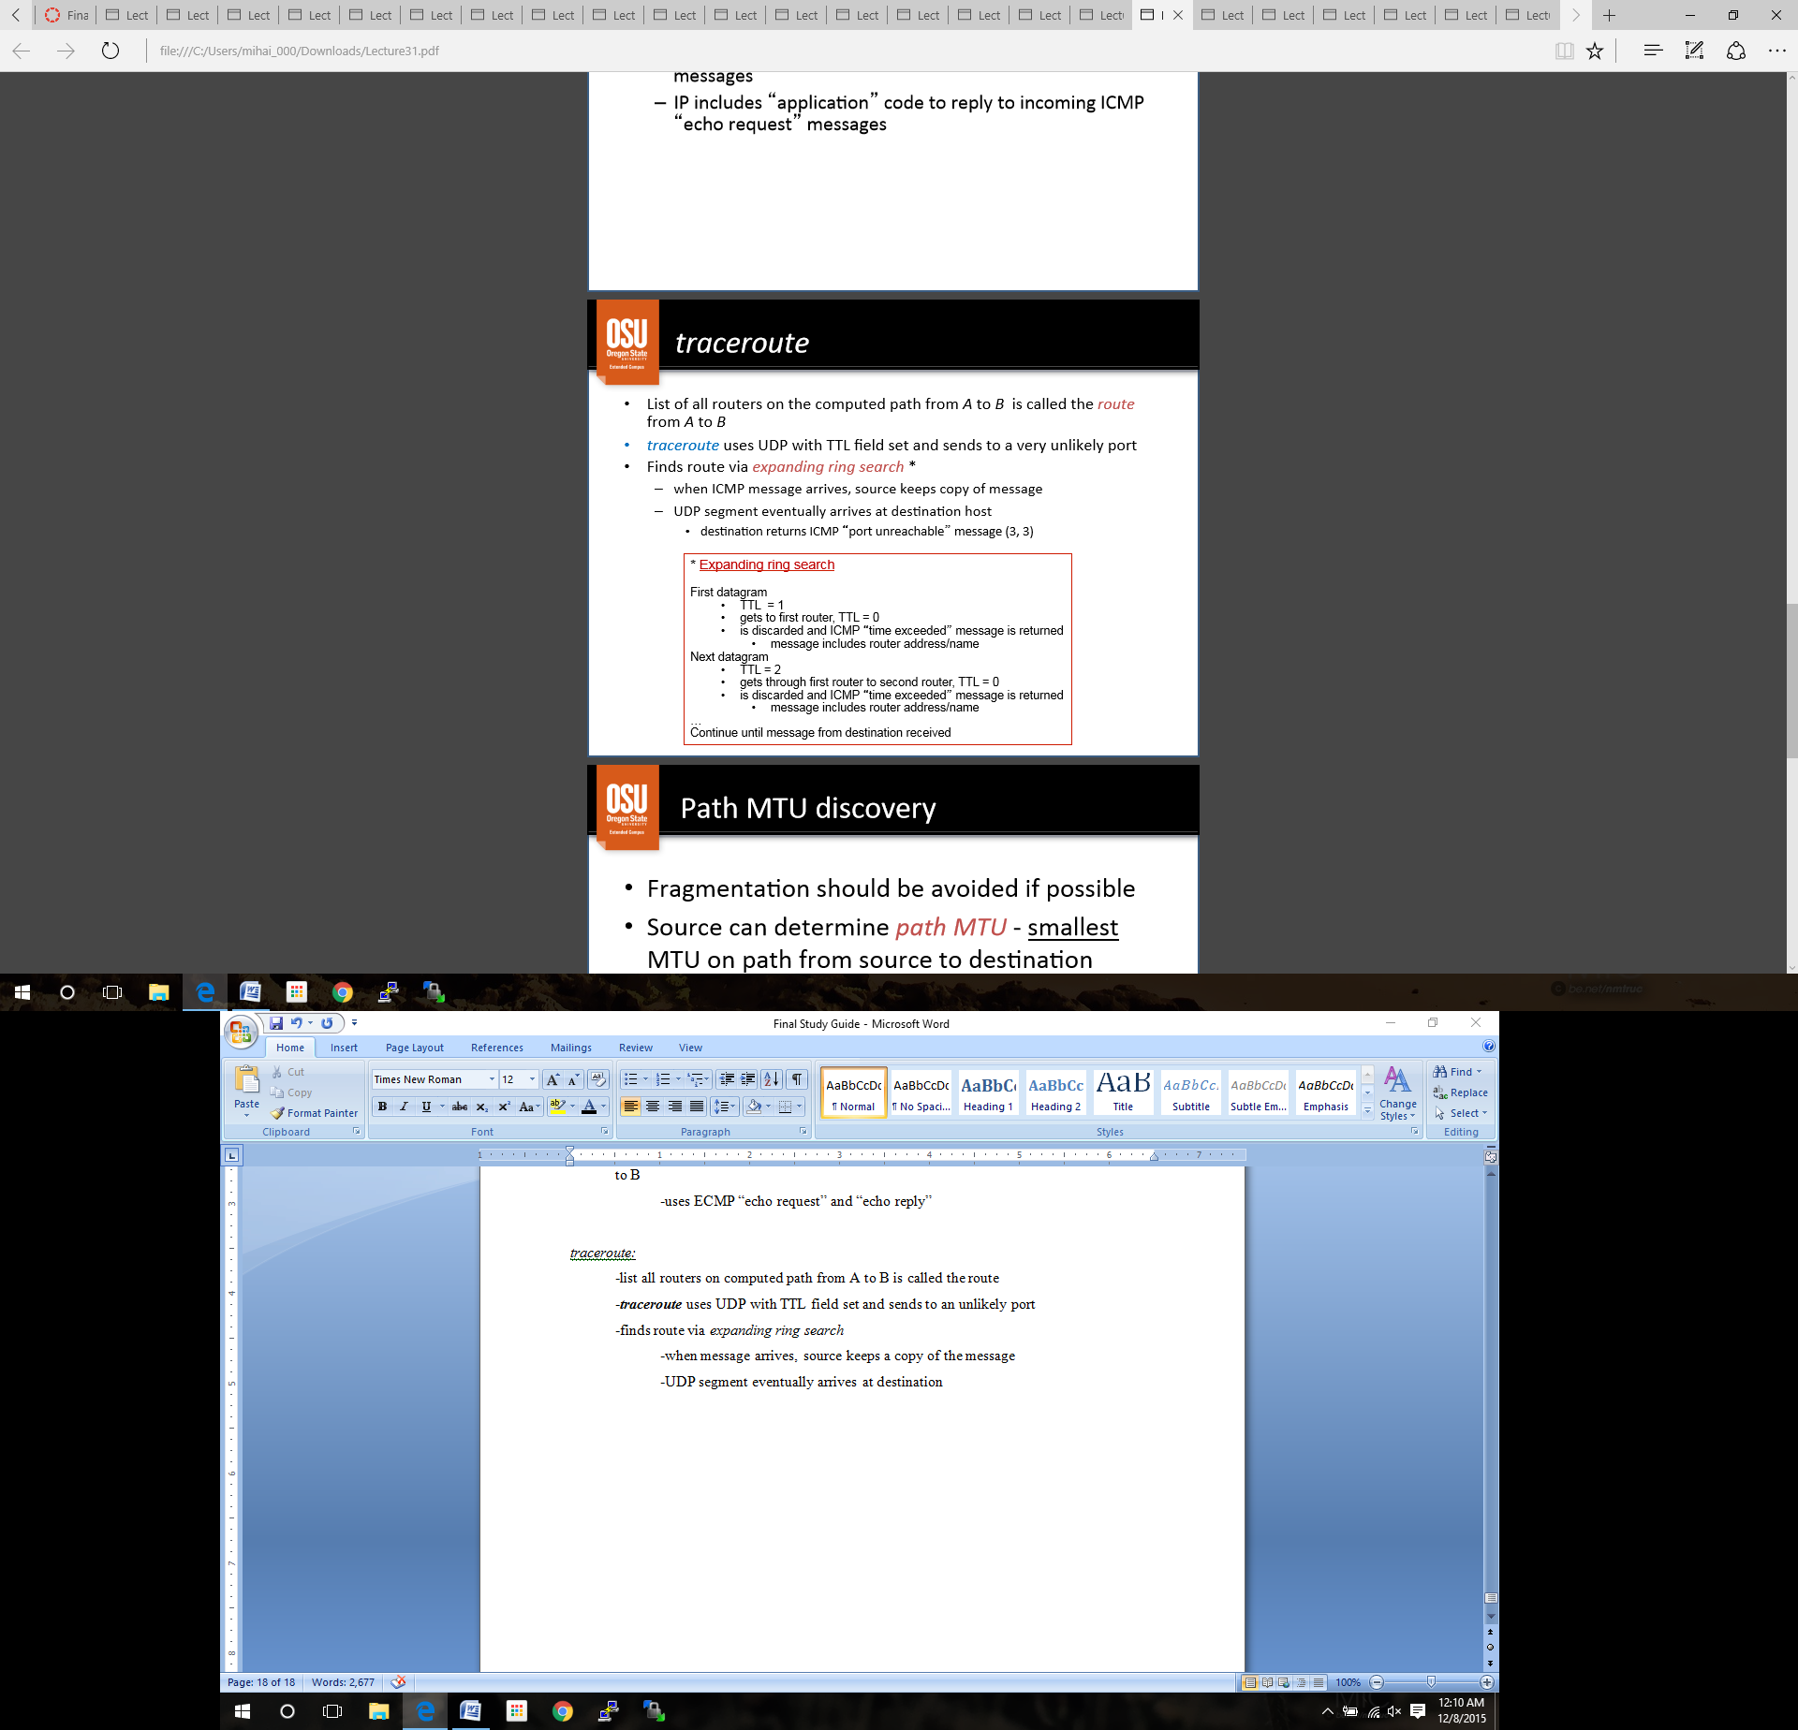 -finds route via *expanding ring search\**

-when message arrives, source keeps a copy of the message

-UDP segment eventually arrives at destination

Path MTU discovery:

-Fragmentation should be avoided if possible

-Source can determine *shortest path MTU*

-probes with *do not fragment* flags set on datagrams

-router with smaller MTU responds with “*fragmentation required*”

-source sends smaller datagrams until destination is reached

Router Discovery:

-Any router can fail, isolating host from internet (black hole)

-router can broadcast request for “*router solicitation*” to auto-configure default route

-router can broadcast “*router advertisement*” of existence when first connected

-routers can share discoveries for updating routing tables

**Lecture 32: IP NAT**

Sharing an IP address is motivated by…

-exhaustion of IP addresses

-conservation of resources, sharing internet access through just one IP address

-home networks, other small LANS

**Network Address Translation (NAT)**:  
 -Multiple computers in one location can share an single **external IP address** (global)

-Entire local network uses just one IP address

-over 65,000 hosts theoretically

-all internet addresses managed *locally*, but external ones are managed *globally*

-can change ISP/external address **without** affecting the local address

-devices inside the *local* network cannot be accessed directly addressed by external hosts

Implementation:

-in line configuration

-all traffic entering/leaving network must go through **NAT device**

-internal communications do not use NAT device

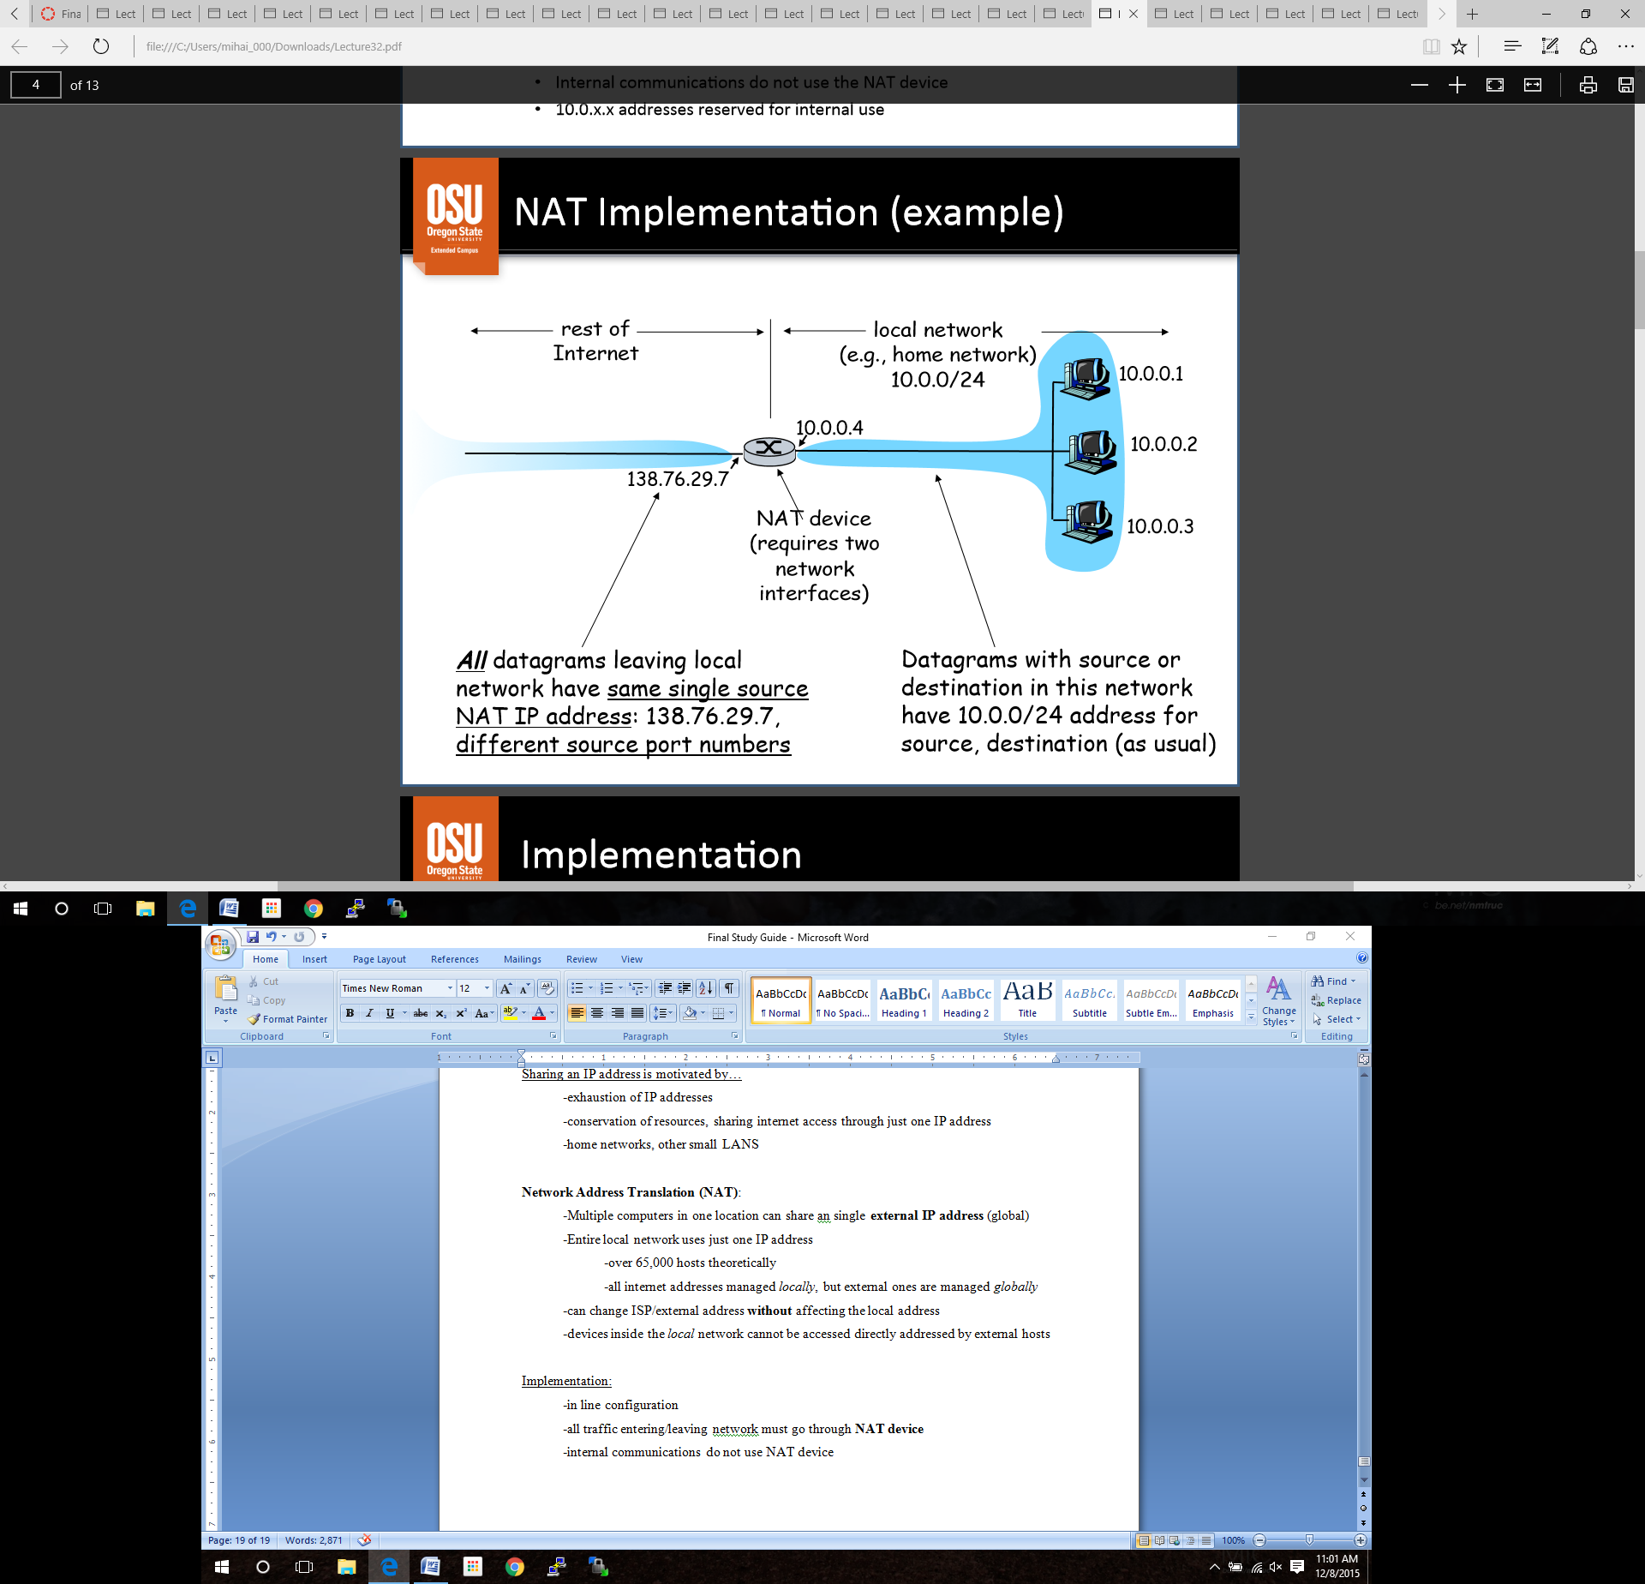Example:

Implementation:

Software solutions

-Standard PC with NAT software

-Linux *masquerade*

-Windows *RRAS* (Routing and Remote Access Server)

-Ok for slower networks

-NAT box must translate each address in the network (ex calculating RTT, congestion, etc.)

Hardware solutions

-Special purpose hardware for high-speed networks

Hybrid solutions

-Routers can implement NAT software

-medium-speed networks

**Network Address and Port Translation** (NAPT):

-most popular implementation of NAT

-keeps track of local and external **IP addresses** and **port numbers**

-allows multiple internal hosts to communicate with multiple external destinations

-allows multiple internal hosts to communicate with one external destination

-the **effect** of NAT is to form a virtual private connection between a *host inside a network* and an *external host*

Example NAT table: ***PRACTICE***

-entry in tables are both IP addresses and port numbers

-port numbers can be reassigned to avoid conflicts

*requires NAT box to do some *transport layer* stuff

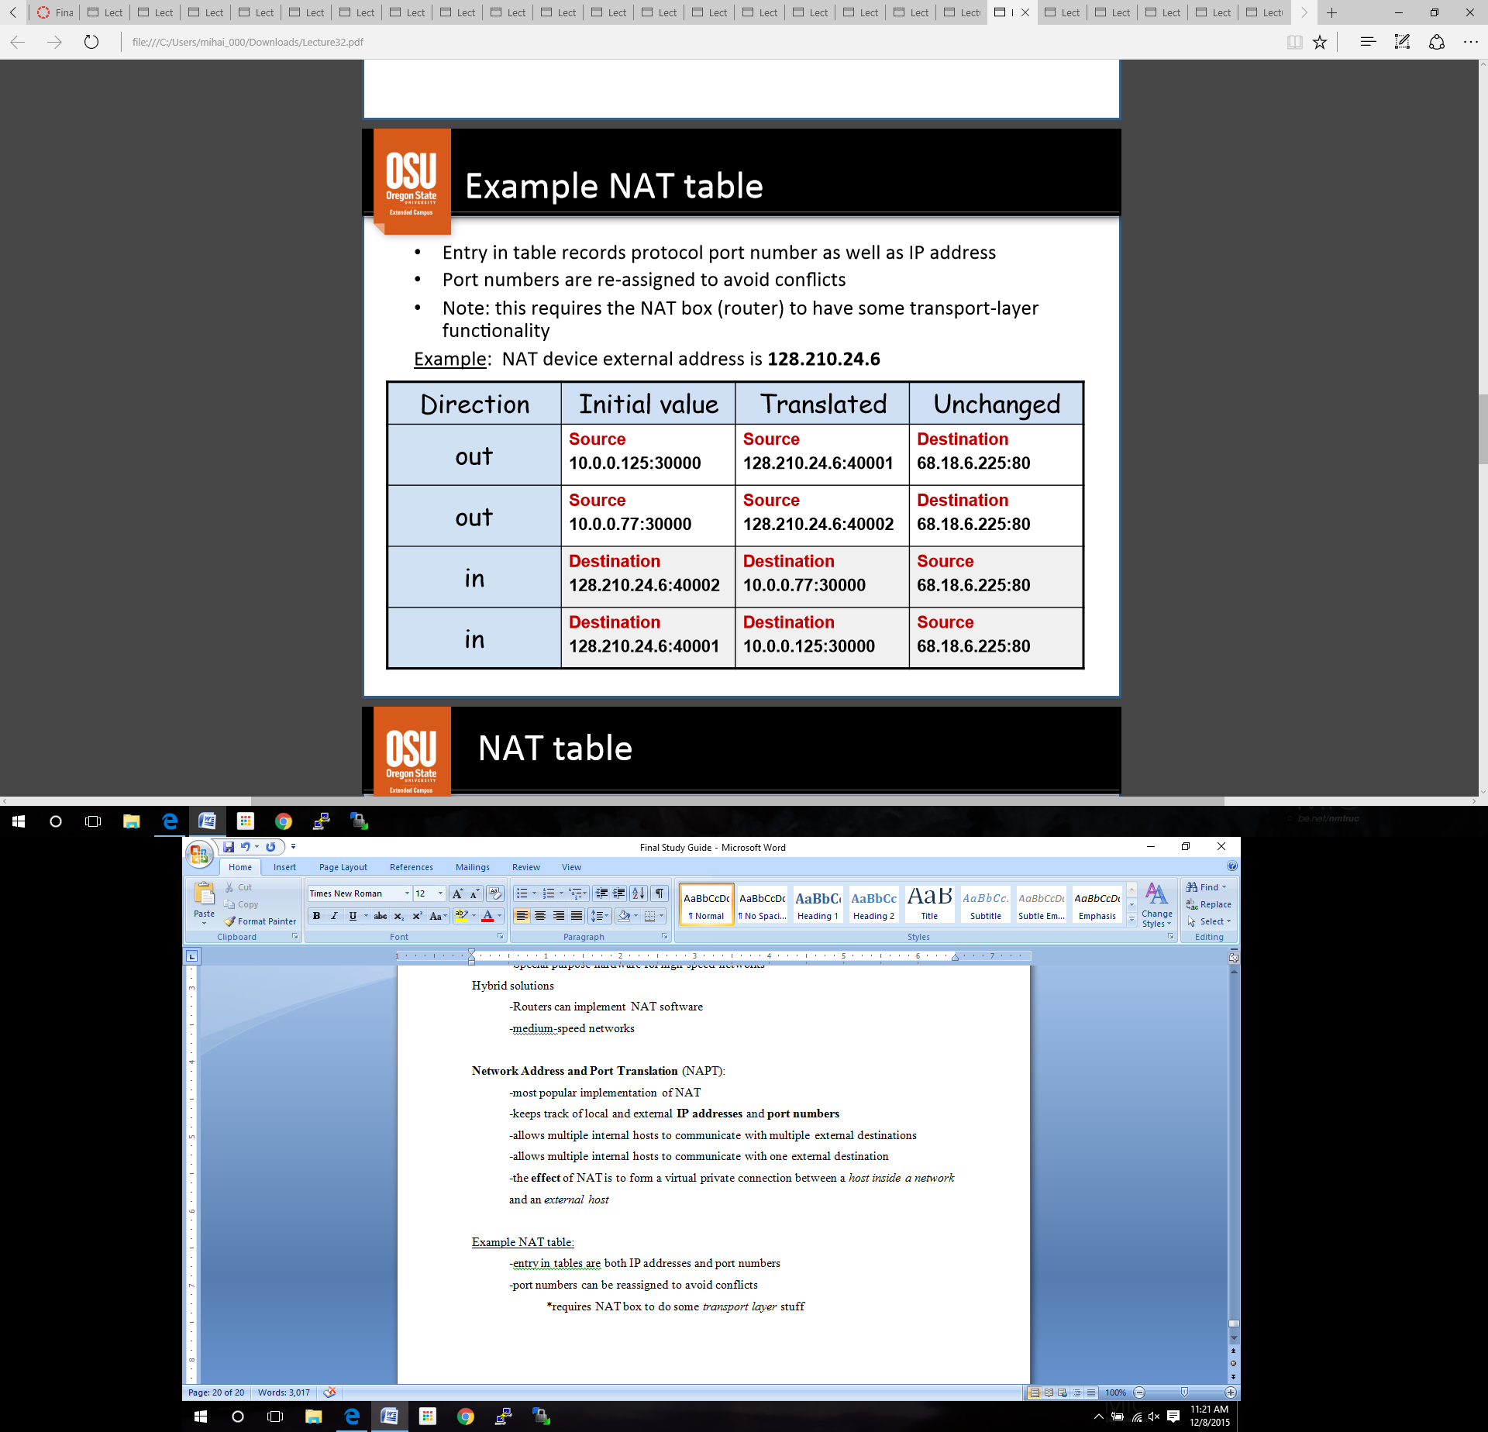

**NAT Table:**

For an *out-going* datagram:

-translate table records (internal *source address*, original source *port number*)

-source address is changed to NAT’s external address

-source port number is reassigned

-translate table records (*destination address*, re-assigned *source port number*)

-calculate **checksum**

-datagram is **reconstructed**

For an *in-coming* datagram:

-*destination address* is changed to the *internal address* and recorded in table

-destination port number is changed to one saved in table

-**checksum** recalculated

-datagram **reconstructed**

NAT traversal problem:

Solution 1:

-statically configure NAT to forward incoming connection requests at given port

Solution 2:

-Universal PnP Internet Gateway Device (IGD) Protocol

-automates static configuration

-allows NAT’ed host to map *private* to *pubic* **IP** and **port**, and advertise public port/IP

Solution 3:

-relaying (used in Skype)

-NAT’ed client makes connection to relay

-external client also connects to relay

-relay creates a bridge for them to transfer packets

Solution 4:

-Twice NAT

-NAT box provides DNS service

-usually works, unless remote request uses domain name instead of IP address

NAT is controversial…

-routers should not only process up to the network layer

-ISP overload

-address shortage could’ve been fixed by **IPv6**

**Lecture 33: IP version 6**

Initial motivation for IPv6 was space exhaustion from IPv4

Changes from IPv4:

-address space is **128 bits**

-support for **audio** and **video**

-fragmentation is **no** longer allowed

-**checksum removed** to reduce processing time

-optional headers allowed (indicated by the “Next Header” field)

-**ICMPv6**: additional message types, more effective inter-router collaboration

IPv6 Addressing:

-128-bit addresses (3.4 x 1038 addresses)

-routers use longest matching prefix

- dotted-decimal would not make sense

-represented in *colon hexadecimal (colon hex)* with /bits to specify netmask

-ex 69DC:8864:FFFF:FFFF:0:1280:8C0A:FFFF / 64

-Zero compression

-series of zeroes indicated by two colons

-if two set, shorten the longer one

-if sets are the same size, shorten the right most one

-IPv6 address with 96 leading zeroes is interpreted as an IPv4 address

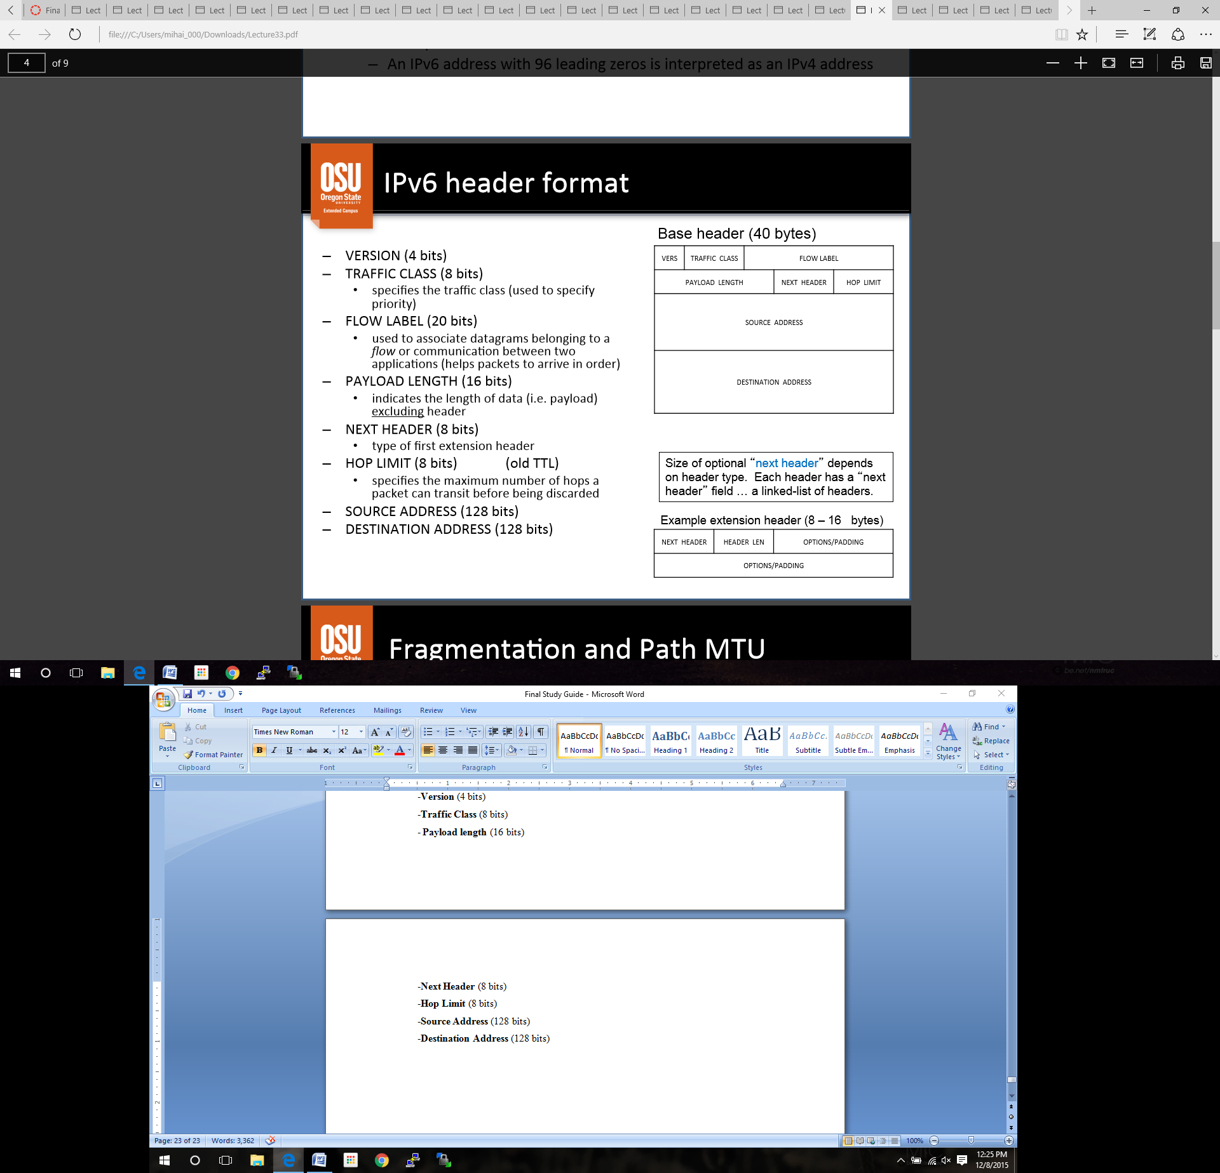

IPv6 header format:

-**Version** (4 bits)

-**Traffic** **Class** (8 bits)

- **Payload** **length** (16 bits)

 -**Next Header** (8 bits)

-**Hop Limit** (8 bits)

-**Source Address** (128 bits)

-**Destination Address** (128 bits)

Fragmentation and Path MTU:

-fragmentation info is in *fragmentation extension header*

-**source** is responsible for fragmentation

-**source** determines ***path MTU***

-uses *path MTU discovery*, send probes of various sizes, waits for destination ICMP message

-routers **do not** fragment, they simply drop the datagram larger than the path MTU

-send ICMP message back to source

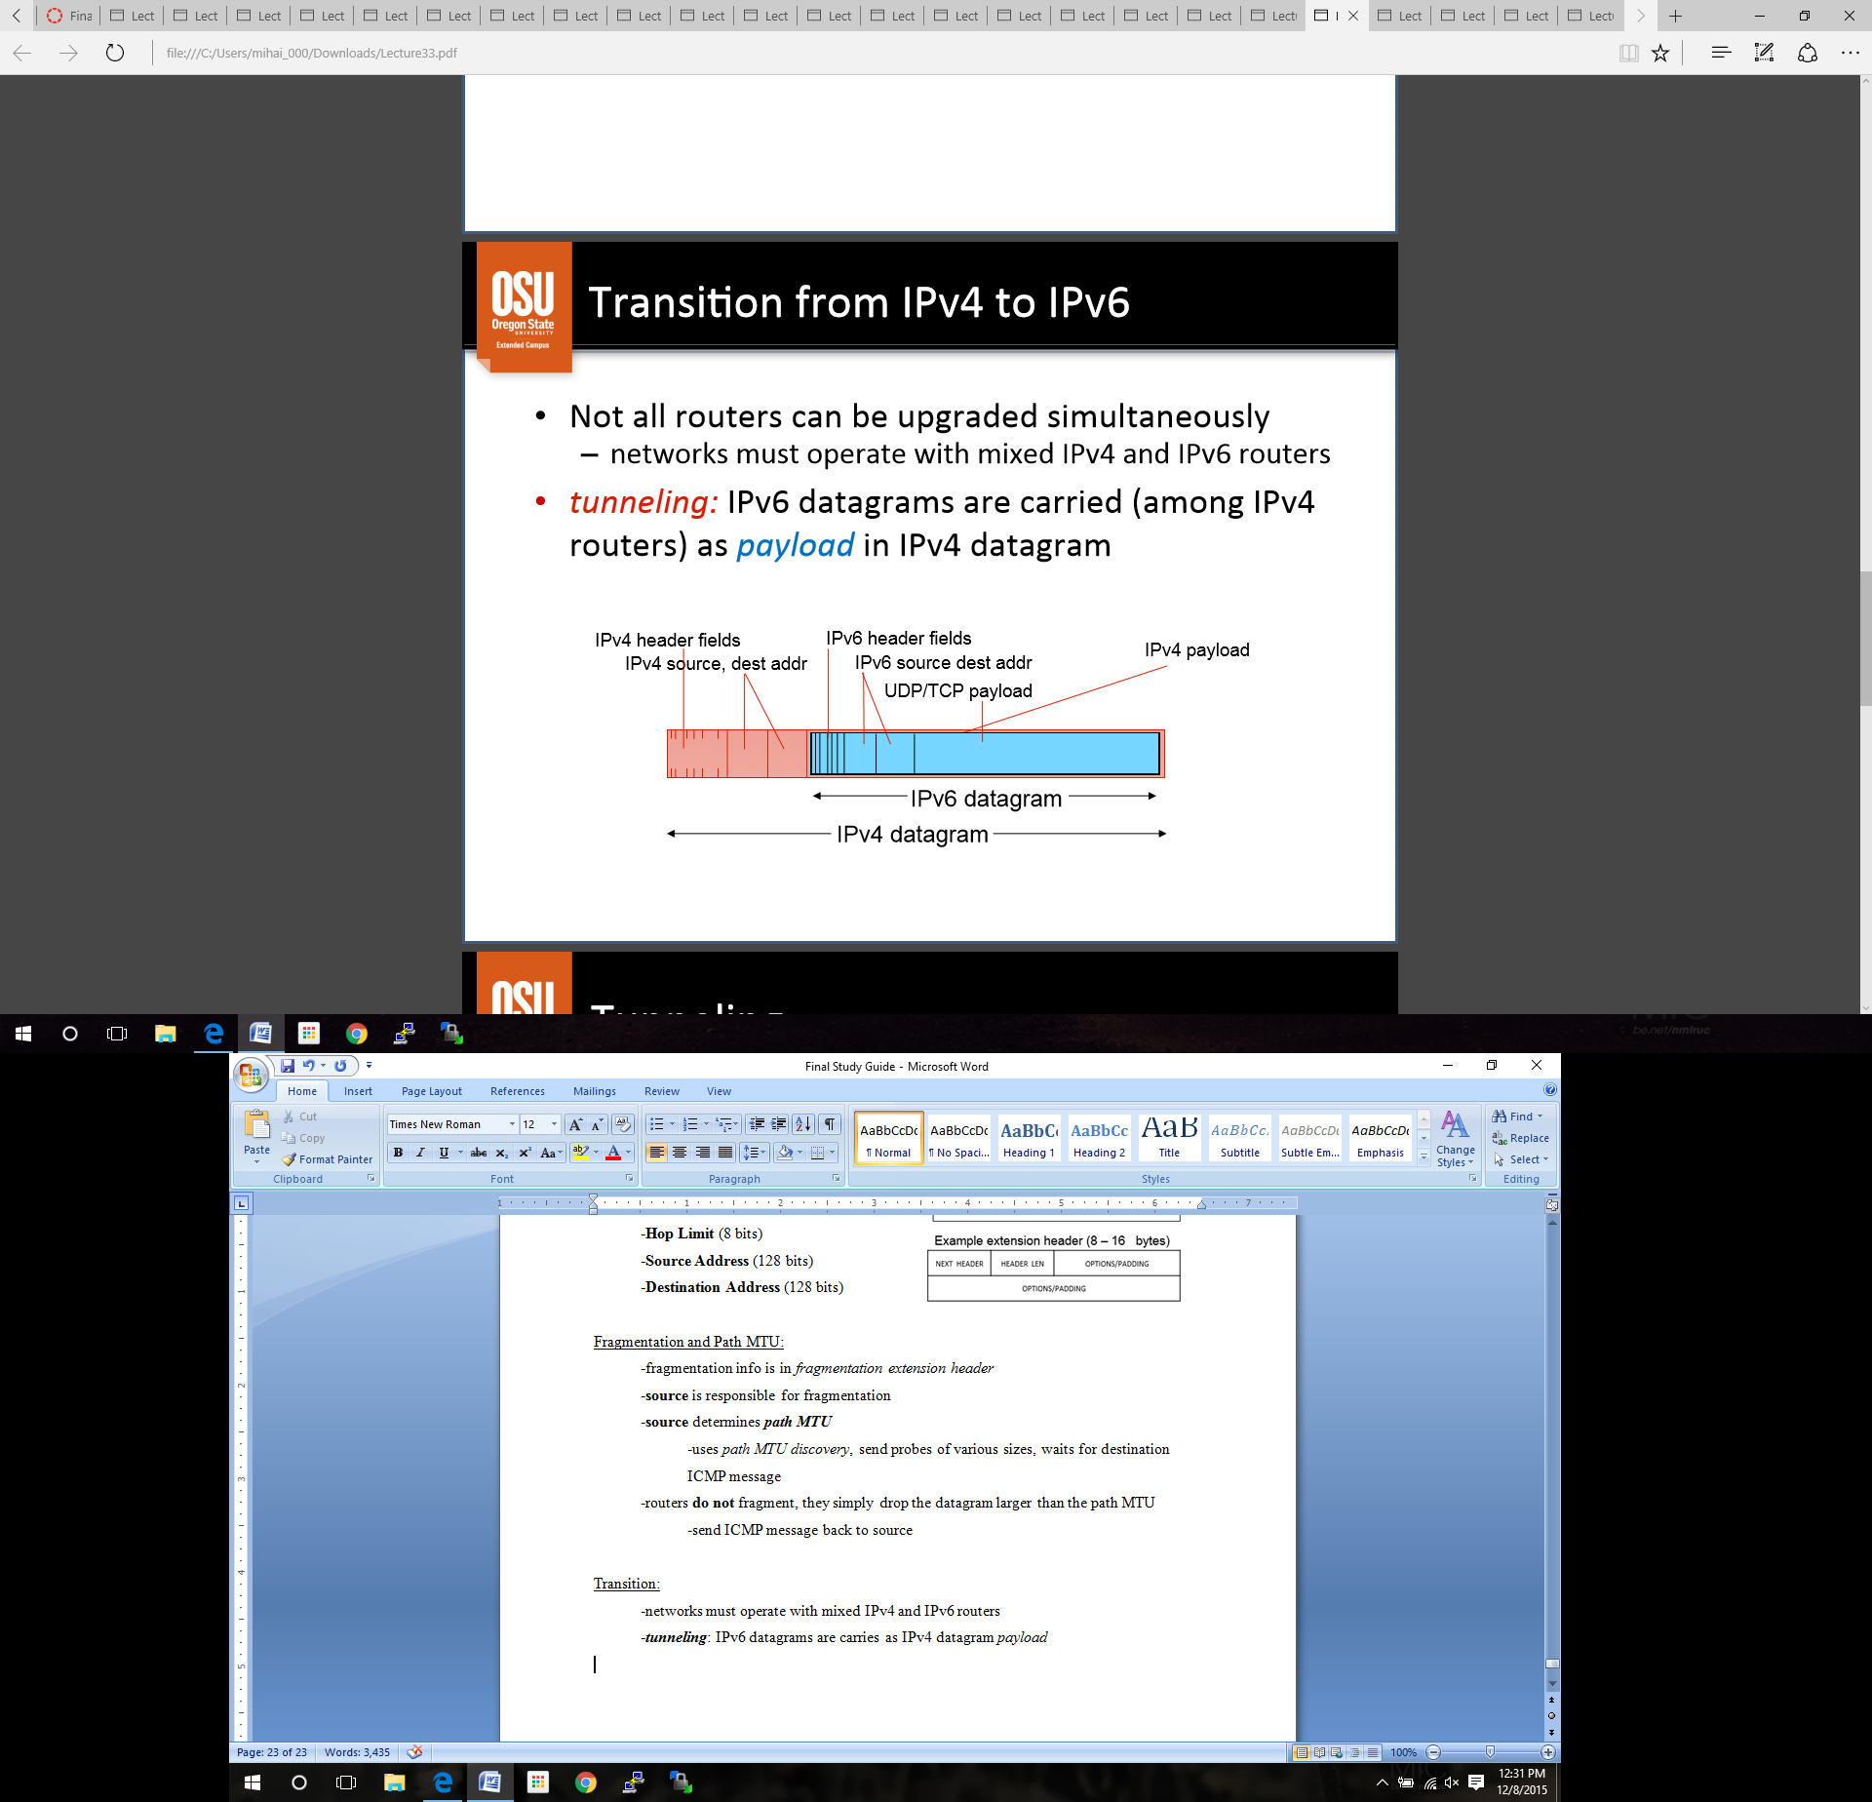Transition:

-networks must operate with mixed IPv4 and IPv6 routers

-***tunneling***: IPv6 datagrams are carries as IPv4 datagram *payload*

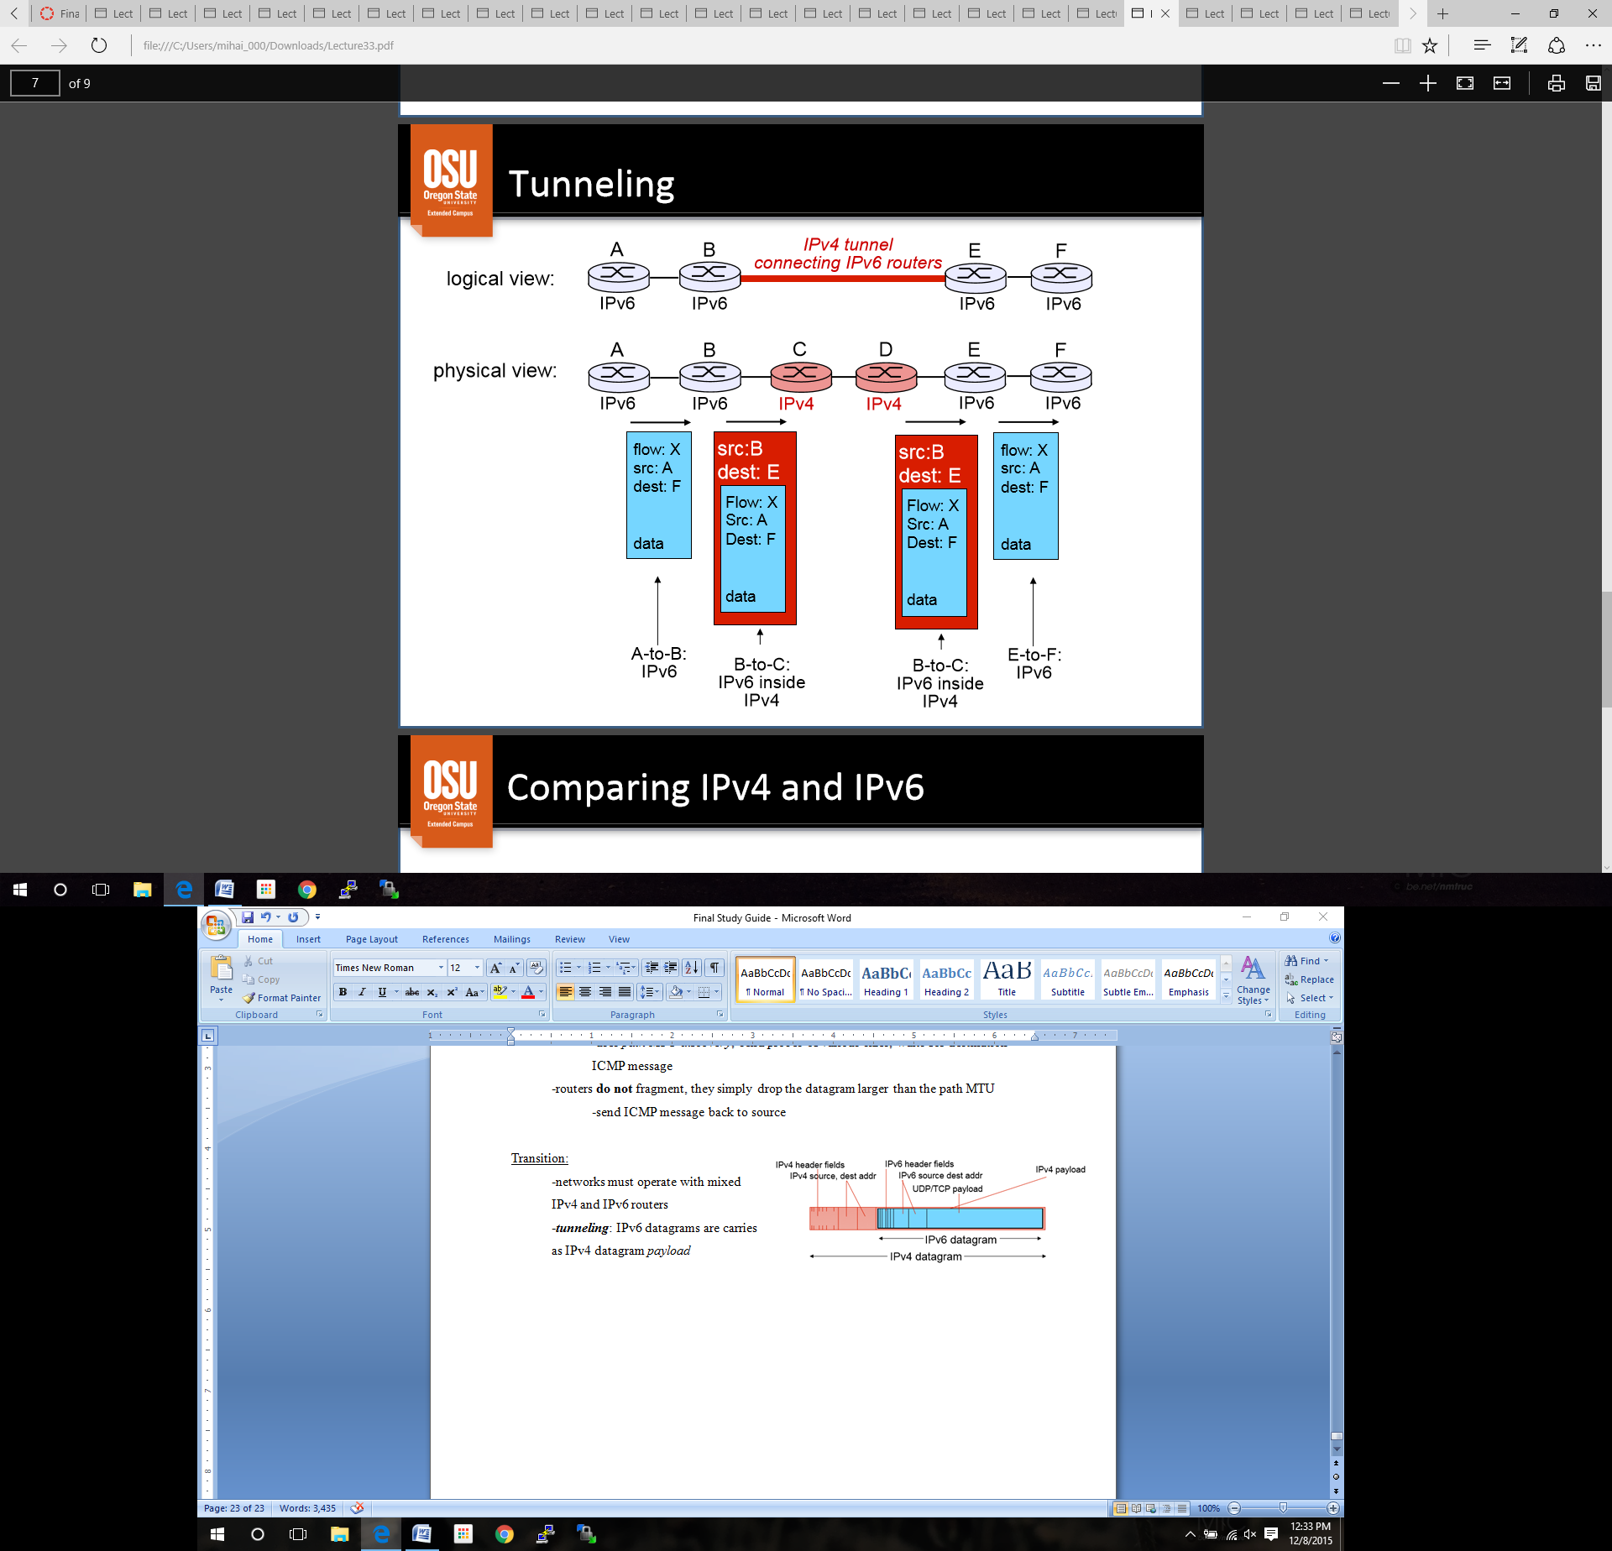

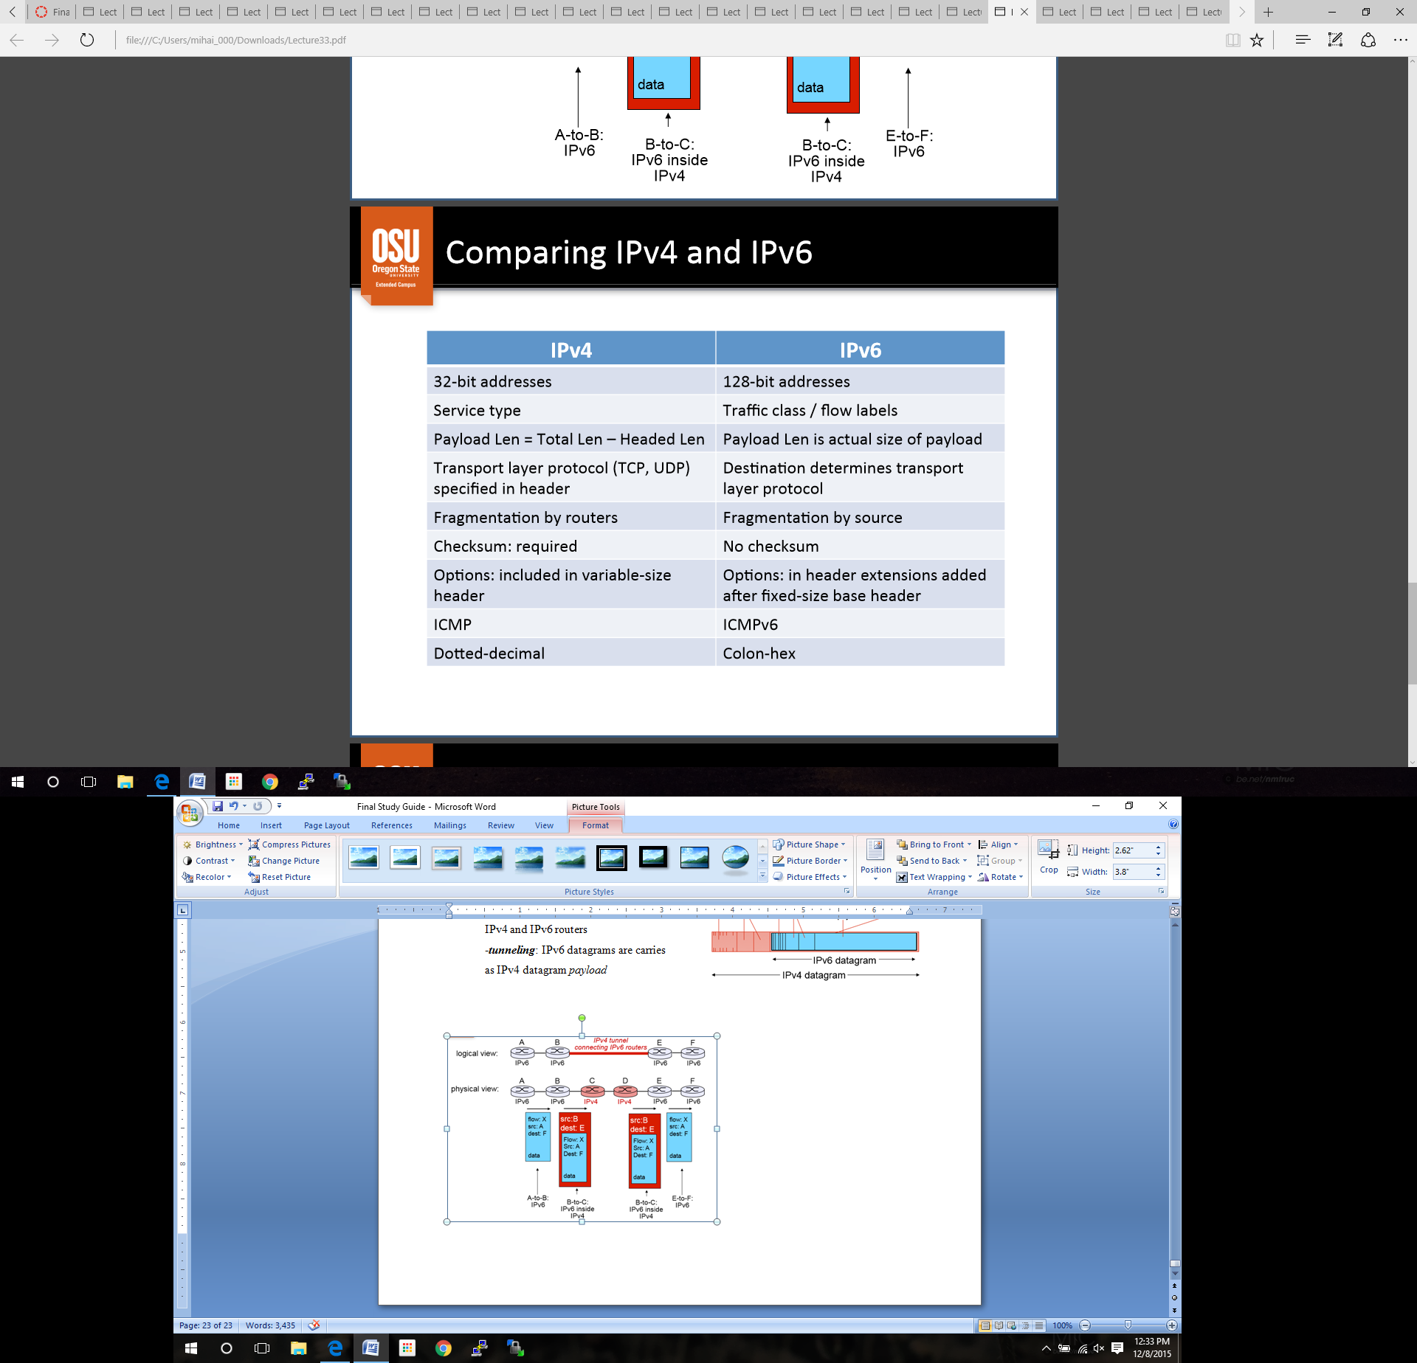**IPv4 vs IPv6**

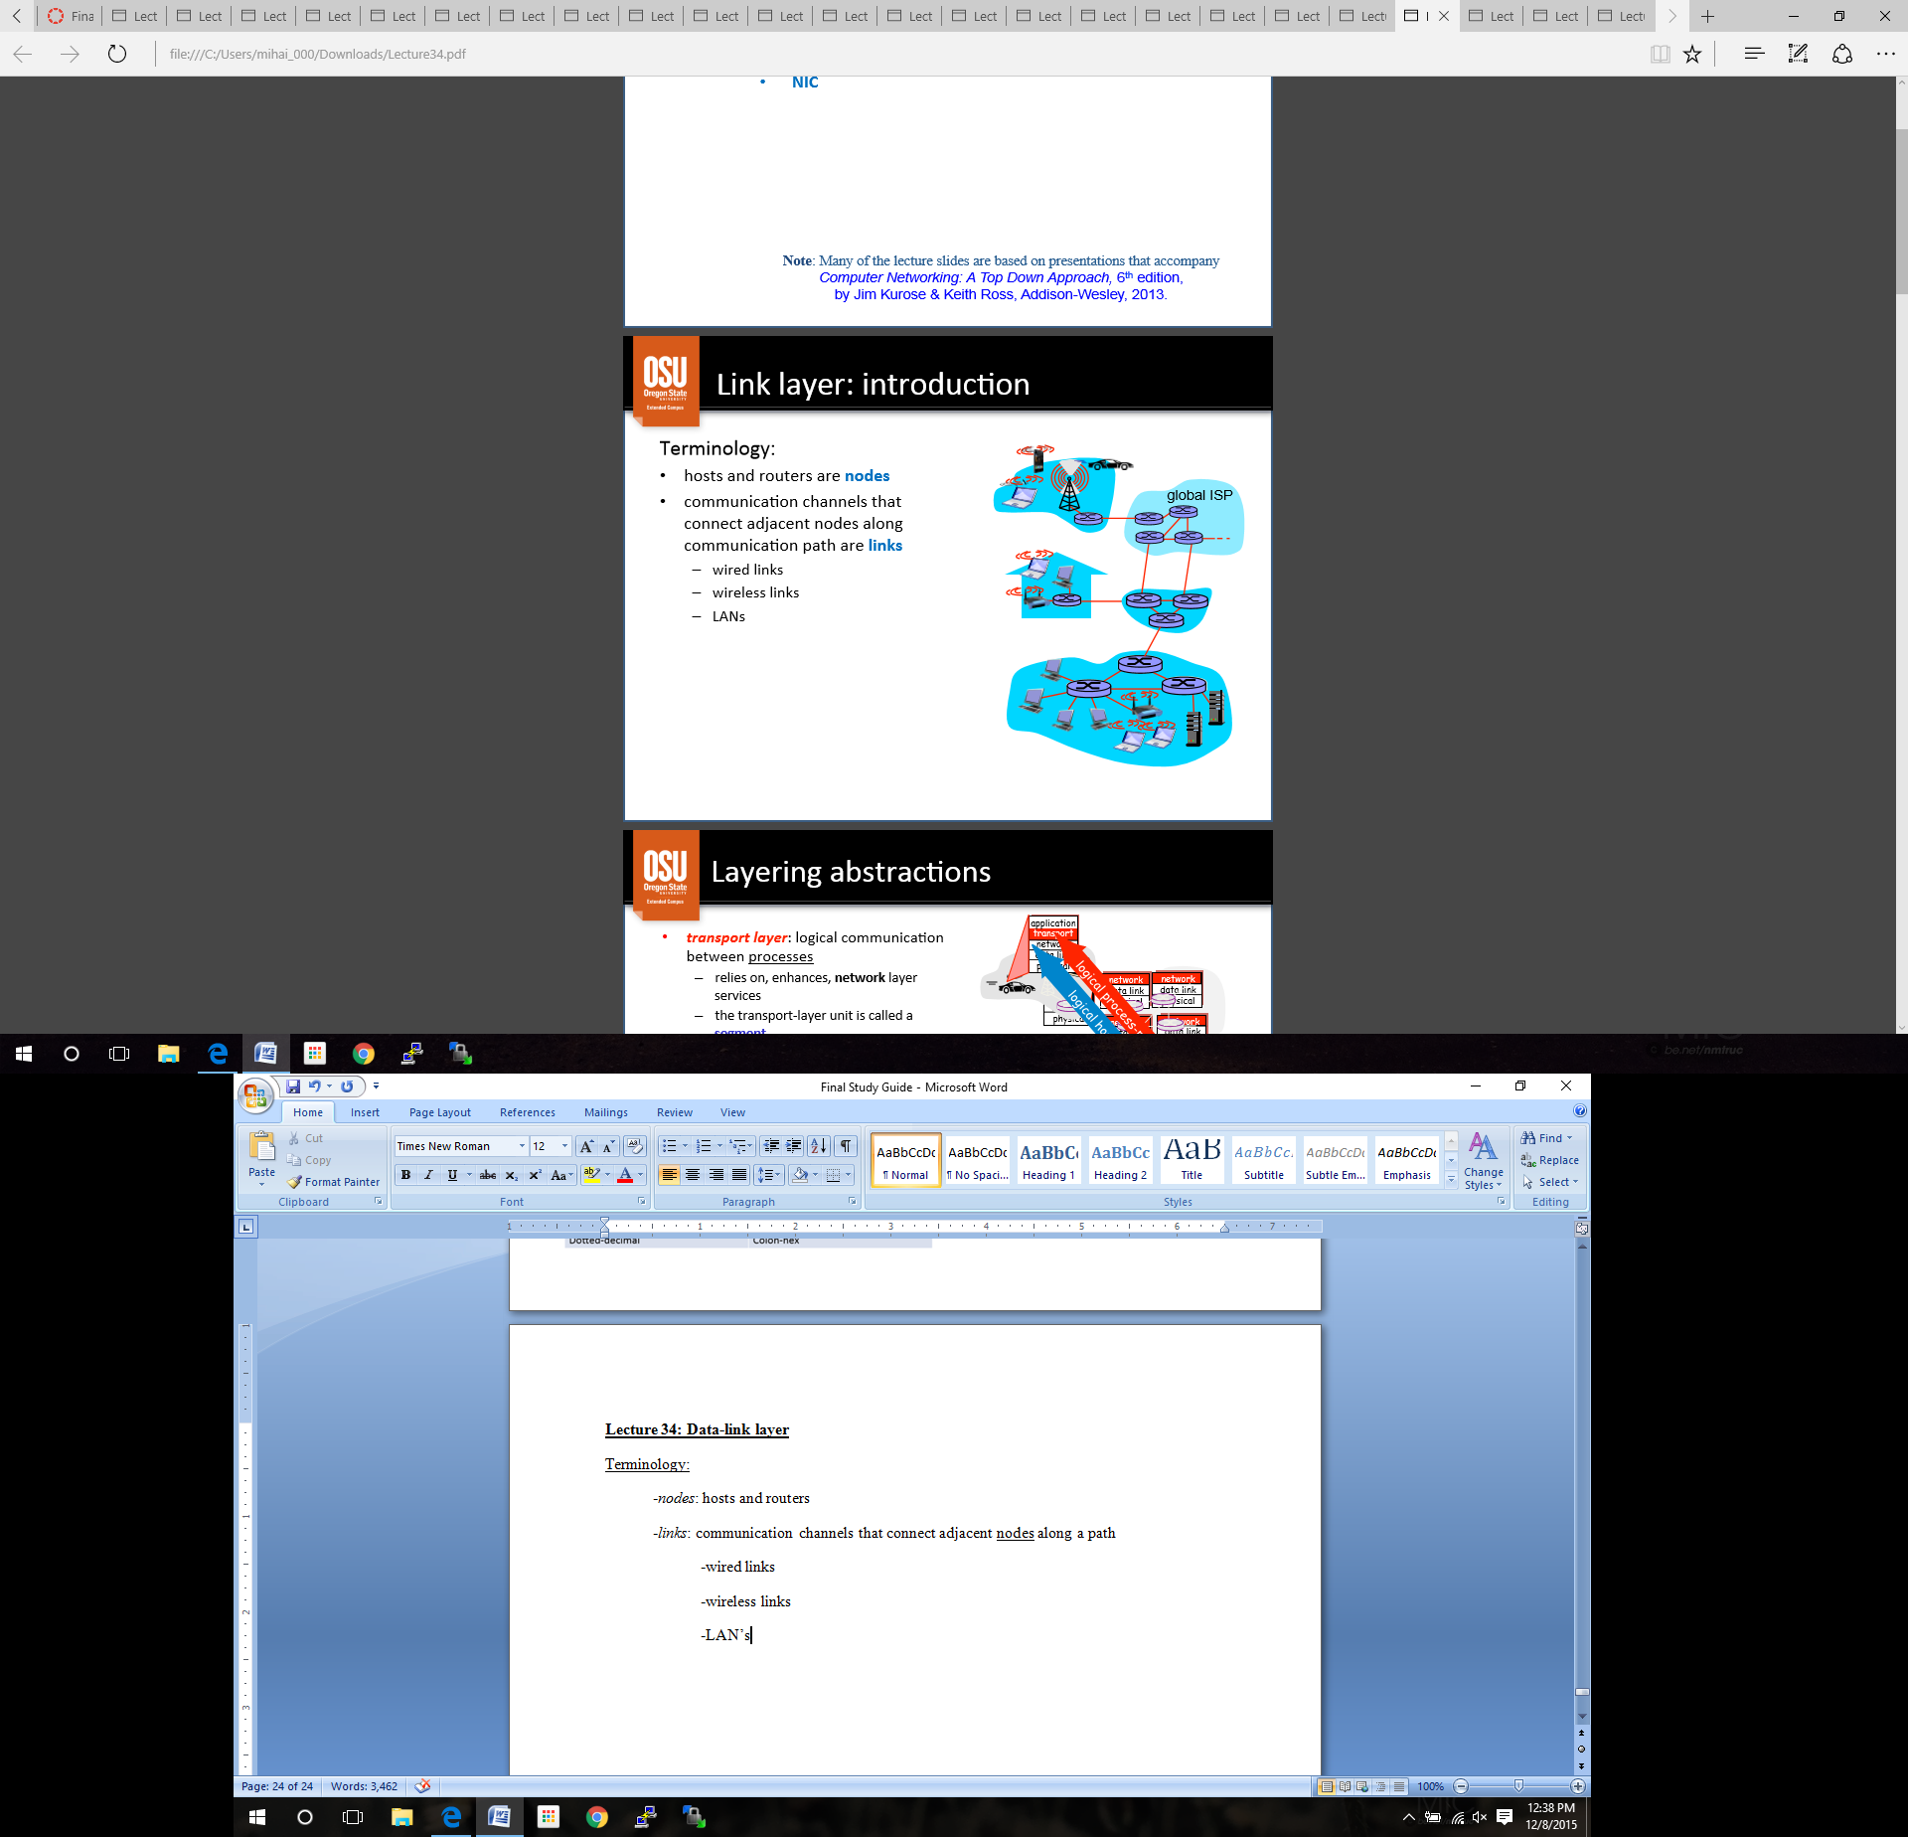**Lecture 34: Data-link layer**

Terminology:

-*nodes*: hosts and routers

-*links*: communication channels that connect adjacent nodes along a path

-wired links

-wireless links

-LAN’s

**Layer abstractions:**

*Transport Layer:* logical communications between processes

-segments

-relies on network layer

*Network Layer*: logical communications between hosts

-datagrams

-relies on link layer

*Data-link Layer:* logical communication between adjacent nodes

-frames

-relies on network layer

**Link Layer Responsibilities:**

-provide hardware addresses used in frame headers

-identify **source, destination**, different from IP address

-encapsulate datagram into frame, add header/trailer

-get access to shared medium

-control flow between adjacent sending and receiving nodes

-avoid, detect, resolve collisions

-detect/correct errors (bit level at receiver)

-errors caused by signal attenuation, **noise**

-some technologies, receiver detects the presence of errors, so it retransmit and/or drops frame

-other technologies, receiver identifies and corrects bit error without retransmission

**Link Layer Protocols:**

-frames may be different by different link-layer protocols over different links

-protocols may provide different services

-reliable deliver between adjacent nodes

-similar to transport layer (ACK, timeout, etc)

-rarely used on low bit-error links, but often used on wireless because of high error rates

**Implementation:**

-network adapter needed in all hosts

-Ethernet card, 802.11 card, etc

-implements interface to physical layer

-attaches into host’s busses

-combination of hardware, software, and firmware

-Some *network/transport layer* functions are being added to NIC

-Direct memory access sends data to memory **without** interrupting CPU

-checksum processing, etc

**Communication:**

Sender:

-encapsulates datagram in hardware frame

-adds address info, error checking bits, reliable data transfer, etc.

-sends to all hosts that are directly connected

Receivers

-check address

-accept if match (or sniffing)

-deals with errors, flow control, etc.

-if it’s OK, it accepts datagram

-reject otherwise

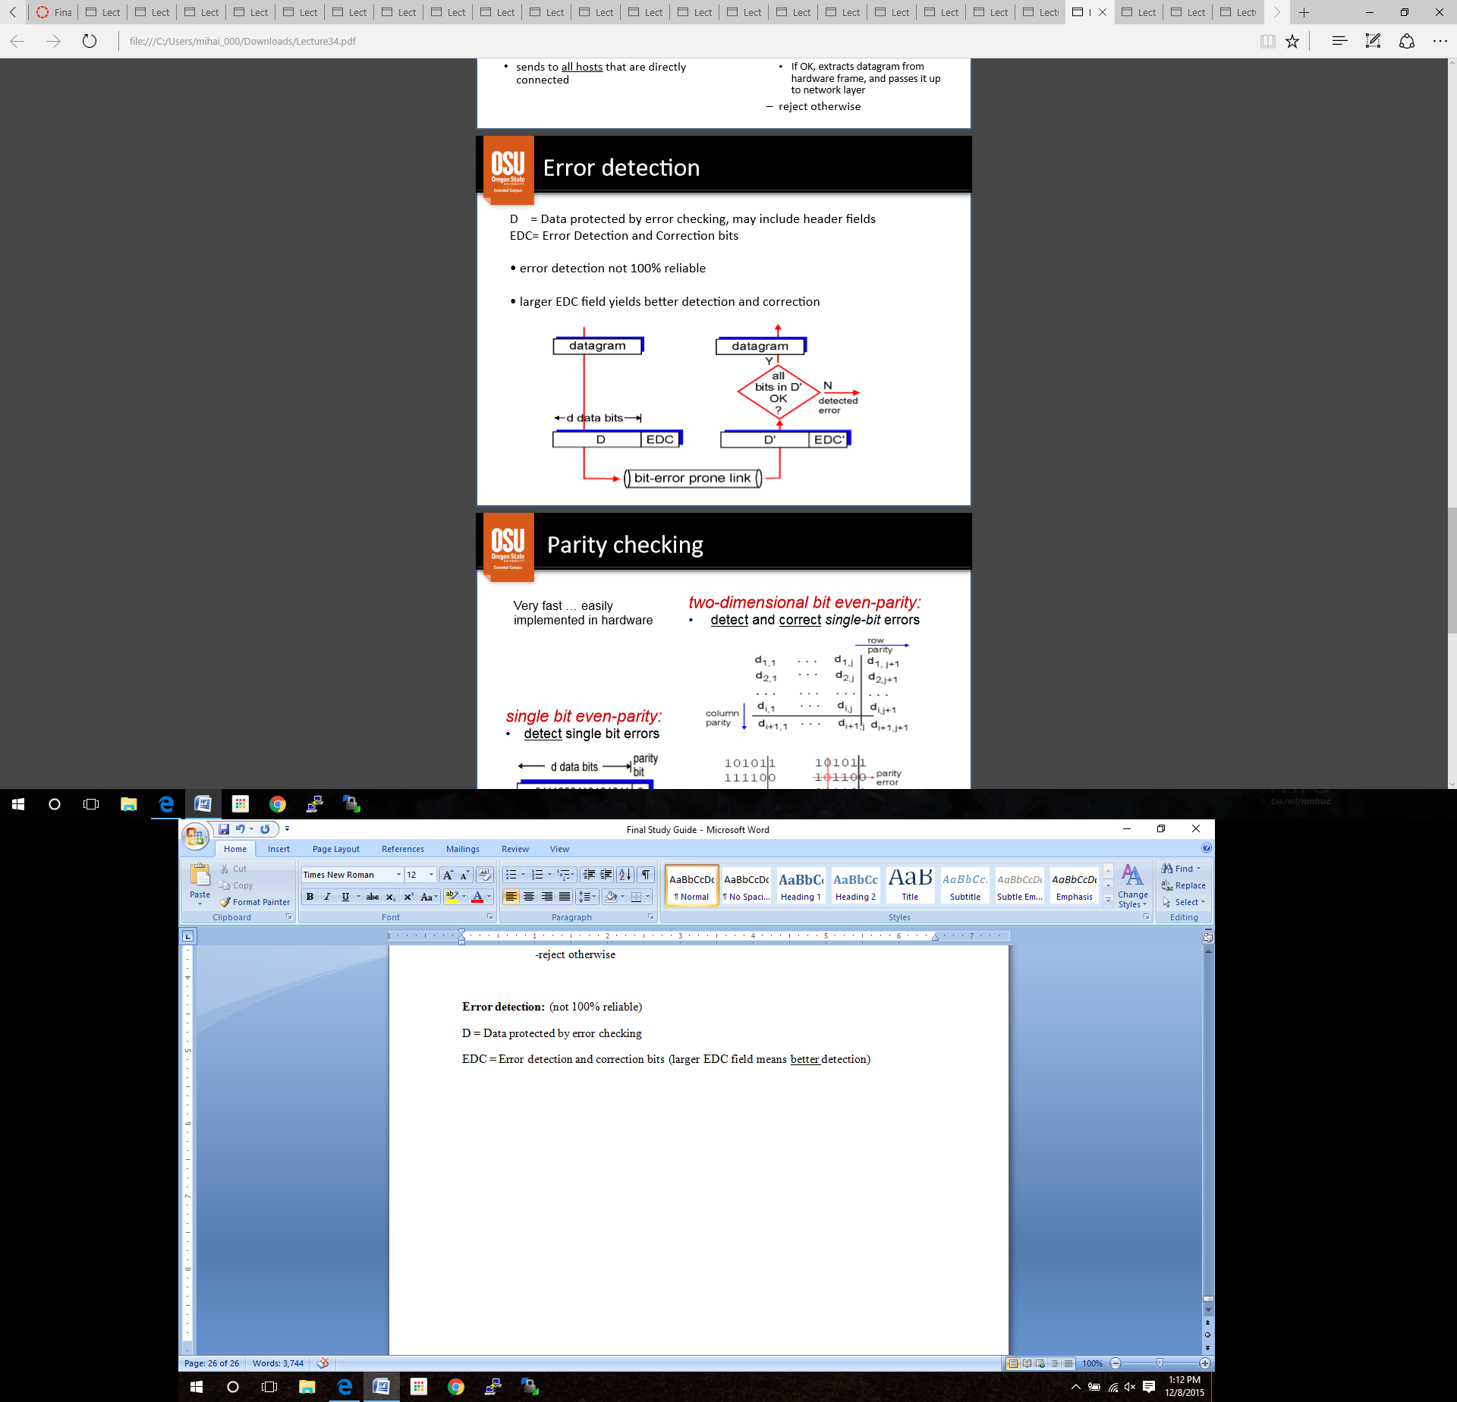

**Error detection:** (not 100% reliable)

D = Data protected by error checking

EDC = Error detection and correction bits (larger EDC field means better detection)

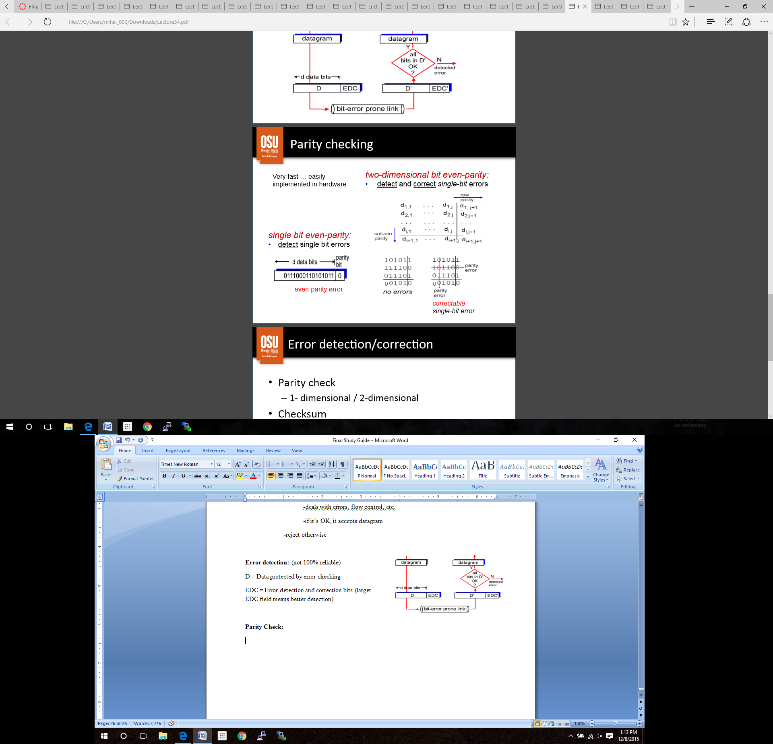**Parity Check:** ***PRACTICE***

Error detection/correction:

-parity check (1 or 2 dimensional)

-checksum

-Cyclic redundancy check (CDR)

-Hamming Codes

**Lecture 35: Multiple Access**

Two type of links to adjacent nodes

-***point to point***: link between host and Ethernet switch

-***broadcast*** (shared medium): Multiple Access protocol required

**Multiple Access Protocols**

For broadcast links, you need Multiple Access protocol.

-distributed algorithm that determines how nodes hare a channel

-*single* broadcast channel

-*protocol* determines when node can transmit

-protocol communication about channel sharing must use channel itself

-cannot go out of bounds

-**two or more** simultaneous transmissions by nodes cause *interference*

-***collision*:** if node receives two or more signals at the same time

**Ideal** multiple access protocol criteria, for broadcast channel of rate *R* bps:

1. when only one node is transmitting, it can transmit at rate *R*

2. when *M* nodes are transmitting, each can transmit at *R/M* bps

3. fully decentralized, meaning there is no special node to determine transmission

**Three classes**, neither of which are ideal…

-*Channel Partitioning*

-divide channel into smaller pieces, such as TDM and FDM

-allocate piece of channel to node for exclusive use

-easy to implement, but does not satisfy criteria #1

-*Random access*

-allow collisions

-recover from collisions

-does not satisfy criteria #2

-*Taking turns*

-nodes with more to send can take longer turns

-supervision required, therefore not satisfying criteria #3

**Random Access Protocols**

When node has a packet to send…

-transmit at full channel data rate *R*

-no supervised coordination among nodes

Two or more nodes transmitting simultaneously causes ***collision***

*Random access MA protocol* specifies (ex **CSMA**)

-how to **detect** collisions

-how to **recover** from collisions

**CSMA (Carrier Sense Multiple Access)**

-listen before transmit

-if channel sensed idle: transmit entire frame

-if channel sensed busy: defer transmission

-***Collisions*** can still occur…

-propagation delay means that two nodes did not sense each other’s transmission

-entire packet transmission is wasted

**CSMA with Collision Detection** (used in wired LAN’s)

-carrier sensing, deferral as in CSMA

-collisions detected within short time

-colliding transmissions aborted, reducing channel waste

-*Collision detection*

-easy in wired LANs: measure signal strength, compare transmit/receive signals

-hard in wireless LANs: received signal strength overwhelmed by local transmission strength

**CSMA with Collision Avoidance** (used in wireless LAN’s)

-carrier sensing, deferral as in CSMA

-Wired (CD), Wireless (CA)

-transmitting computer ends short “reservation” message, destination responds with short reserving message

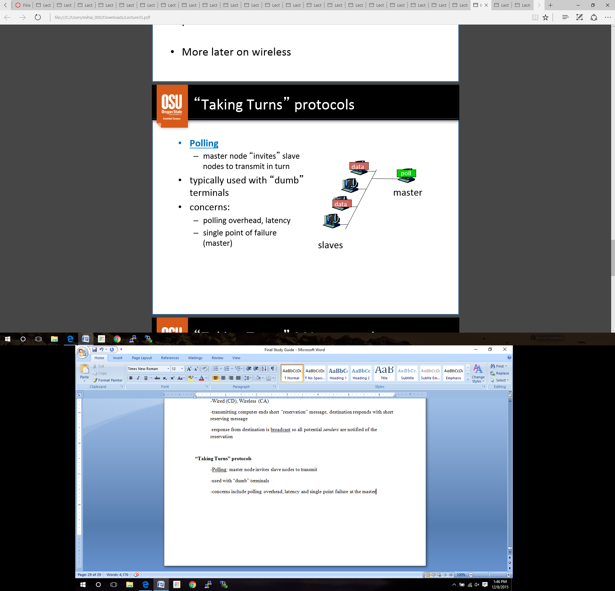-response from destination is broadcast so all potential *senders* are notified of the reservation

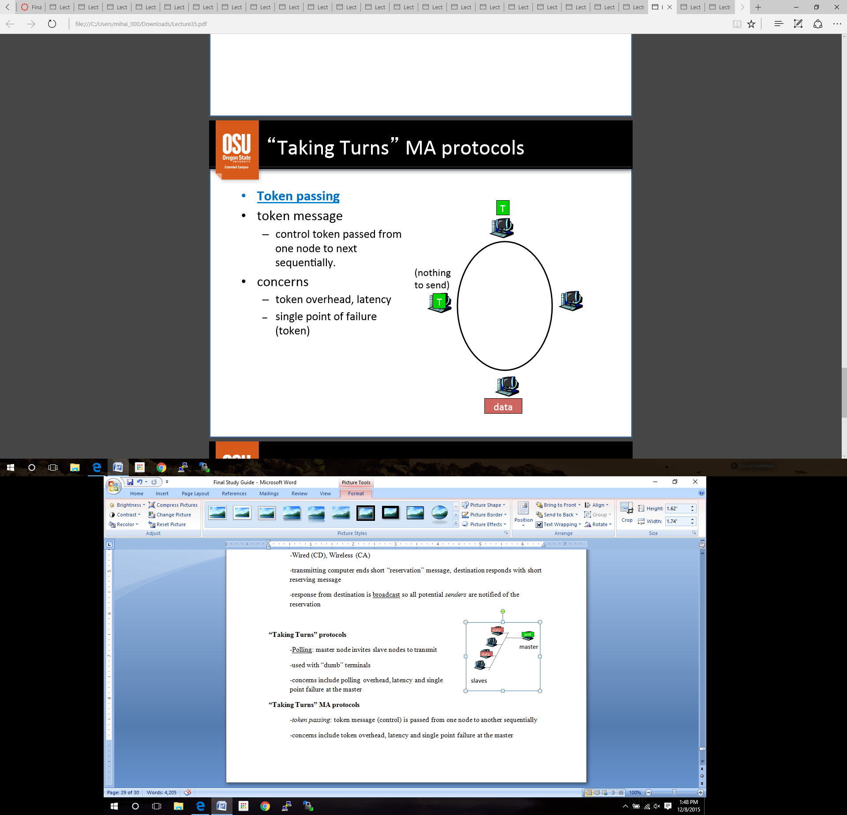

**“Taking Turns” protocols**

-Polling: master node invites slave nodes to transmit

-used with “dumb” terminals

-concerns include polling overhead, latency and single point failure at the master

**“Taking Turns” MA protocols**

-*token passing*: token message (control) is passed from one node to another sequentially

-concerns include token overhead, latency and single point failure at the master

**Lecture 36: MAC Addresses:**

*IP address* is a virtual address.

-network layer address

-gets datagram to destination IP subset

*MAC (Media Access Control)* address is a physical address

-function: get frame from one place to the other thorough the physical network

-**every communication** at the physical layer is sent to a MAC address

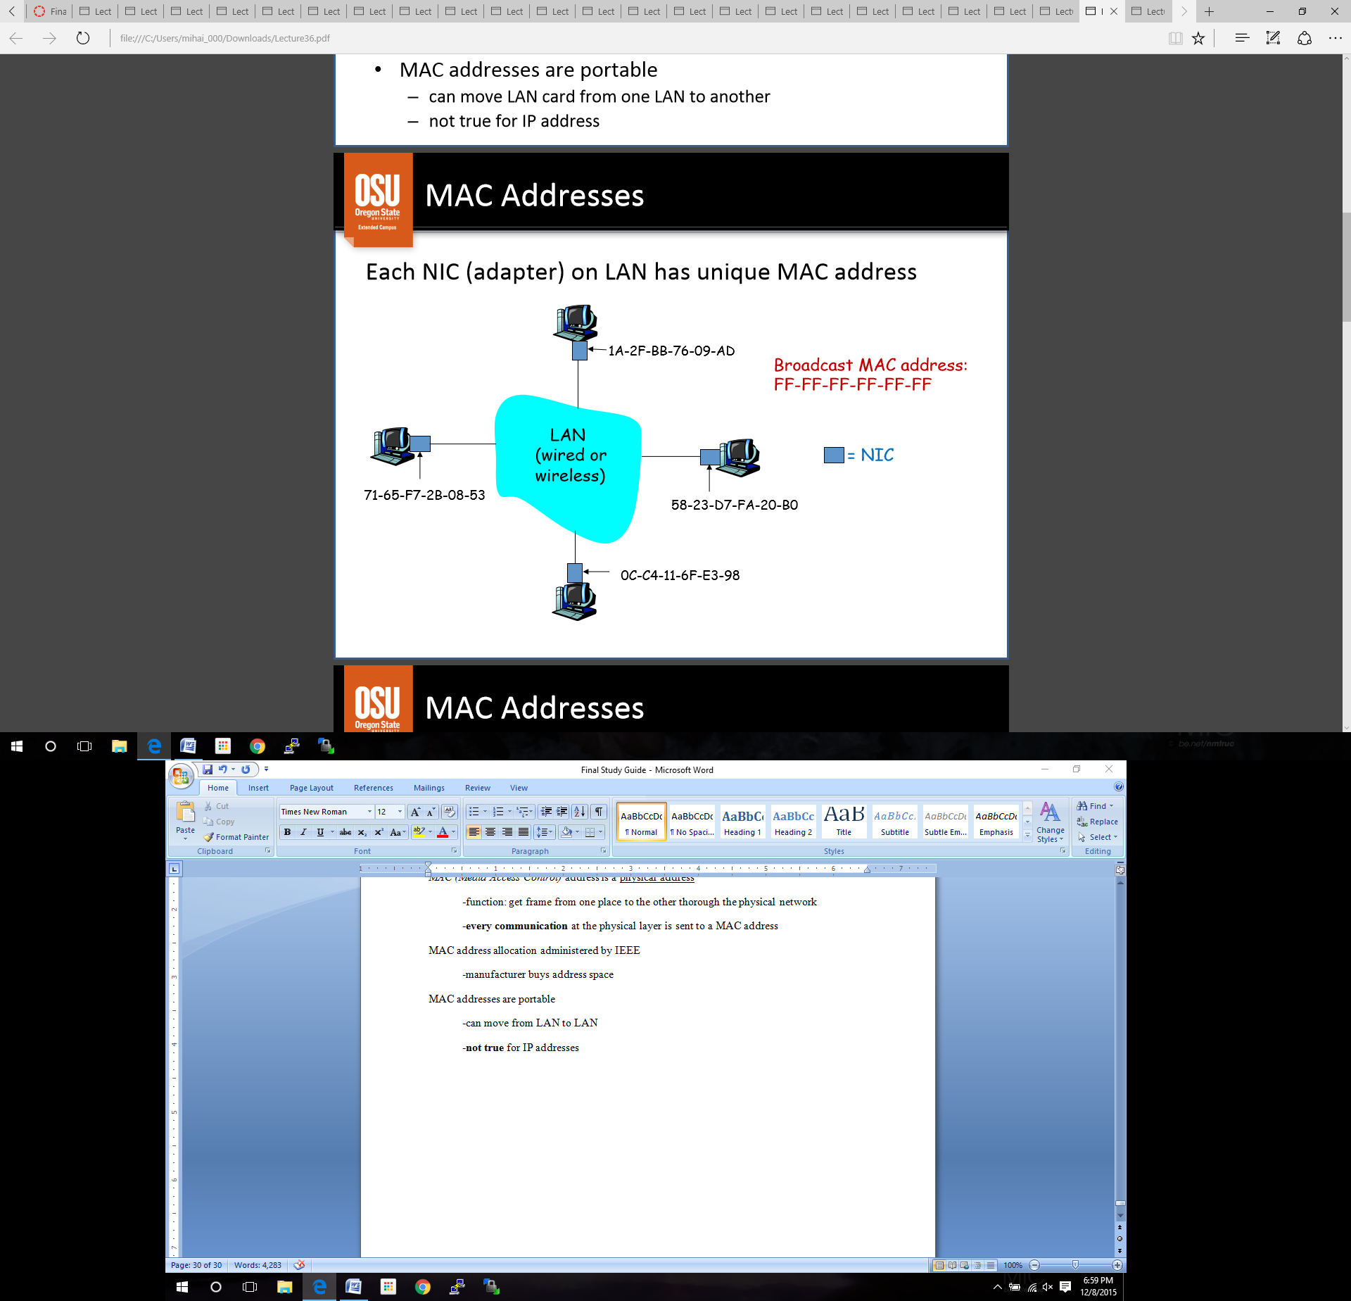MAC address allocation administered by IEEE

-manufacturer buys address space

MAC addresses are portable

-can move from LAN to LAN

-**not true** for IP addresses

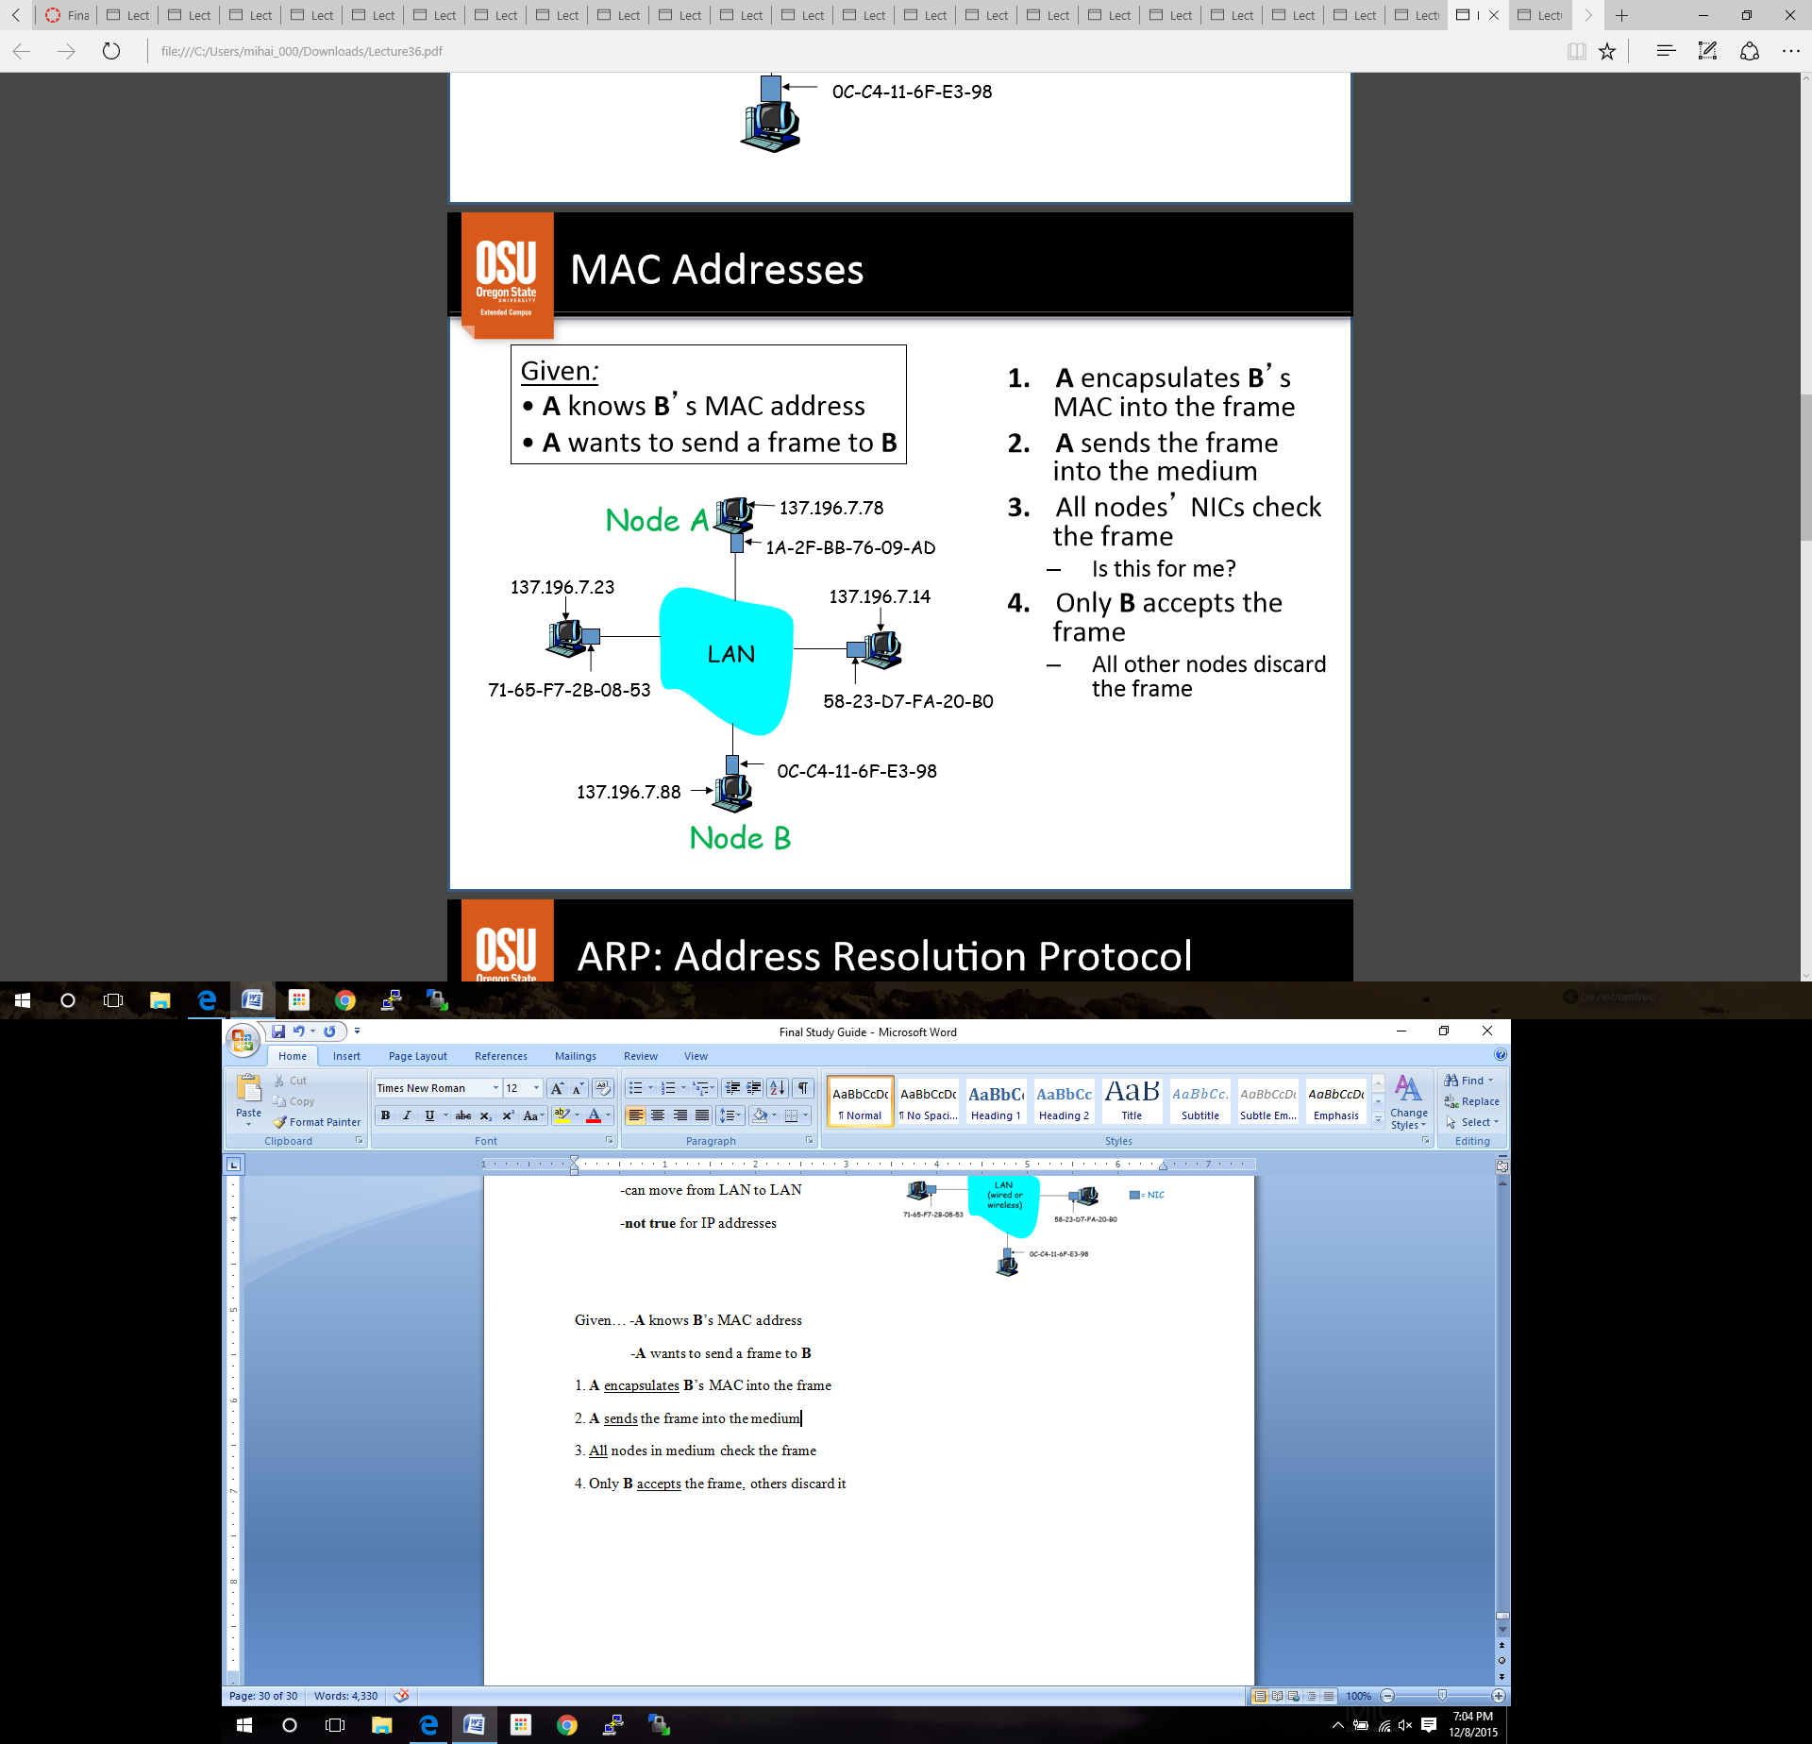

Given… -**A** knows **B**’s MAC address

-**A** wants to send a frame to **B**

1. **A** encapsulates **B**’s MAC into the frame

2. **A** sends the frame into the medium

3. All nodes in medium check the frame

4. Only **B** accepts the frame, others discard it

For **APR (A**ddress **R**esolution **P**rotocol):

1. **A** looks up **B**’s MAC address in its APR table

2-4. *same as above*

APR Case 1:

1. **A** broadcasts APR query packet, containing **B**’s IP address

**-**on broadcast address FF­FF-FF-FF‐FF‐FF

2. **B** receives APR packet and responds with its MAC address back to **A**

3. **A** sends frame to **B** since it now knows its MAC address

-**A** ***caches*** IP to MAC address pair into its APR table

-Plug and play from this point on.

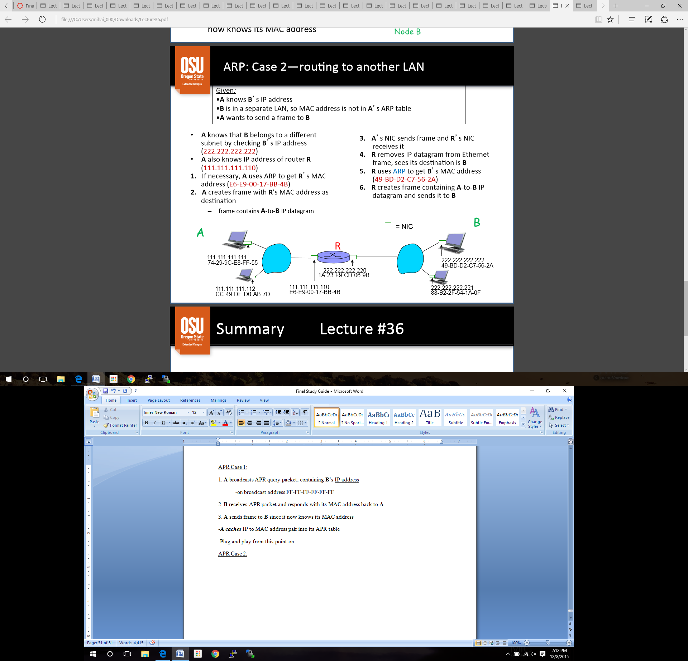APR Case 2:

**Lecture 37: LAN topologies**

Networks can be classified by ***shared medium*** or by ***topology*** (shape).

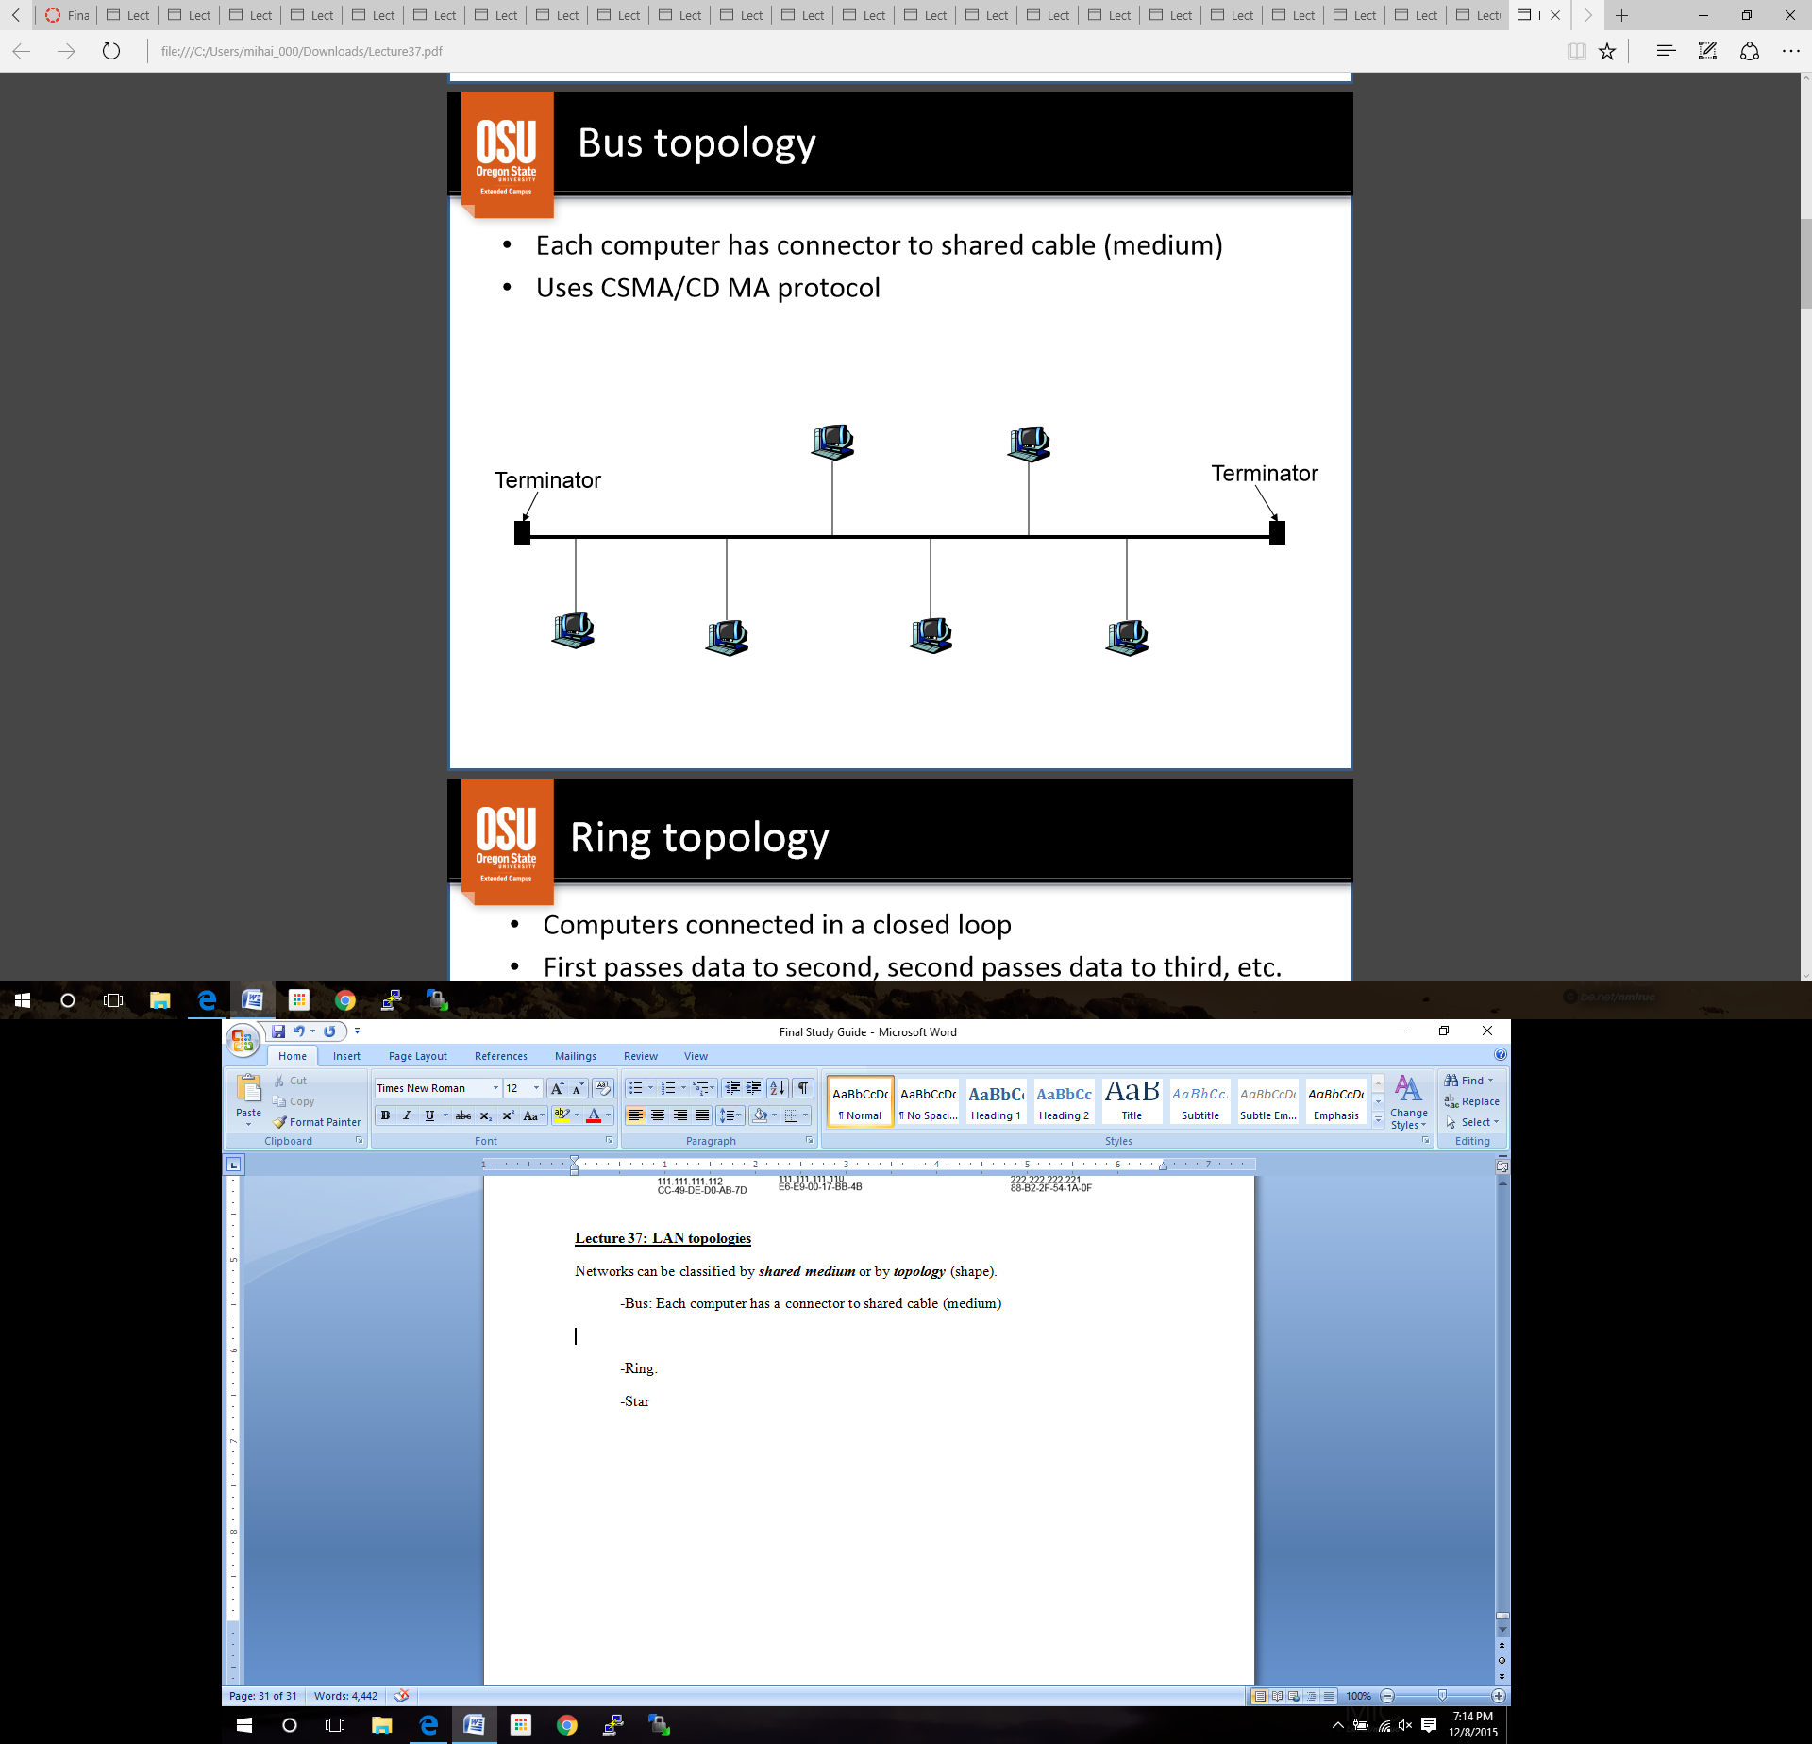 -Bus: Each computer has a connector to shared cable (medium)

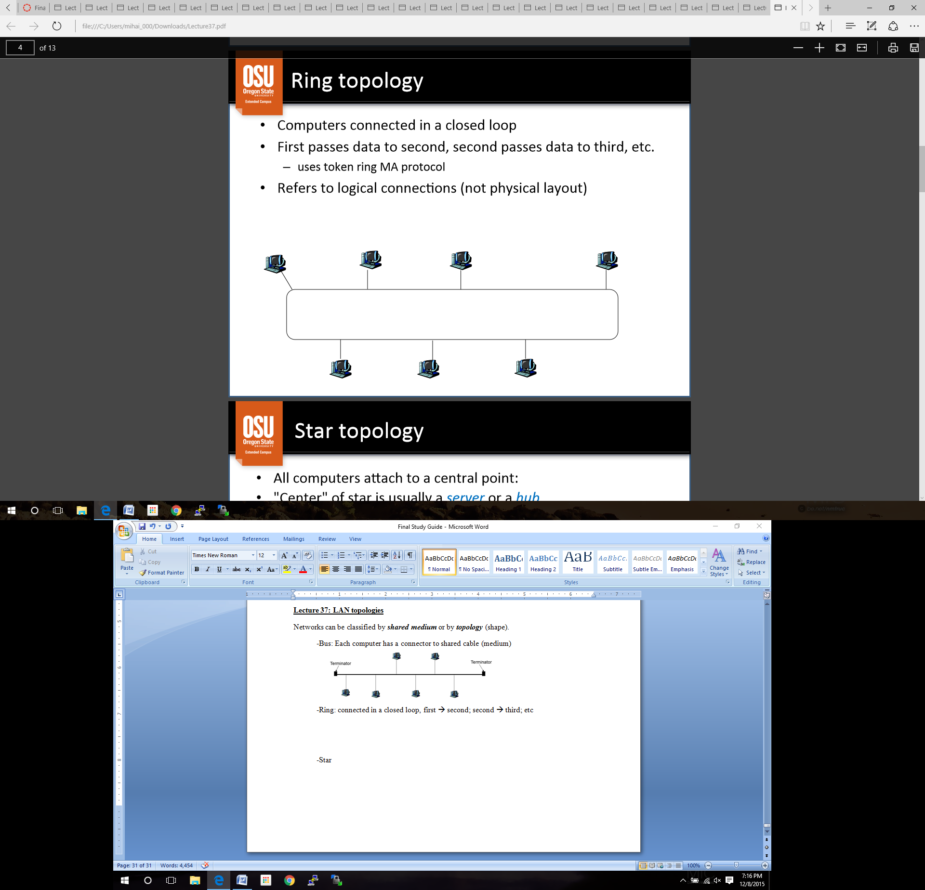-Ring: connected in a closed loop, first 🡪 second; second 🡪 third; etc

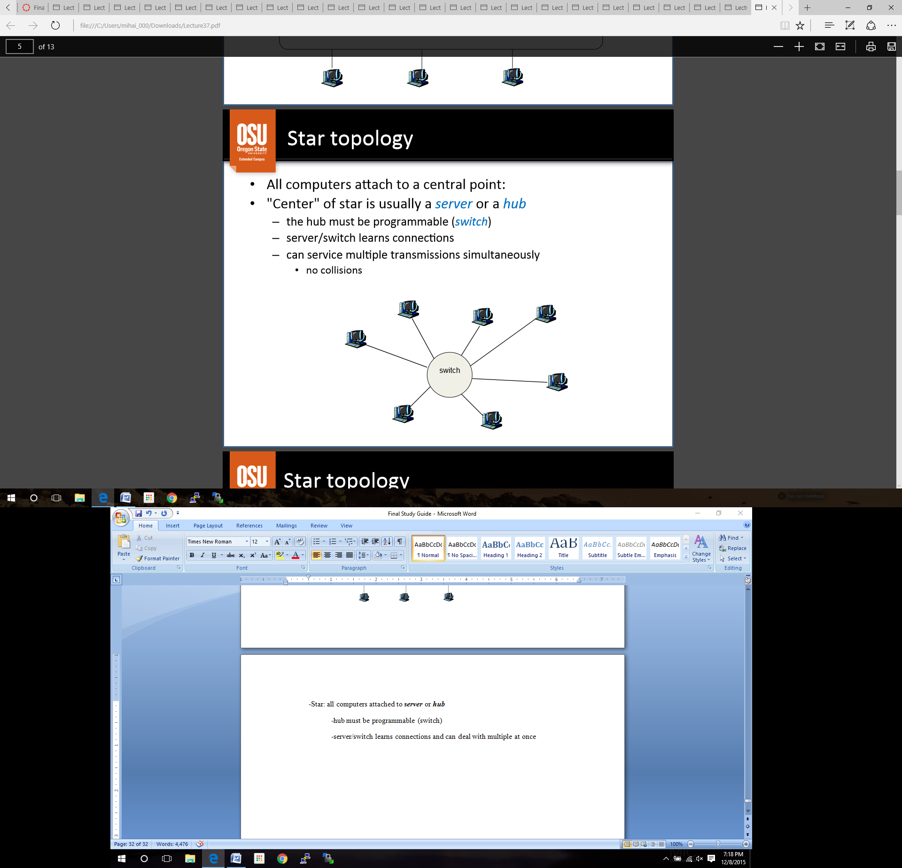-Star: all computers attached to ***server*** or ***hub***

-hub must be programmable (switch)

-server/switch learns connections and can deal with multiple at once

-“***Topology***” refers to logical connections, **not** physical layout

**Switch: *multiple* simultaneous transmissions**

-hosts have dedicated connection to switch, which buffers packets

-each link is its own collision domain

-A to A’ can send at the same time as B to B’ with no collisions

**Example** bus topology: Ethernet (original)

-wildly used LAN technology

-standards managed by IEEE

-uses CSMA/CD protocol

-uses single coax cable

-one Ethernet cable, called a segment

-no longer than 500 meters, but no less than 3 meters

-CSMA/CD still requires a short ***network diameter***\*

*max distance between any two nodes

-Bus topology was popular thorough the 90’s, now it’s all about star

Many different Ethernet standards

-common MA protocol (CSMA/CD) and frame format

-different speeds (10 Mbps, 100 Mbps, etc)

-different physical layer media (cable, wireless, etc)

Ethernet: link layer common standards:

-*connectionless*: no handshake between sending and receiving NIC’s

-*unreliable*: receiving NIC’s does not send ACK

-unless sender is using something reliable (**TCP**), data is lost

-sending NIC encapsulates IP datagram in frame

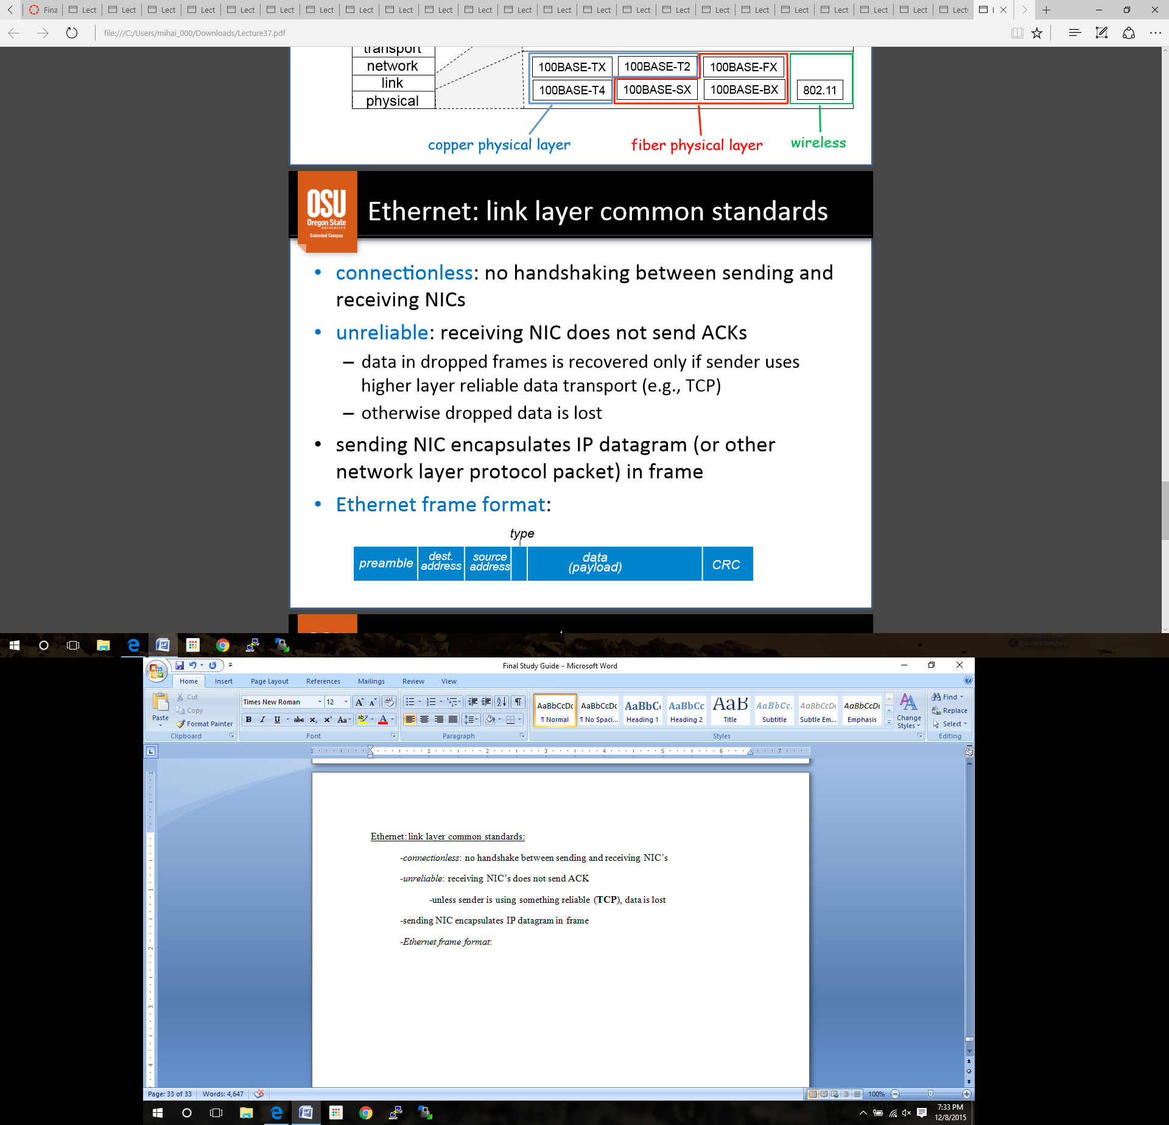-*Ethernet frame format*

-**preamble:** 8 bytes, used to synchronize receiver/sender clock rates

-**addresses:** 6 byte destination/source MAC addresses

-**type:** indicates network layer protocol (mostly IP)

-**payload:** complete network layer datagram

-**CRC:** cyclic redundancy check at receiver (error detected 🡪 frame is dropped)

**Lecture 38: Ethernet frame and delimiters**

-***Frame*** (hardware frame) denotes a packet with a specific format on a specific hardware technology.

-Each hardware technology defines standard ***delimiters*** (start and end)

-Can be used to detect transmission problems such as…

-missing *end* indicates that the sending computer crashed

-missing *start* indicates receiving computer missed the beginning

-any bad frame is thrown out

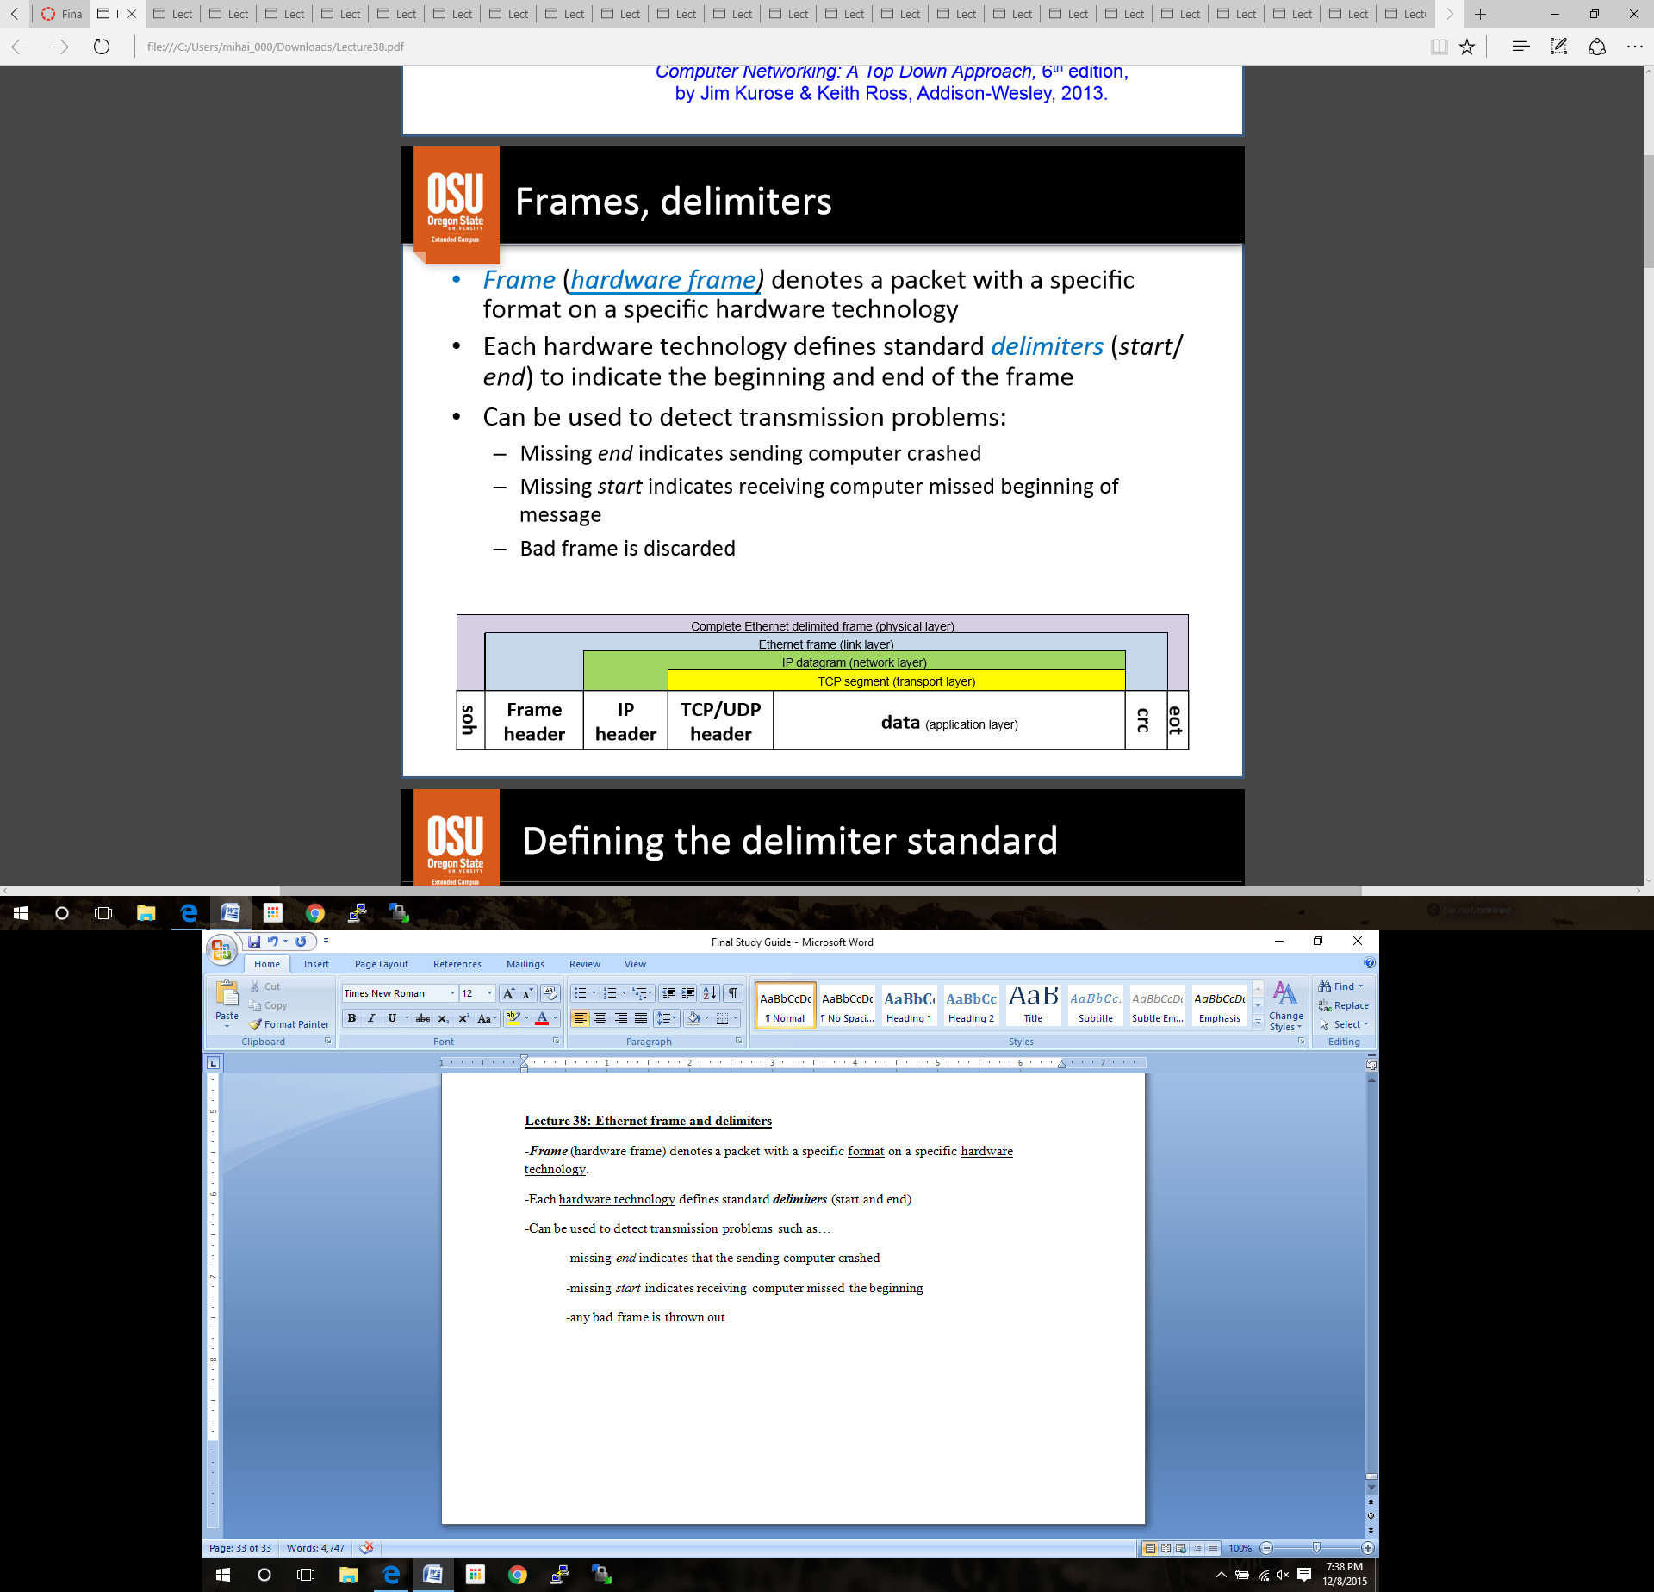

**Defining the delimiter standard**

-can choose any unused data values for delimiters

-if data is limited to ASCII, you can use non printable characters (control codes)

ex. “soh” (start of header) and “eot” (end of text)

-*Source computer*: encapsulates a hardware frame between delimiters

-*Destination computer*:

-interprets then discards **soh**

-manages hardware frame

-interprets then discards **eot**

*Arbitrary Data*

-if soh and eot are used inside the data, they will be *misinterpreted* as delimiters

-sender and receiver must agree on encoding special characters for ambiguous transmission 🡪 Byte Stuffing

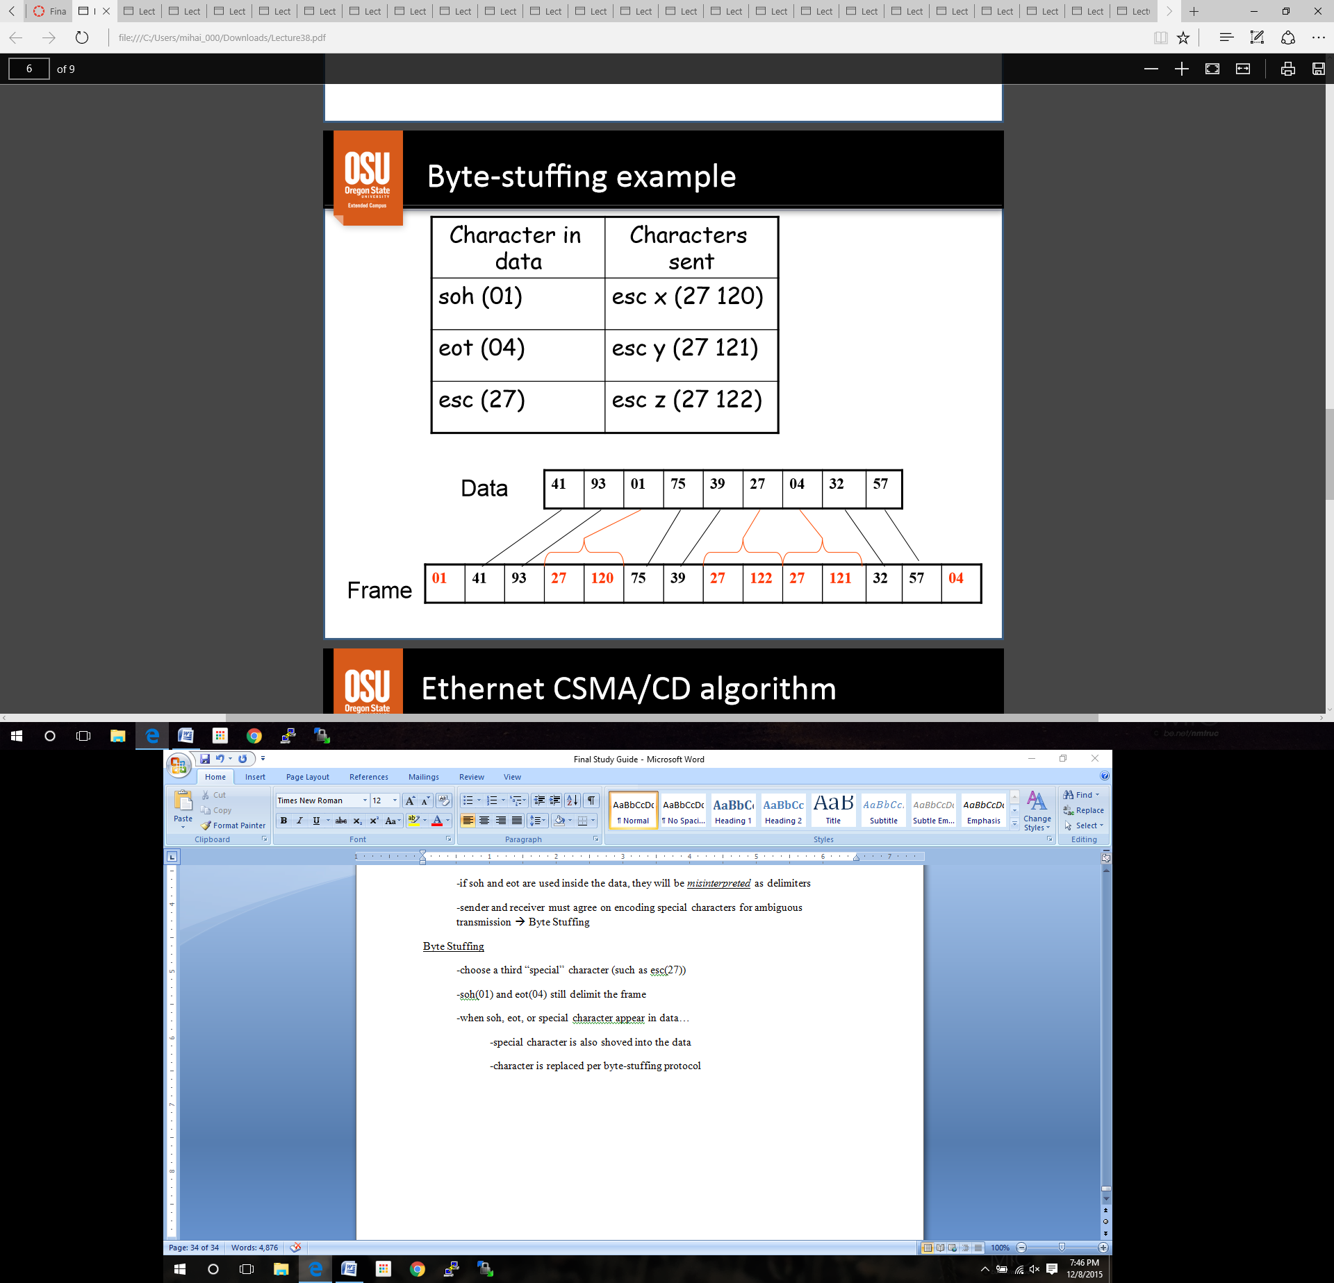Byte Stuffing ***PRACTICE*** Example:

-choose a third “special” character (such as esc(27))

-soh(01) and eot(04) still delimit the frame

-when soh, eot, or special character appear in data…

-special character is also shoved into the data

-character is replaced per byte-stuffing protocol

**Ethernet CSMA/CD algorithm**

1. NIC receives datagram from network layer, makes frame

2. -If NIC sense channel *idle*, starts frame transmission

-If NIC sense channel *busy*, waits until channel is *idle*, then transmits

3. -If NIC transmits entire frame with **no error**, NIC is done with frame

-If NIC detects another transmission while transmitting

-***collision***: aborts and sends jam signal

-after aborting, NIC enters **exponential backoff**

Exponential backoff ***PRACTICE***

-adaptive retransmission attempts to estimate current load

*heavy load*: random wait will be longer

-after *m*th collision, NIC chooses K at random from {0, 1, 2,…, 2m‐1}

Choosing random K:

-first collision: choose K from {0, 1}; *delay* is K * 512 bit times

-after second collision: choose K from {0, 1, 2, 3,…, 1023}, etc

-bit time: time to transmit one bit

**Lecture 39: Wireless**

**Wireless and Mobile Networks**

-*wireless*: communication over a wireless link

-*mobility*: changing points of entry to network

Elements of a wireless network

***Access point (AP,*** *also called* ***base-station)***

-typically connected to a wired network

-*relay*: responsible for sending packets between wired networks and wireless hosts in its area (such as a cell tower)

***Wireless link***

-typically connect hosts to access point

-may also be AP-AP link

-link access coordinated by MA protocol

-various data rates, transmission distance, etc.

***Wireless hosts***

-laptop, PDA, IP phone

-run applications

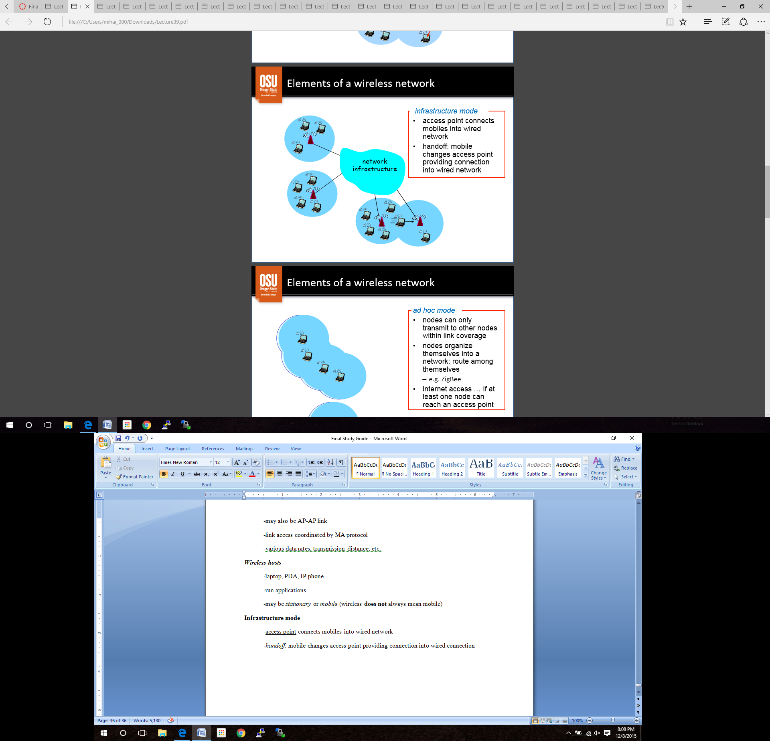 -may be *stationary* or *mobile* (wireless **does not** always mean mobile)

**Infrastructure mode**

-access point connects mobiles into wired network

-*handoff*: mobile changes access point providing connection into wired connection

**Ad hoc mode**

-nodes can only transmit to other nodes within link coverage

-nodes organize themselves into a network and route amongst themselves

-Inter access is there if at least one node can reach an access point

**Wireless: differences from wired link**

-*undirected medial* (difficult to tell what the destination is)

-*decreased signal strength* (path loss because of physical media)

-*interference from other sources* (other devices, electromagnetic interference)

-*multipath propagation* (radio signal bounces off objects, arriving at different times)

-*Much more difficult than wired!!!*

**IEEE 802.11: multiple access protocol**

-CSMA: *sense before transmitting* (if medium is busy, do not transmit)

-**no** collision detection

-difficult to sense

-can’t sense all collisions anyway (hidden terminal, etc)

-collisions causes garbled message and is dropped due to error

-*goal*: ***avoid collisions***

-CSMA/CA protocol

**Avoiding Collisions: Wireless CSMA/CA**

1. Allow sender to reserve a channel

a. sender sends *request-to-send (RTS)*

b. access point broadcasts *clear-to-send (CTS)* reservation response

c. all nodes are notified that original sender is CTS

2. Sender sends entire data frame

3. Access point *broadcasts* ***channel-open***

-theoretically, other stations defer transmission; longer data packets should **not** collide

-actually, RTS’s may collide; new node might join after CTS

**Traffic control: Wireless CSMA/CA**

-Any station may receive simultaneous requests

-causes collision at receiver

-**both** requests are lost

-neither sender gets a reservation

-both senders use Ethernet style ***random backoff and retry***

-Any station may receive closely spaced requests

-receiver selects one (priority, etc)

-receiver broadcasts CTS specifying selected sender

-sender that is **not** selected uses ***random backoff and retry***

**ZigBee**

-wireless (ad hoc) mesh networking standard

-based on the IEEE 802.15.4 standard for wireless personal area networks

-low cost allows this to be used in *wireless control* and *monitoring applications*

-low power usage means *batteries* last longer

-***One Laptop Per Child*** (OLPC) project

-ZigBee in sparse ad-hoc environment

**Lecture 40: Mobility**

What is *mobility*?

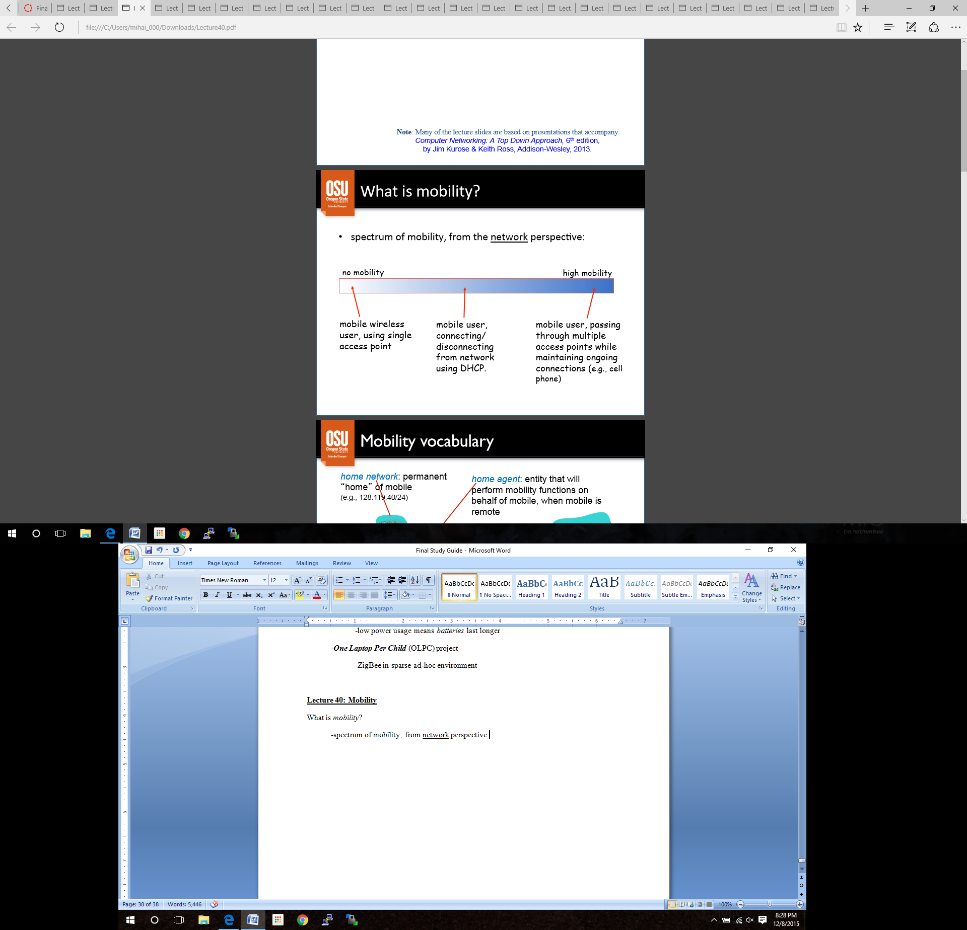 -spectrum of mobility, from network perspective:

Vocabulary

-***Home network***: permanent “home” of the mobile

-***Home agent***: entity that wil perform finctions on behalf of the mobile, when mobile is remote

*-****Permanent address***: address in home netork, can always used to reach mobile

…when in an visited network…

-***Permanent address:*** remains the same

-***Visited network***: network in which the mobile currently resides

-***Care-of address***: address in visited network

-***Foreign agent***: entity in visited network that performs mobility functions for mobile

-***Correspondent***: wants to communicate with the mobile

**Two approaches to *mobility***

1. Let routing handle it

-routers advertise *permanent address*

-routing tables indicate where each mobile is located

-no changes on end system

2. Let end-systems handle it

-*indirect routing*: communication from correspondent to mobile goes through home agent

-*permanent address* is used by correspondent (**doesn’t** know where mobile is)

-*care of address* is used by home agent to forward datagrams

-***triangle routing***: correspondent🡪home🡪network🡪mobile

-inefficient when correspondent and mobile are in same network

-if mobile user moves to another network…

-user’s **mobile** registers with the **new foreign agent**

-**new foreign agent** registers with **user’s home agent**

-**user’s home agent** updates **care-of address** for mobile

-**correpondent**’s packets continue to be forwarded to mobile with **new care-of address**

-*direct routing*: correspondent gets foreign address of mobile, and sends directly to it

-*permanent address*: used by correspondent to get care-of address (**knows** where mobile is)

-*care-of address*: used by correspondent directly

-overcomes ***trinagle routing*** problem

-if mobile user moves to another network…

-**new foreign agent** gets **user’s home agent** from **former foregin agent**

-**new foreign agent** assigns **new care-of address** for mobile

-**new foreign agent** notifies **correspondent** and **user’s home agent** of **new care-of address** of mobile

-**user’s home agent** updates **care-of address** for mobile

-**correspondent** continues direct communication with mobile with the **new care-of address**

**Wireless/mobility impact on higher layer protocols:**

-Logically, impact should be small

-*best effor* service model is unchanged

-TCP and UDP currently run on wirelss/mobile

-…but performance says otherwise.

-packet **loss/delay** due to bit-errors and handoff

-TCP interprets loss as congestion

-longer delay from RTS/CTS collisions and care-of addressing/forwarding

-limited bandwith of wireless links

**Lecture 41: Security**

Cyber Crime

-internet enables new types of crimes

-explosive growth of the problem

-most laws have been to **react** to the problem, not **prevent** it

-cost of protection and security breaches are high

Wireless/mobility makes crimes easier to *commit*, and harder to *trace*.

Security Policies:

-“secure” is not a guarantee

-need to define *security policy* for an organization

-costs and benefits need to be looked over before a decision of what *security* to use

-**must** consider stored information and transmitted information

-users of the security **must** be educated

Maintaining security:

-***Data integrity***: data should be transitted unchanged, stored data should be safe

-***Data availability***: authorized users should have access, which should **not** be interrupted

-***Data confidentiality***: only authorized users should have access (no snooping, wiretapping, etc)

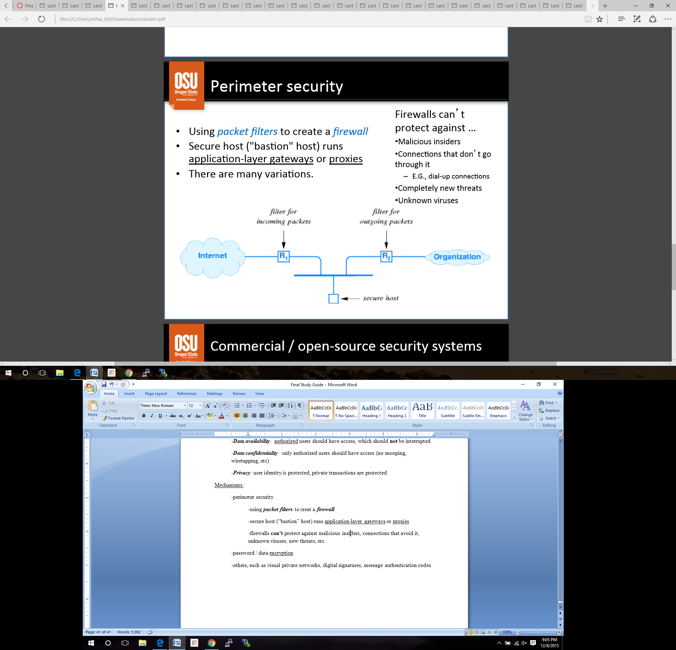-***Privacy***: user identity is protected, private transactions are protected

Mechanisms:

-perimeter security

-using ***packet filters*** to creat a ***firewall***

-secure host (“bastion” host) runs application-layer gateways or proxies

-firewalls **can’t** protect against malicious insiders, connections that avoid it, unknown viruses, new threats, etc.

-password / data encryption

-others, such as visual private networks, digital signatures, message authentication codes

Comon / open-source security systems

-**IDS:** Intrusion Detection System

-**Kerebos** from MIT

-**SSH** and **OpenSSH:** Secure Shell

-**SSL** and **OpenSSL:** Secure Socket Layer

**Lecture 42: Security / encryption**

Password / data encryption

-messages are encoded by the sending protocol

-encoded messages are *decoded* at the receiving protocol

-there are many encryption algorithms (functions)

-simple substitution to very complex calculations

-most used *mod* with large prime numbers

-***private key*** encryption ***PRACTICE***

M = message K = key E = encrypted message

**Sender** E = *encrypt*(K, M)

**Receiver** M = *decrypt*(K, E)

-***public key*** enctyption ***PRACTICE***

-each user has **two** keys (public and private) and the decrypt/encrypt algorithms

M = message K = key E = encrypted message

**Sender** E = *encrypt*(K*public*, M) [destination user’s *public* key]

**Receiver** M = *decrypt*(K*private*, E)[destination user’s *private* key]

-easy to *change* key and *ensure confidentiality* of key

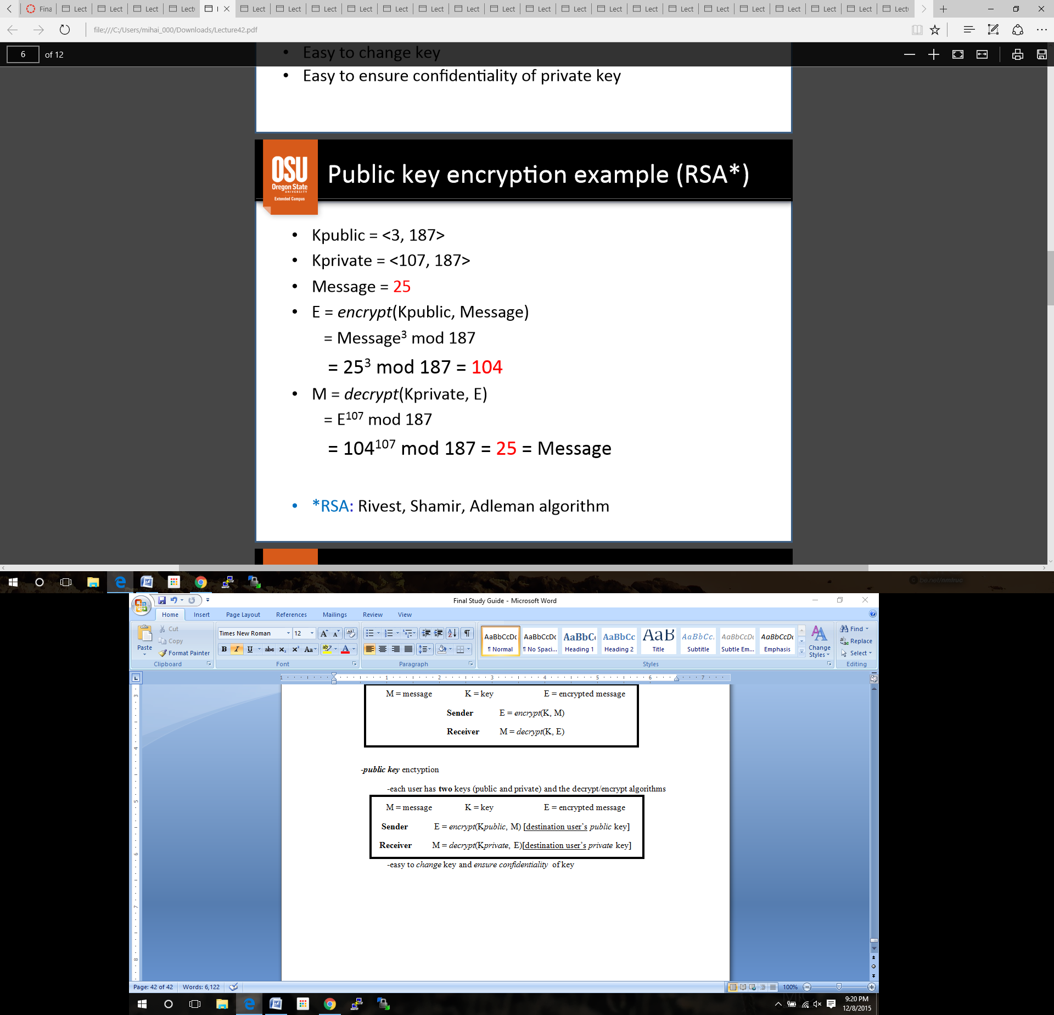

**Public Key Encryption Example 🡪**

RSA (Rivest, Shamir, Adleman algorithm): Chooking keys

1. Choose two large prime numbers *p* and *q*.

2. Compute **n** = *pq*, **z** = (*p*-1)(*q*-1)

3. Choose **e** (**e** < **n**) such that **e** has no common factors with **z**

4. Choose **d** such that **ed**-1 is divisible by **z** (**ed** *mod* **z** = 1)

5. *Public* key is (**e, n**) and the *private* key is (**d,n**)

*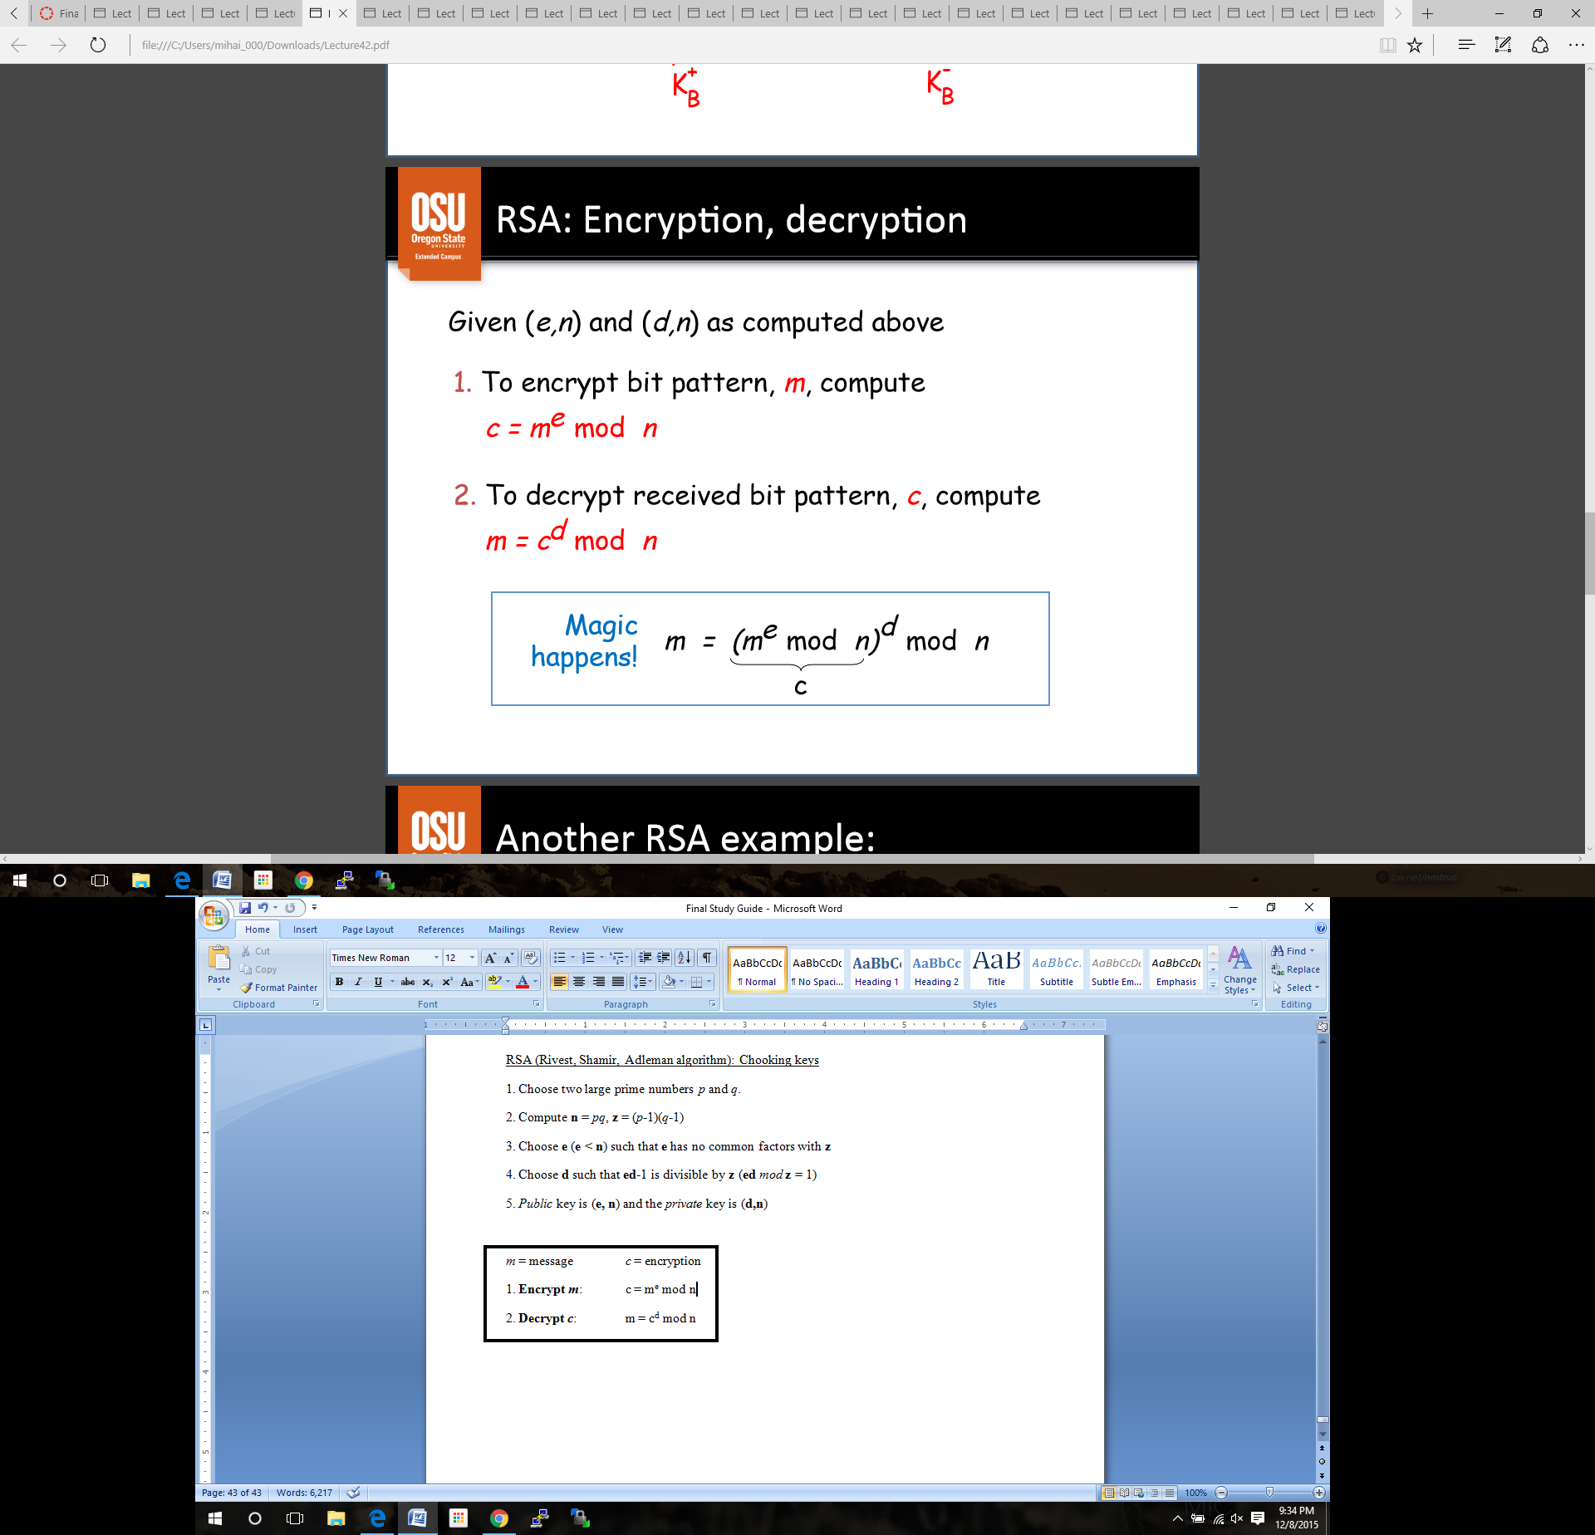m* = message *c* = encryption

1. **Encrypt *m***: c = me mod n

2. **Decrypt** ***c***: m = cd mod n

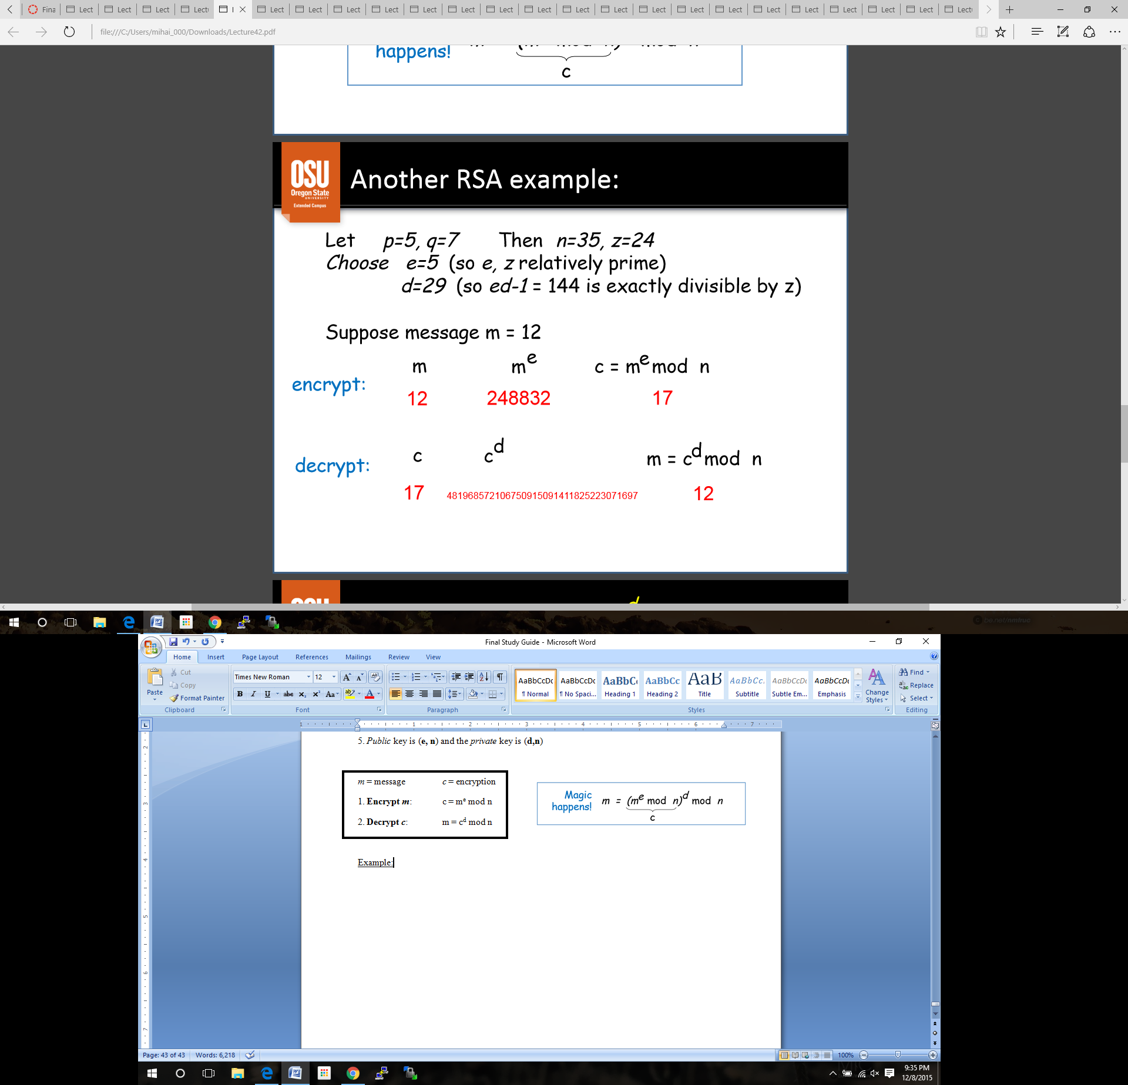Example:

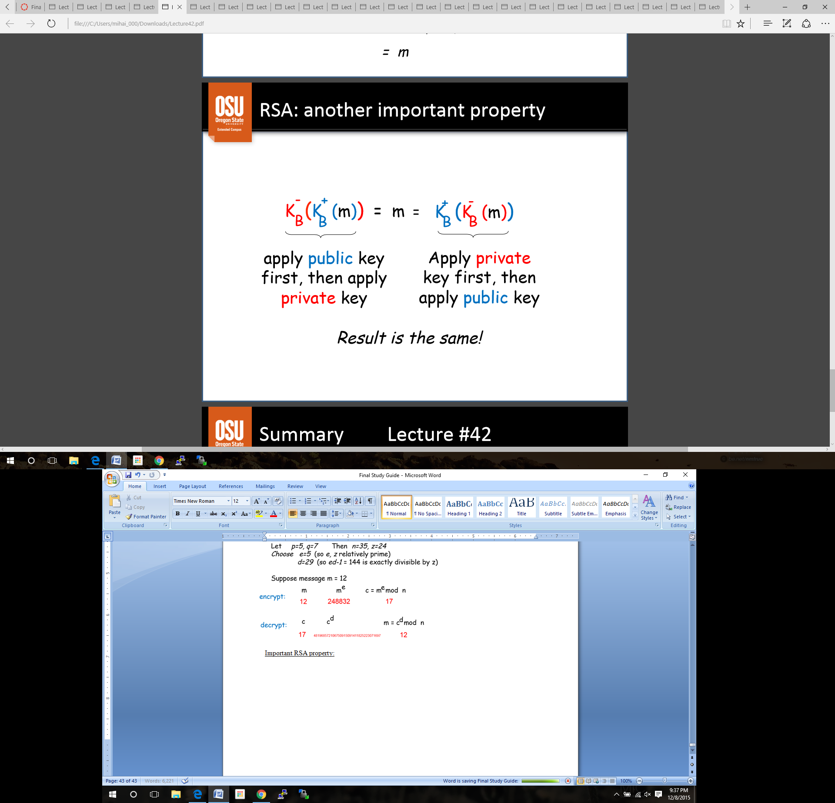Important RSA property:

*Quiz Solutions:*

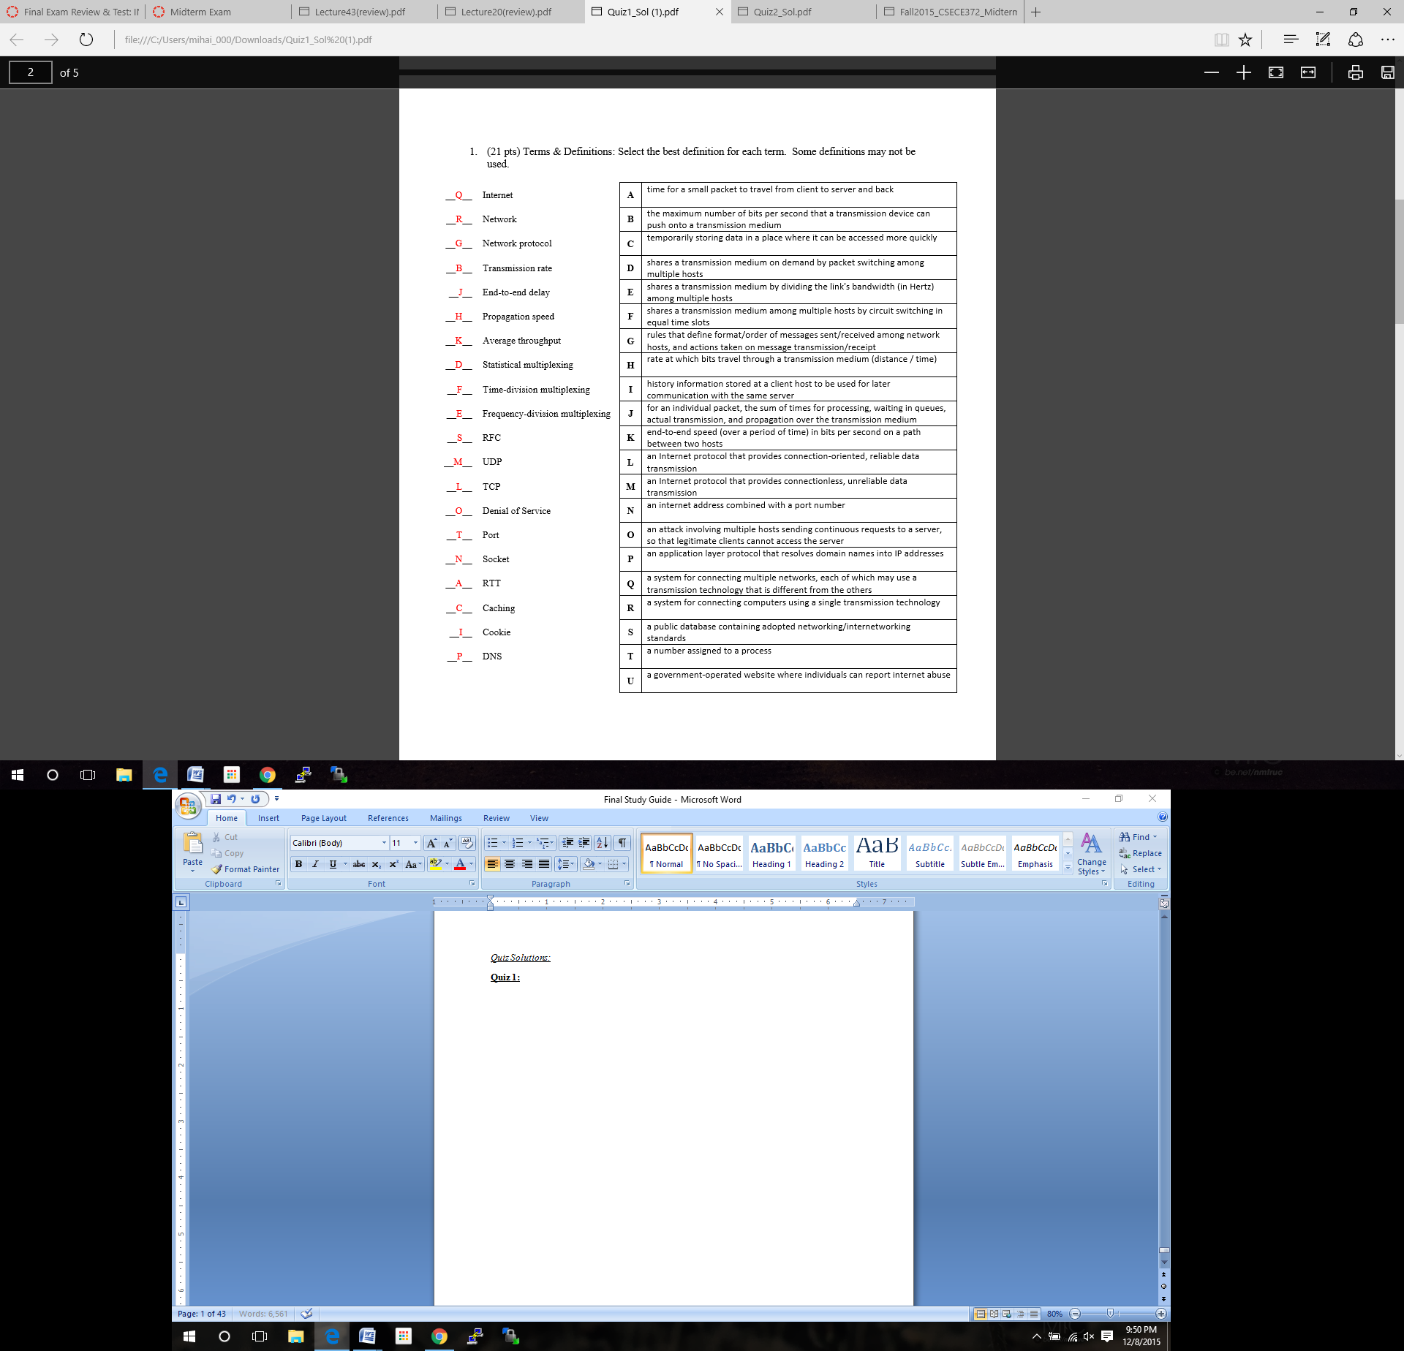**Quiz 1:**

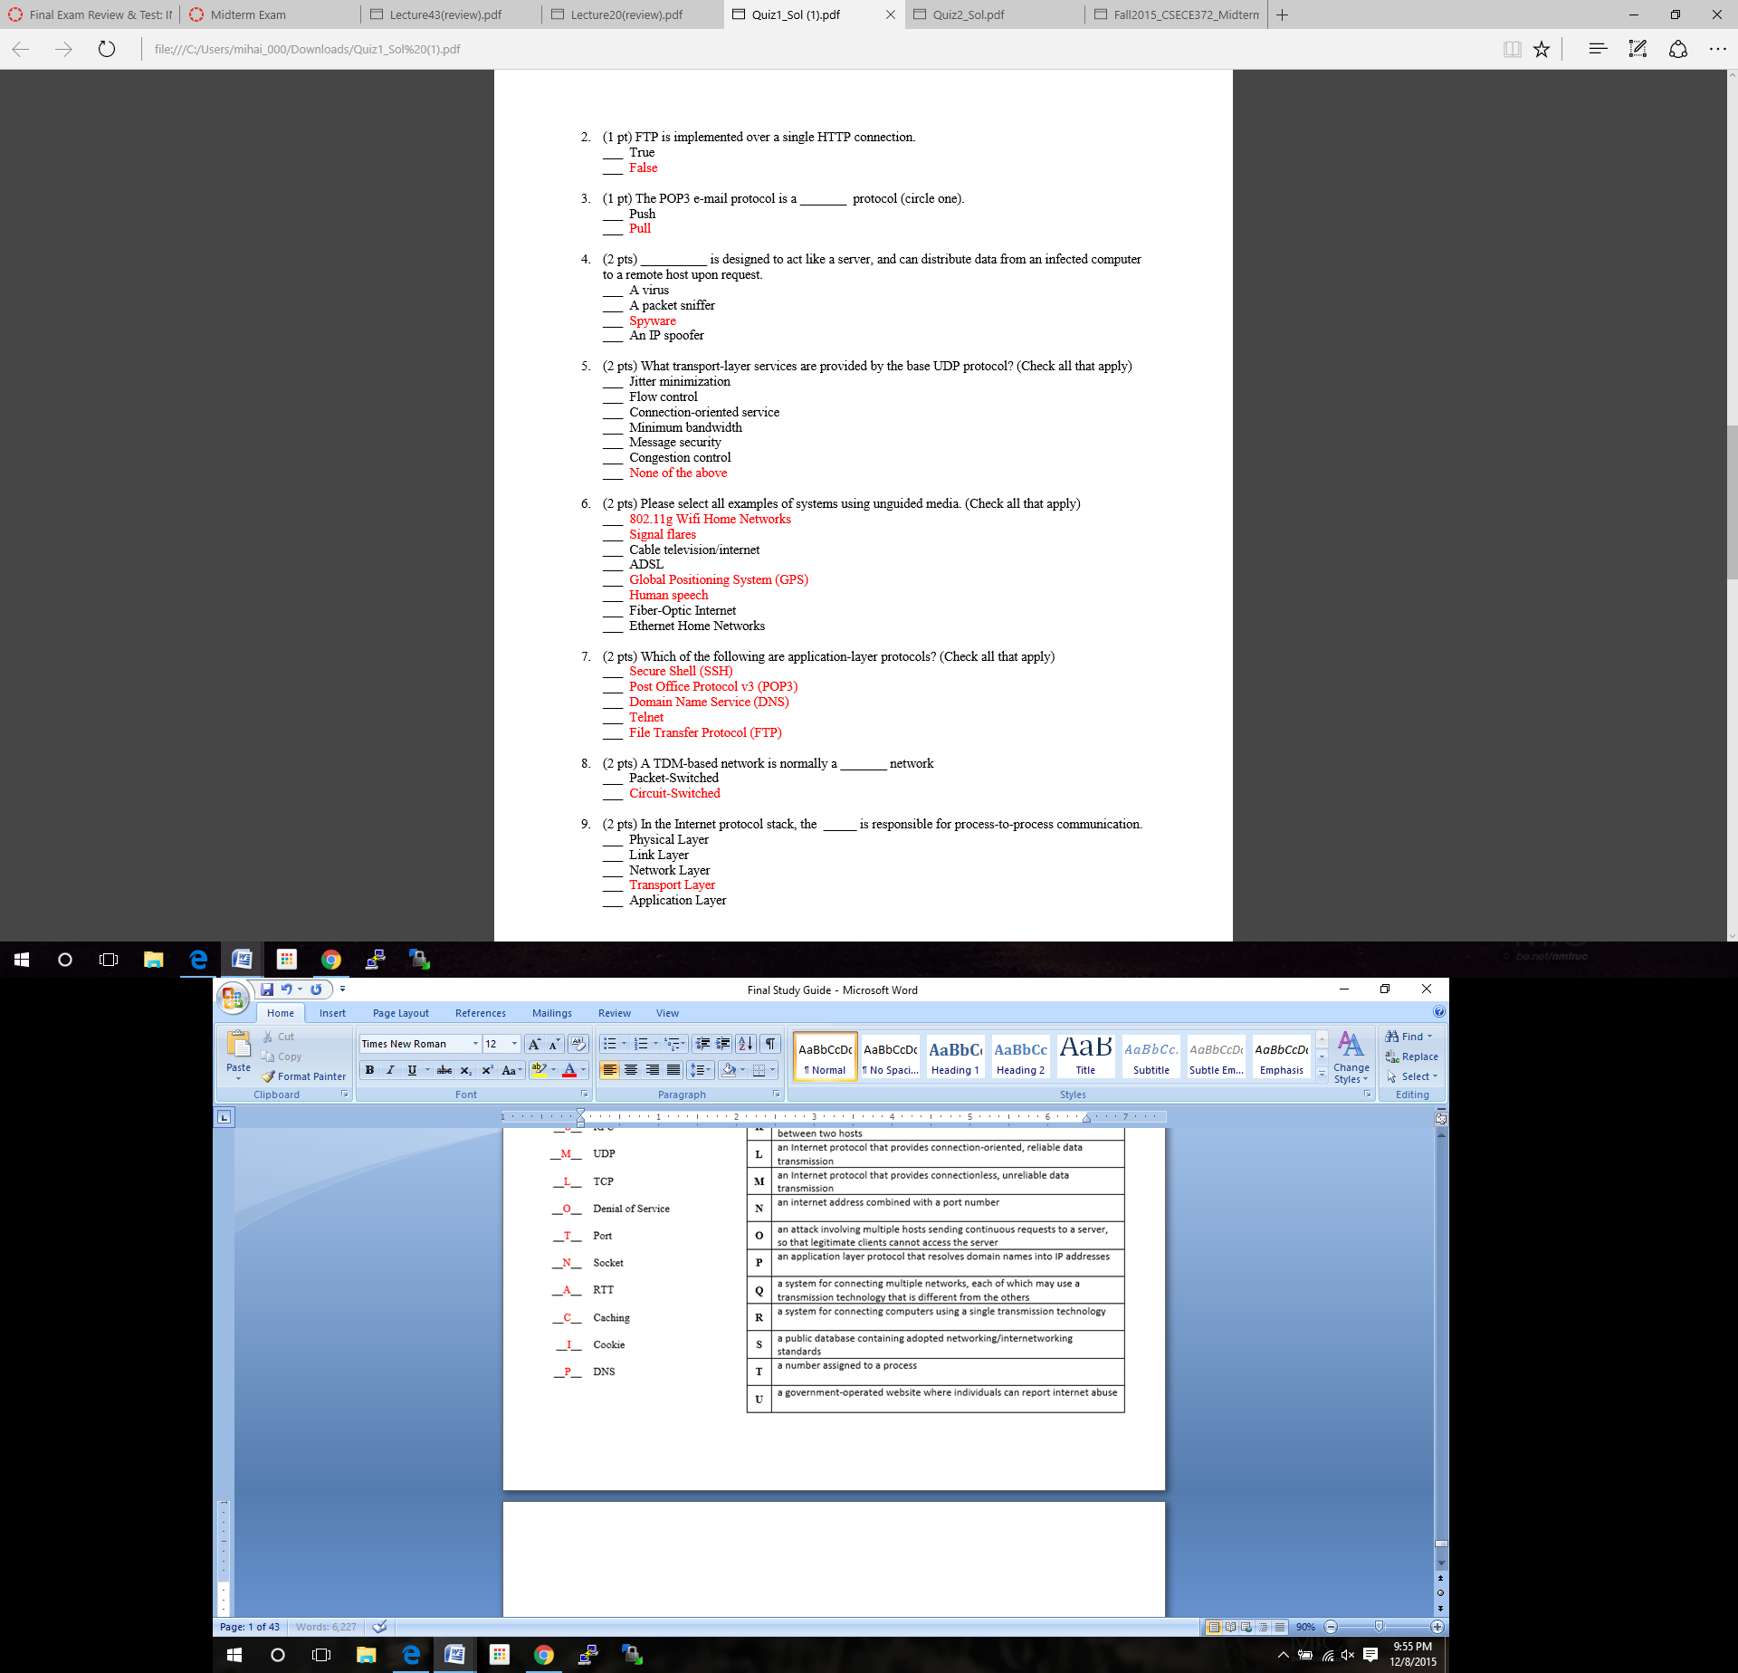

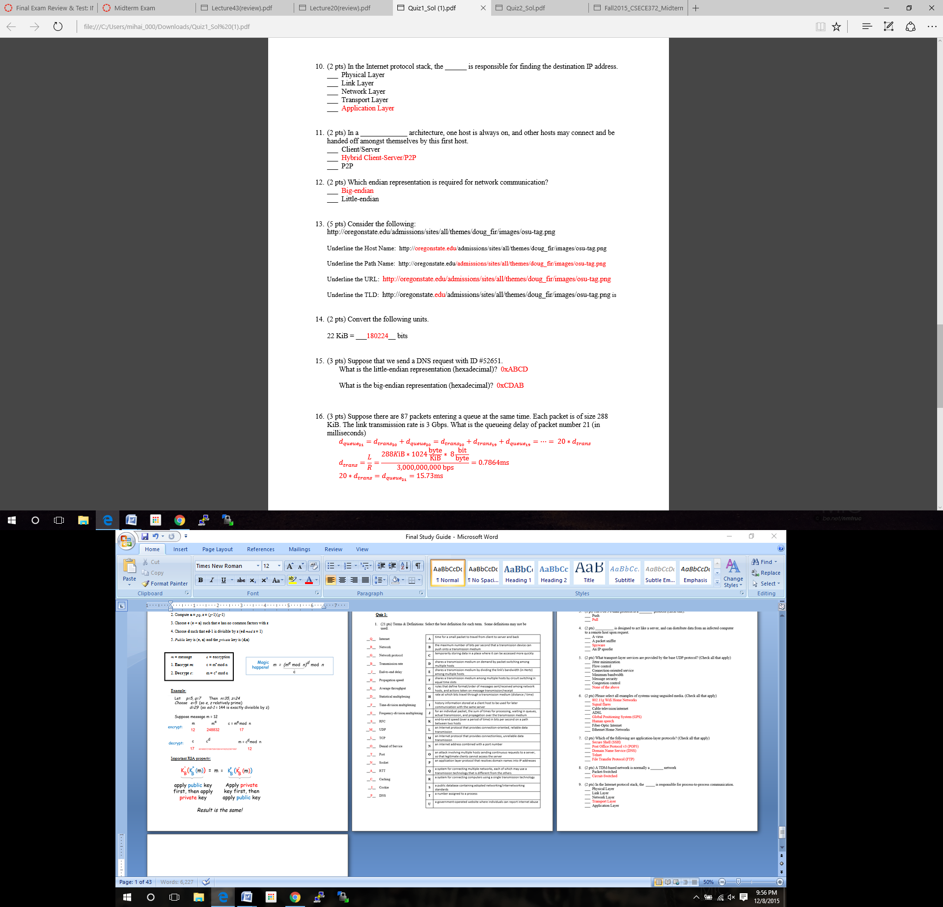

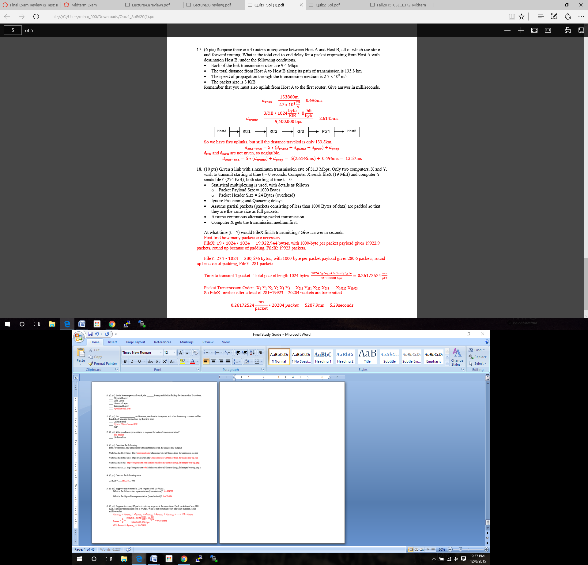

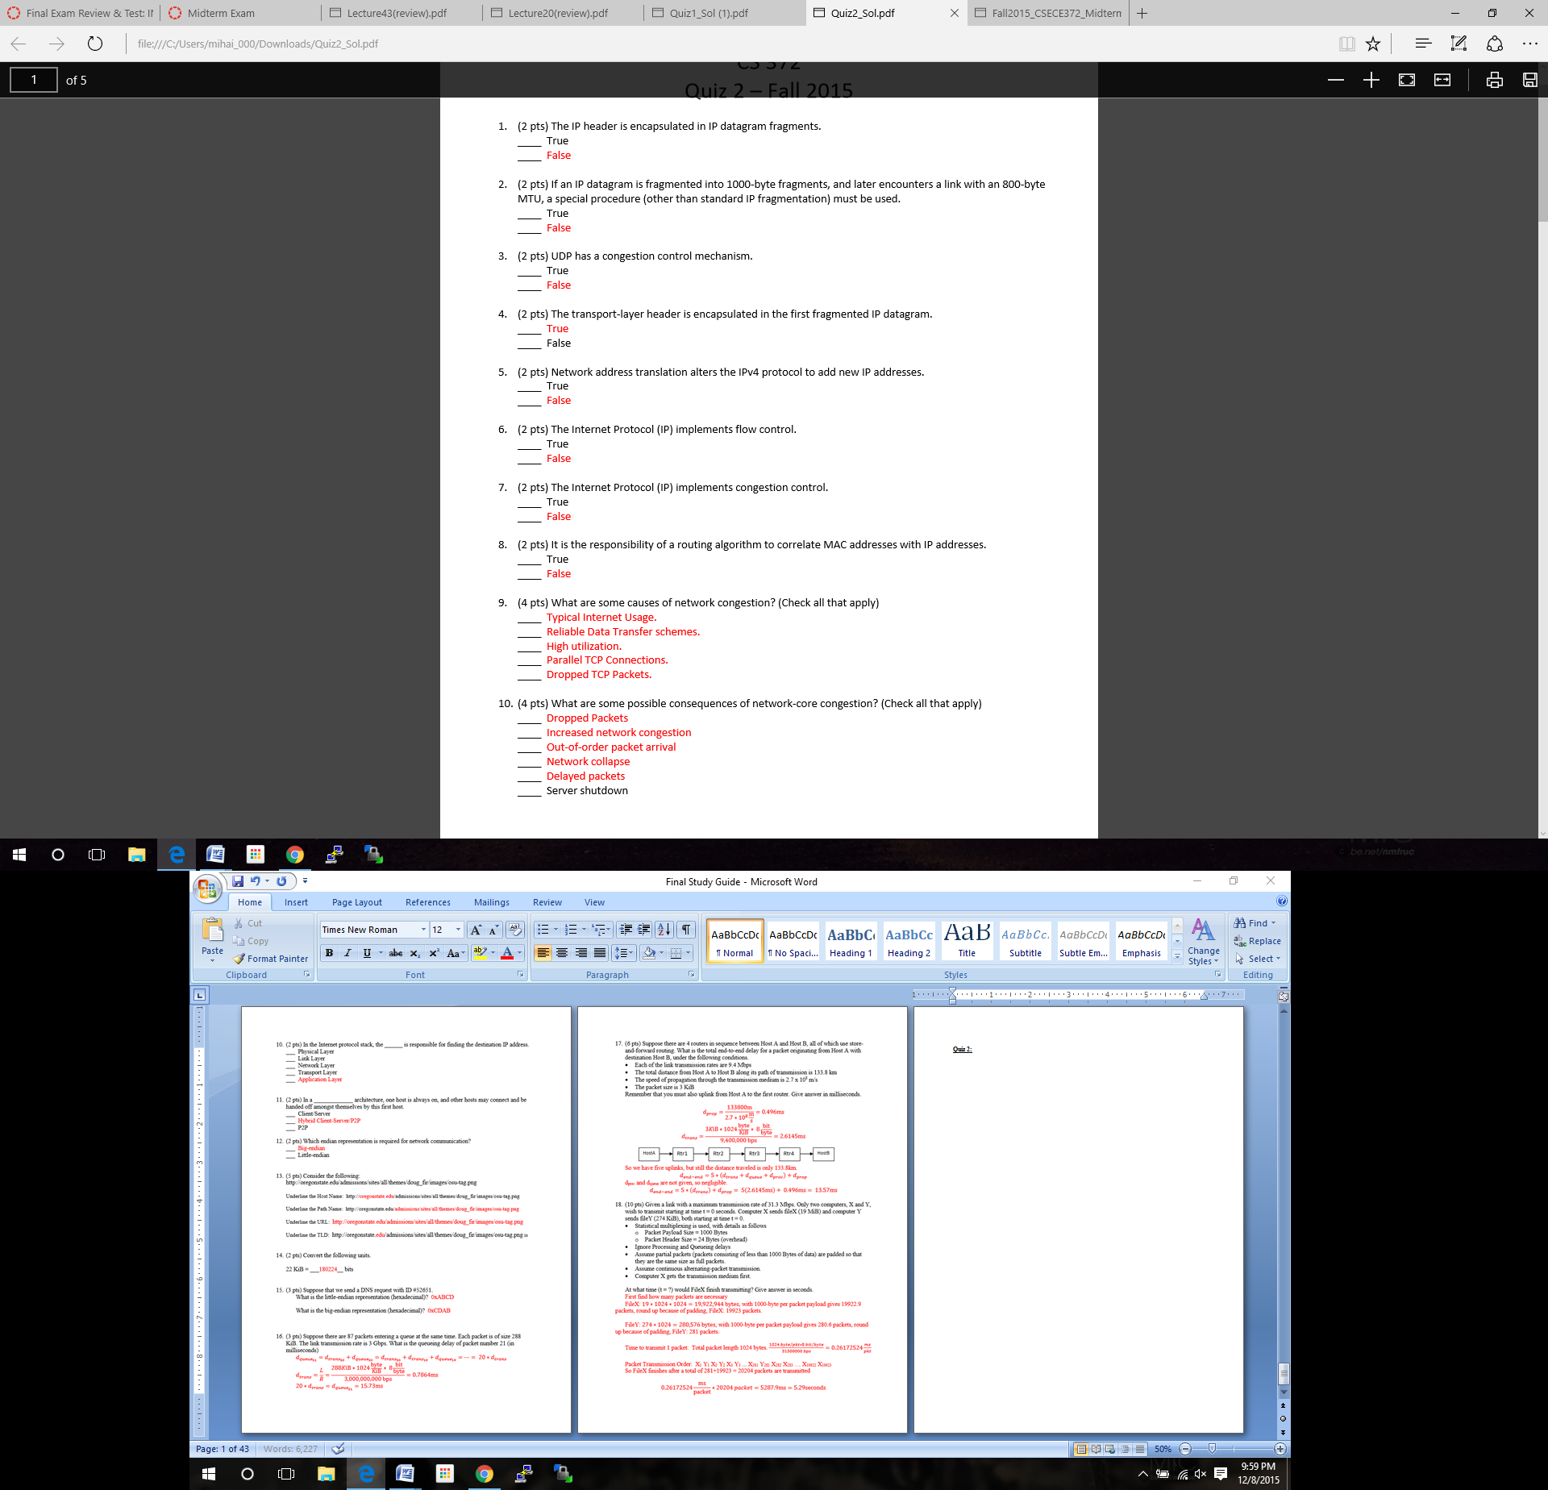**Quiz 2:**

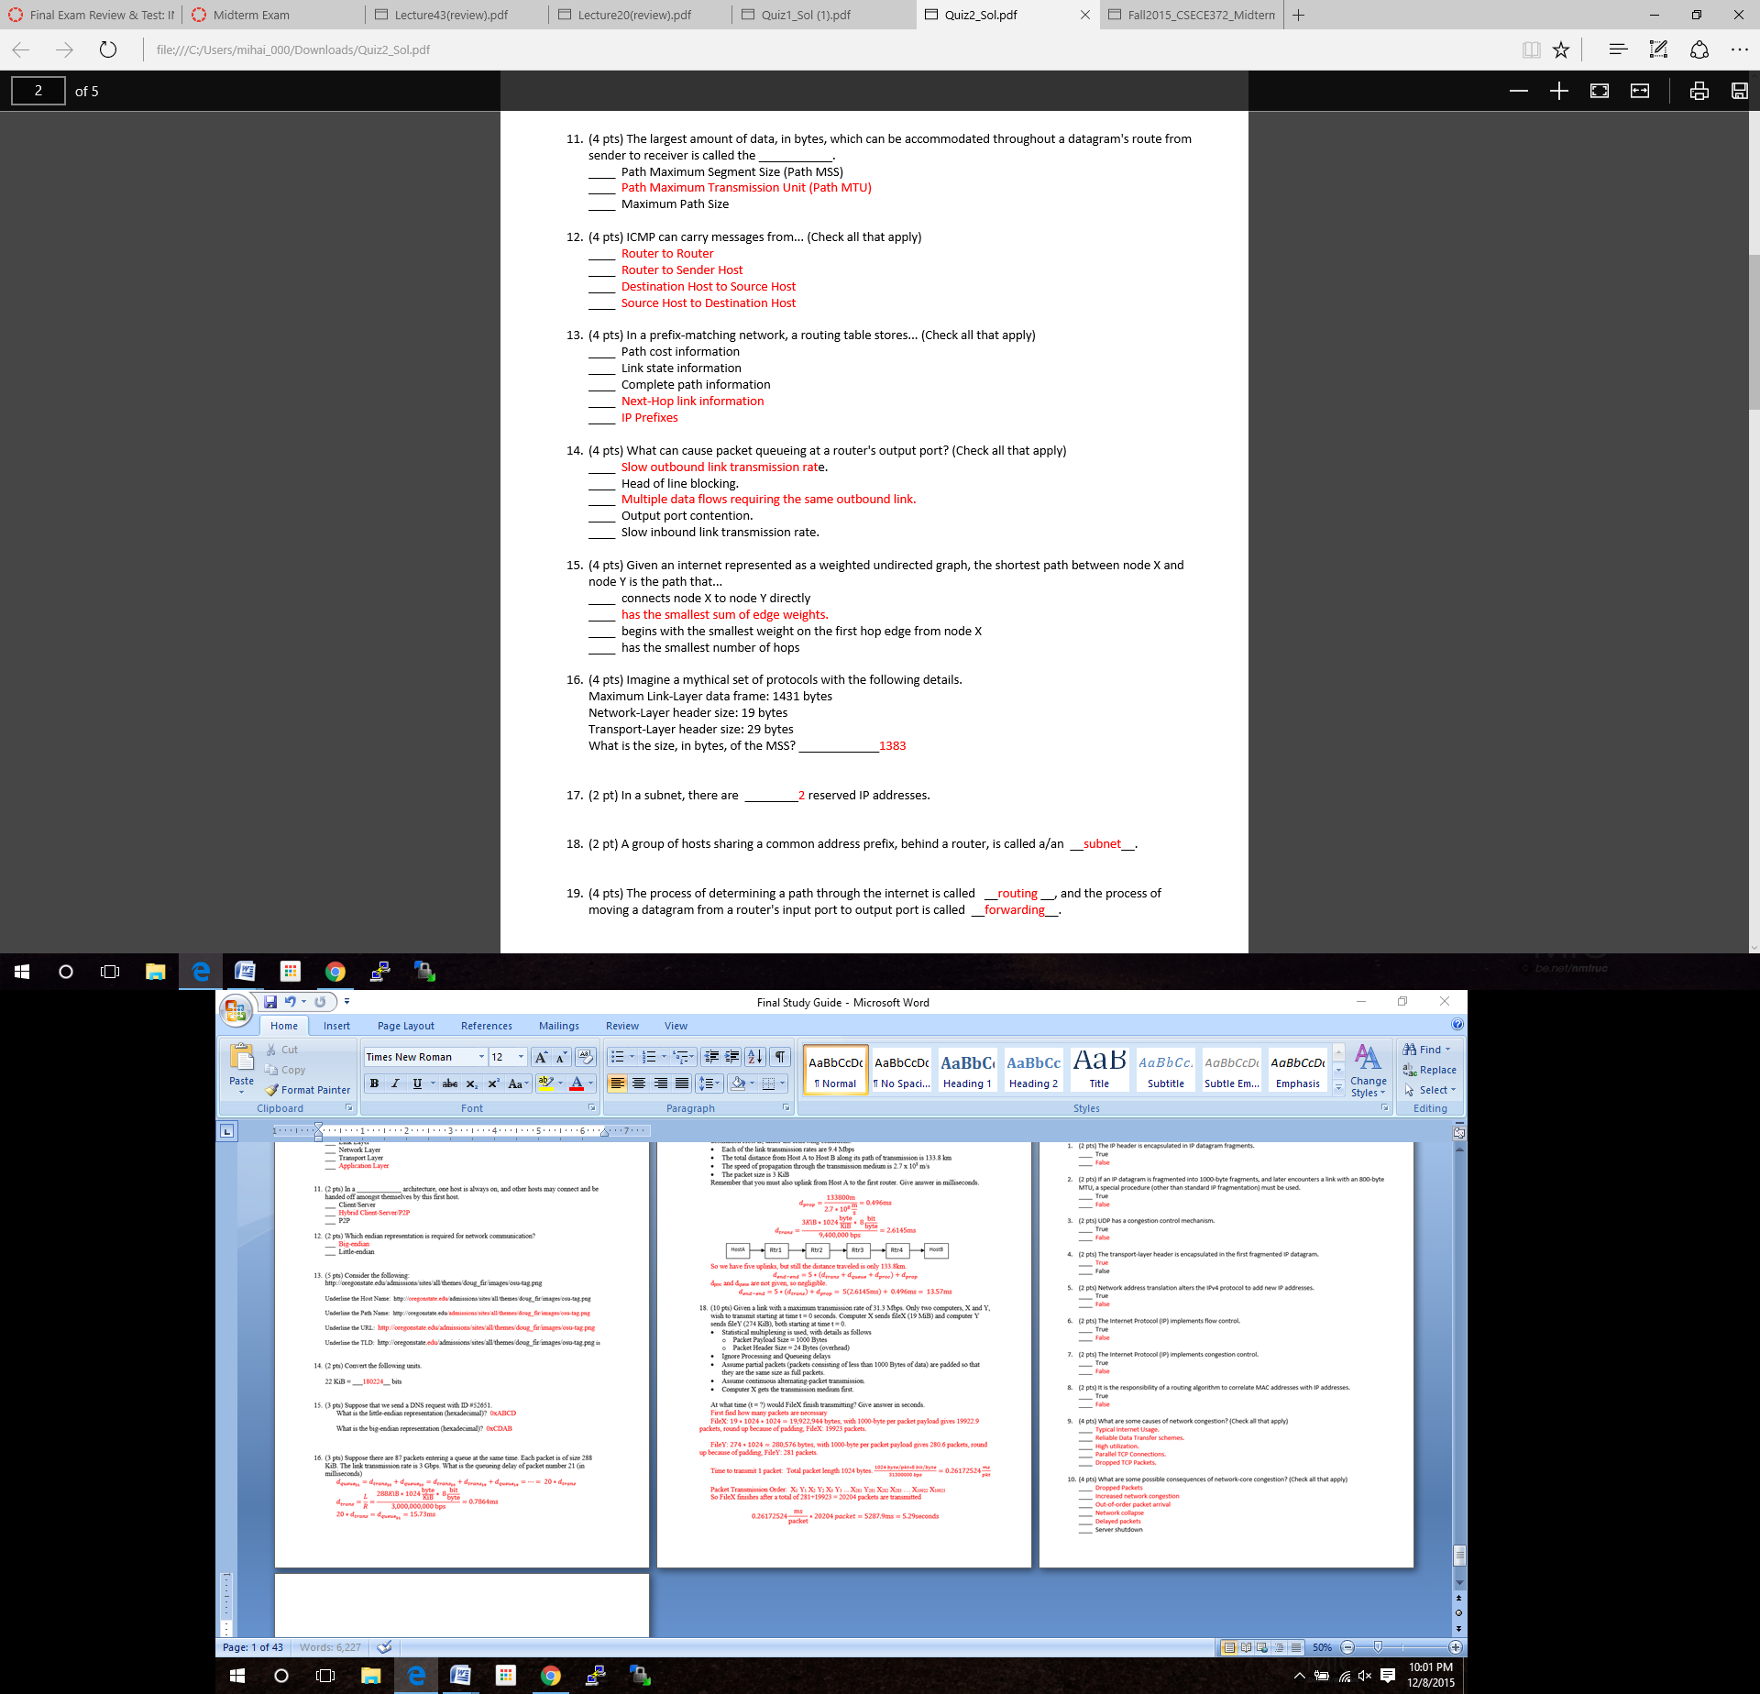

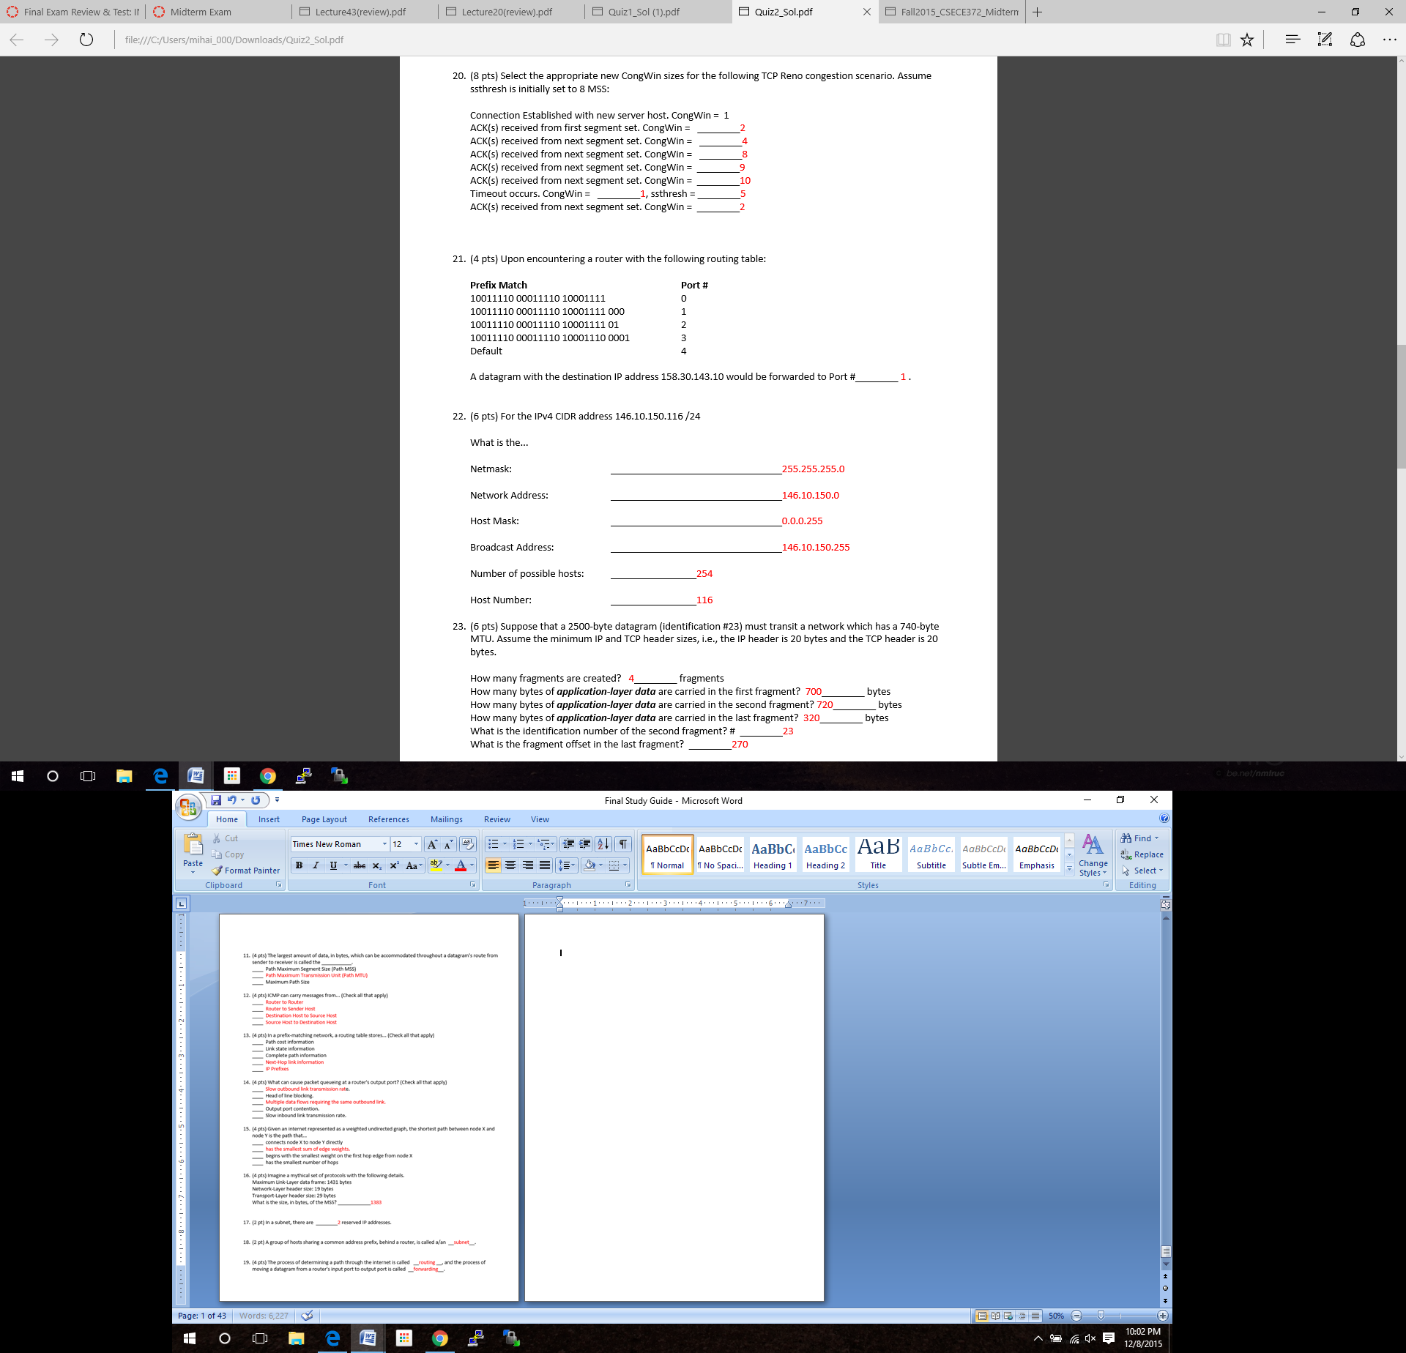

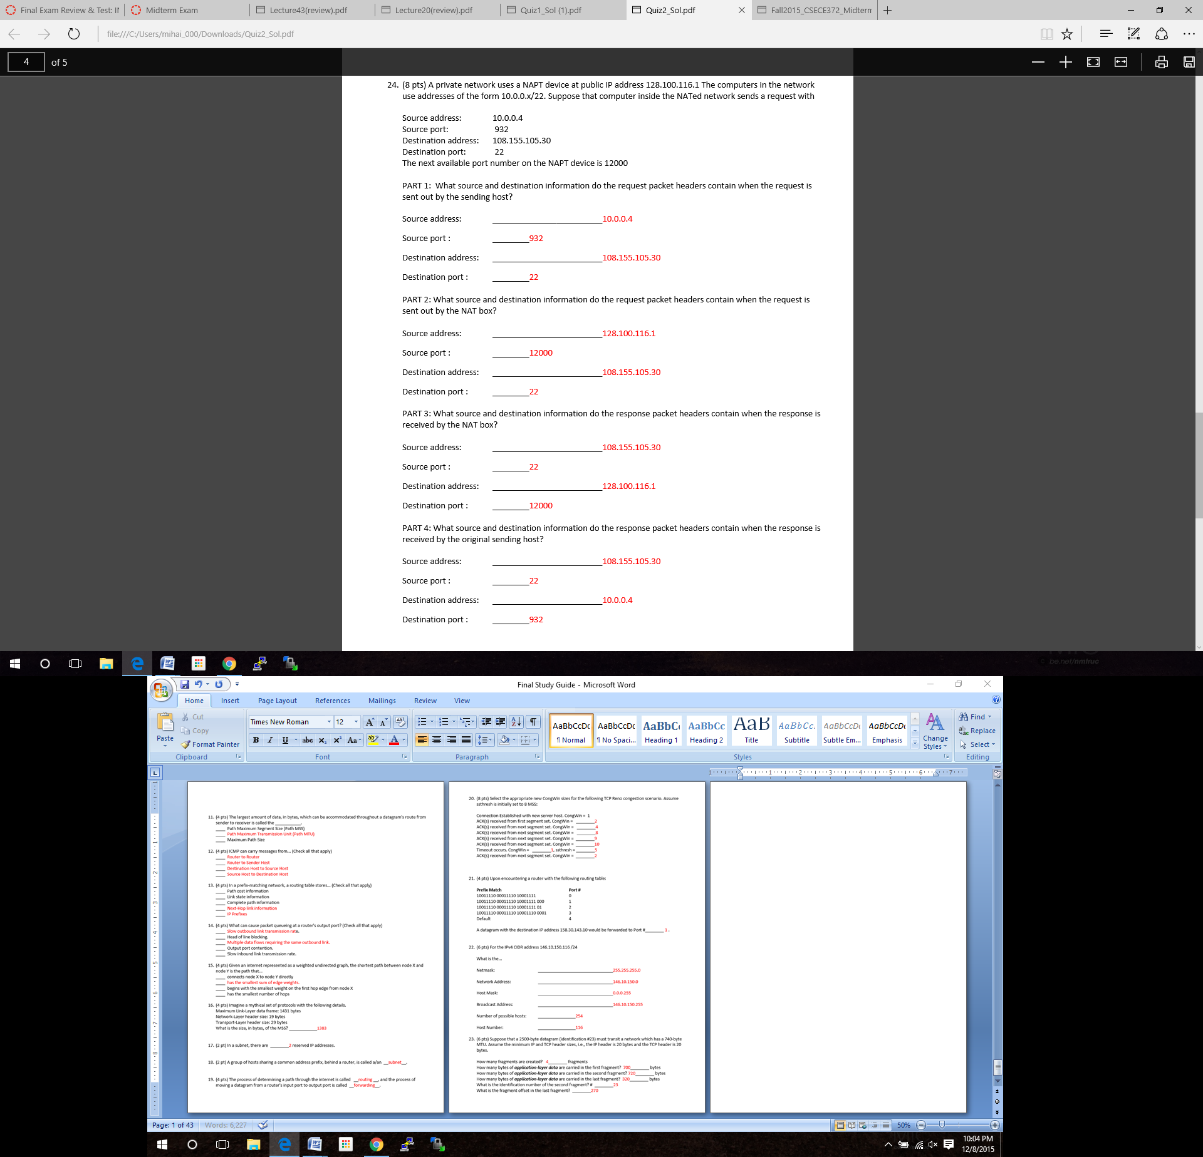

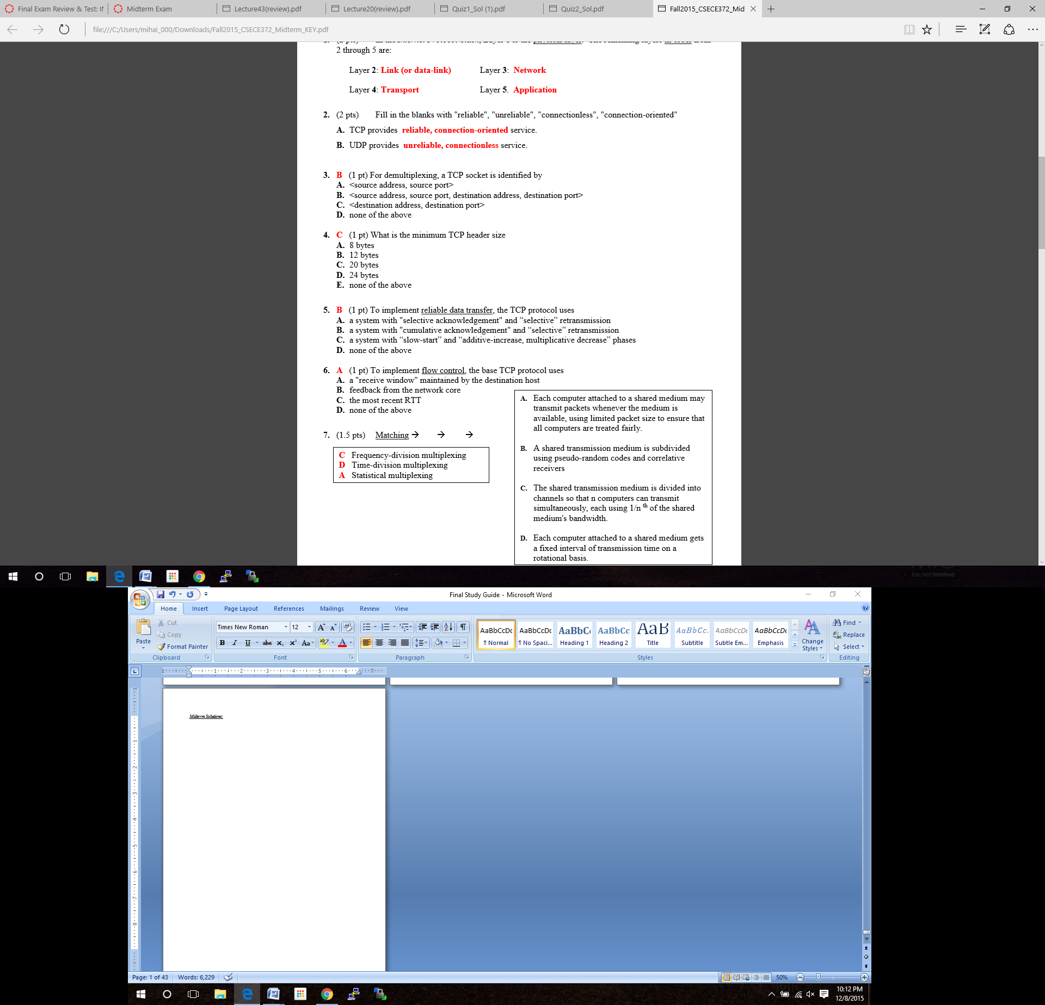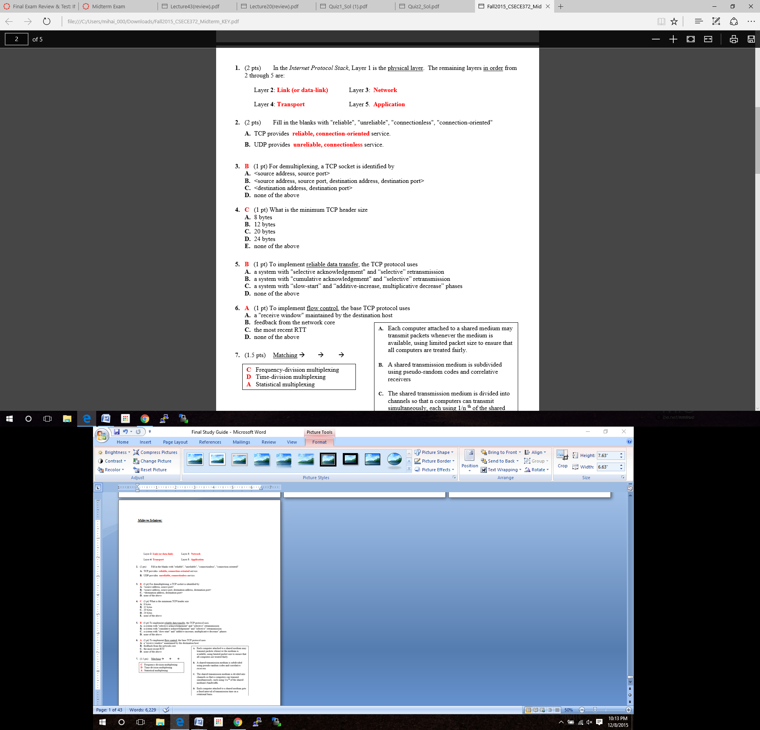

***Midterm Solutions:***

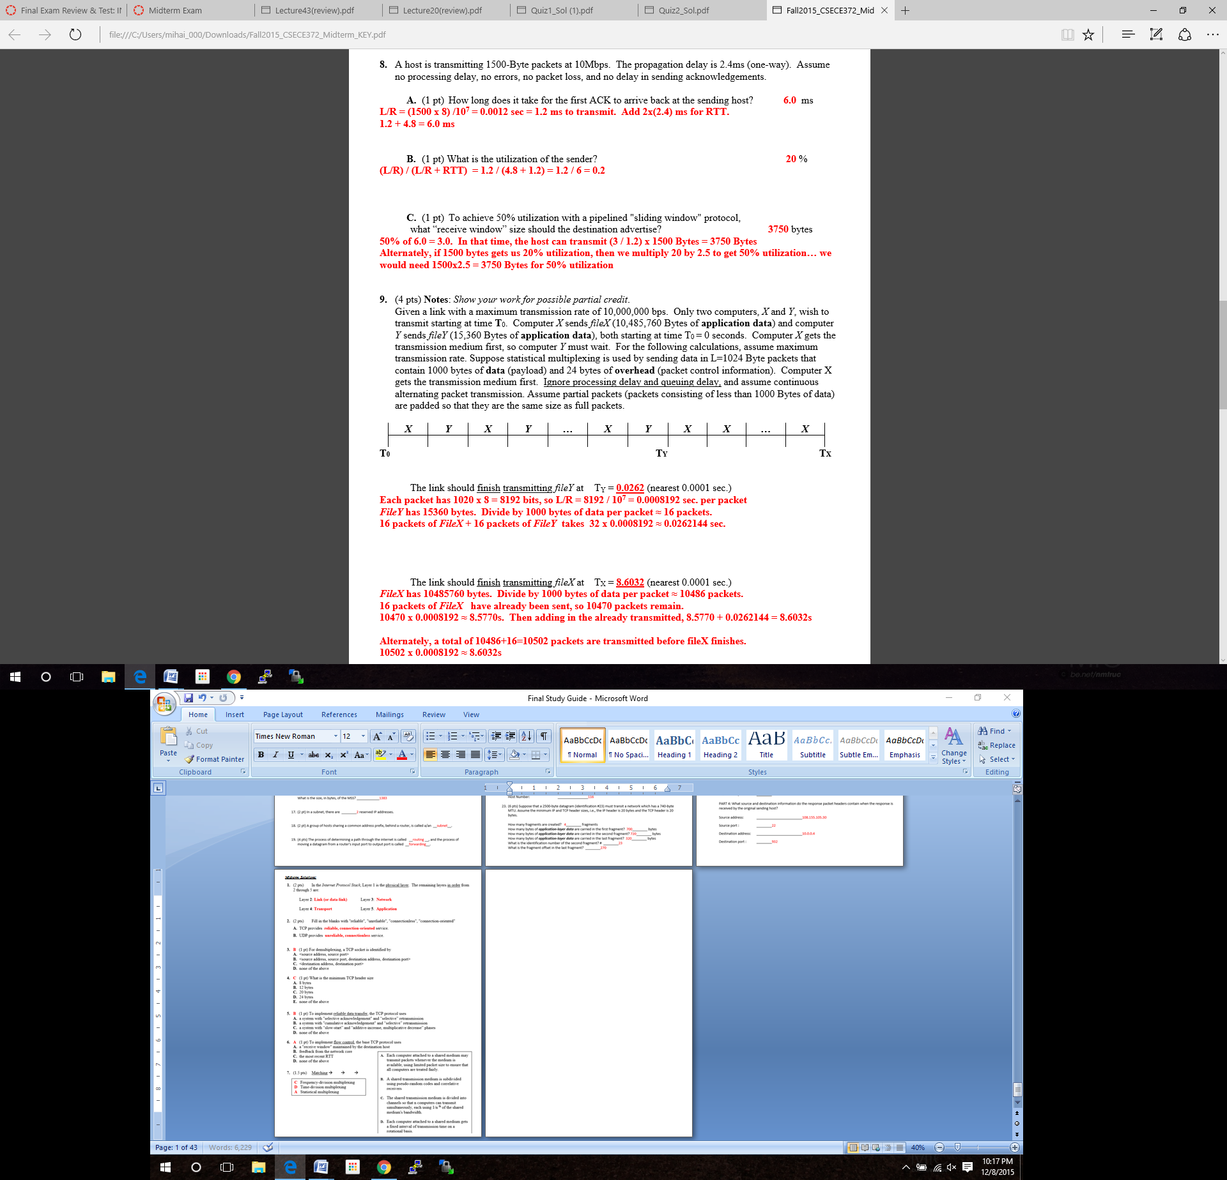

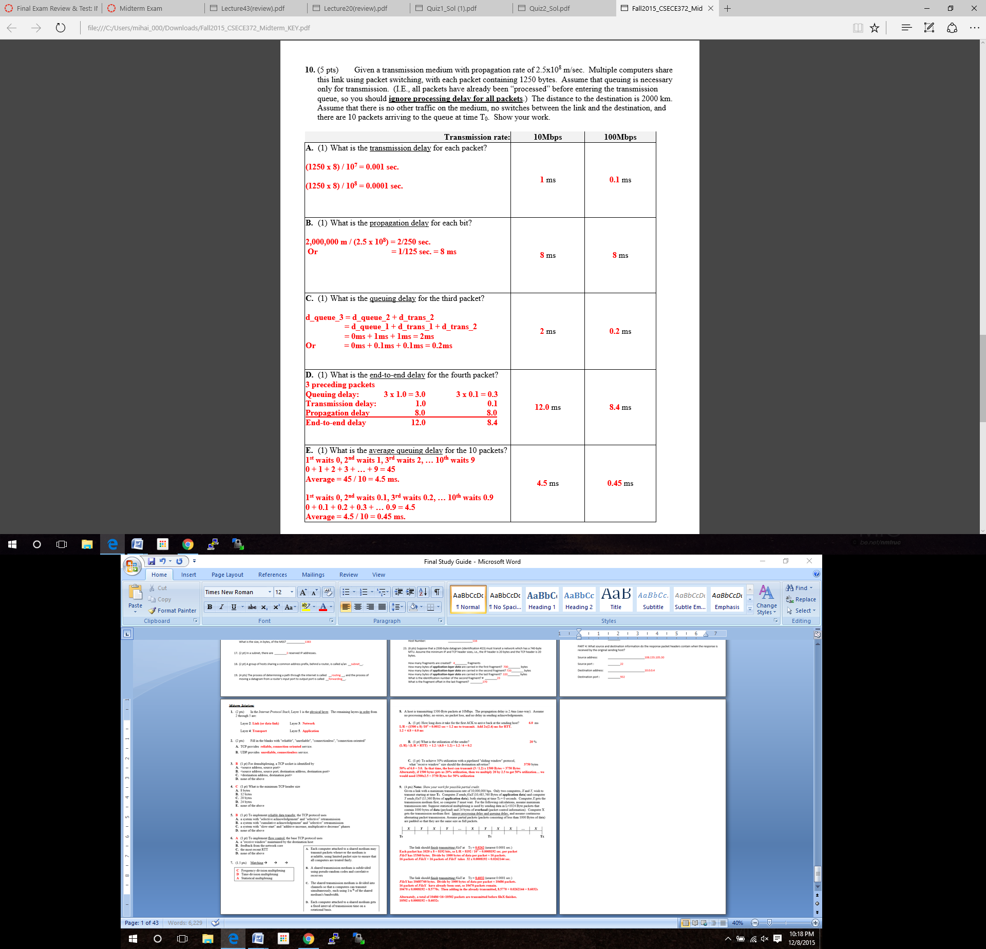

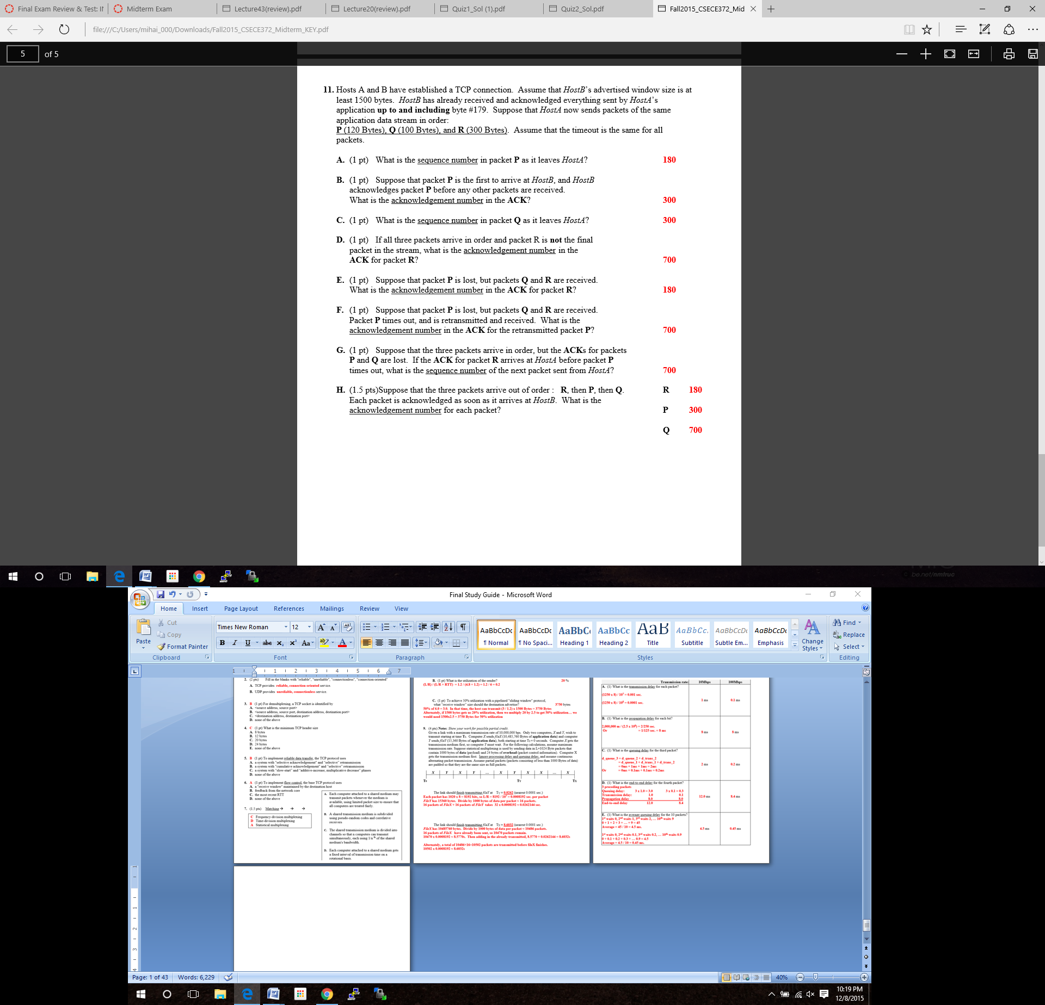

*Lab Solutions:*

**Lab 3:**

**1.** Answer the following questions:

a) What is the IP address and TCP port number used by the client computer (source) that is transferring the file to gaia.cs.umass.edu? To answer this question, it’s probably easiest to select an HTTP message and explore the details of the TCP packet used to carry this HTTP message, using the “details of the selected packet header window” (refer to Figure 2 in the “Getting Started with Wireshark” Lab if you’re uncertain about the Wireshark windows.

Source IP Address: 10.248.46.132

TCP Source Port: 54592

b) What is the IP address of gaia.cs.umass.edu? On what port number is it sending and receiving TCP segments for this connection?

Destination IP Address: 128.119.245.12

TCP Destination Port: 80

c) What is the IP address and TCP port number used by your client computer (source) to transfer the file to gaia.cs.umass.edu?

I used my own trace for parts a) and b).

**2.** What is the sequence number of the TCP SYN segment that is used to initiate the TCP connection between the client computer and gaia.cs.umass.edu? What is it in the segment that identifies the segment as a SYN segment?

TCP SYN segment sequence number = 0

The Flag is set to 0x002, which depicts that this is a SYN segment.

**3.** What is the sequence number of the SYNACK segment sent by gaia.cs.umass.edu to the client computer in reply to the SYN? What is the value of the Acknowledgement field in the SYNACK segment? How did gaia.cs.umass.edu determine that value? What is it in the segment that identifies the segment as a SYNACK segment?

SYNACK segment sequence number = 0

SYNACK Acknowledgement field value = 1

This value was determined based on the fact that the acknowledgement number is the ` next anticipated number from the sender. The Flag 0x012, meaning (SYN, ACK), is what identifies the segment as a SYNACK.

**4.** What is the sequence number of the TCP segment containing the HTTP POST command? Note that in order to find the POST command, you’ll need to dig into the packet content field at the bottom of the Wireshark window, looking for a segment with a “POST” within its DATA field.

The sequence number of the TCP segment connecting the HTTP POST command is 1.

**5.** Consider the TCP segment containing the HTTP POST as the first segment in the TCP connection. What are the sequence numbers of the first six segments in the TCP connection (including the segment containing the HTTP POST)? At what time was each segment sent? When was the ACK for each segment received? Given the difference between when each TCP segment was sent, and when its acknowledgement was received, what is the RTT value for each of the six segments? What is the EstimatedRTT value (see Section 3.5.3, page 239 in text) after the receipt of each ACK? Assume that the value of the EstimatedRTT is equal to the measured RTT for the first segment, and then is computed using the EstimatedRTT equation on page 239 for all subsequent segments. Note: Wireshark has a nice feature that allows you to plot the RTT for each of the TCP segments sent. Select a TCP segment in the “listing of captured packets” window that is being sent from the client to the gaia.cs.umass.edu server. Then select: Statistics->TCP Stream Graph->Round Trip Time Graph.

|  |  |  |  |  |
| --- | --- | --- | --- | --- |
|  | Sequence Number | Time Sent (sec) | ACK return time (sec) | RTT (sec) |
| 1 | 1 | 0.103215000 | 0.161002000 | 0.057787 |
| 2 | 576 | 0.105847000 | 0.211659000 | 0.105812 |
| 3 | 1836 | 0.105867000 | 0.212734000 | 0.106867 |
| 4 | 3096 | 0.105875000 | 0.212735000 | 0.106860 |
| 5 | 4356 | 0.205828000 | 0.240660000 | 0.034832 |
| 6 | 5616 | 0.208288000 | 0.290820000 | 0.082532 |

EstimatedRTT = ( 1 – 0.125 ) * EstimatedRTT + 0.125 * SampleRTT

EstimatedRTT of segment 1:

EstimatedRTT = 0.875*(0.057787) + 0.125*(0.057787) = 0.057787 seconds

EstimatedRTT of segment 2:

EstimatedRTT = 0.875*(0.057787) + 0.125*(0.105812) = 0.063790 seconds

EstimatedRTT of segment 3:

EstimatedRTT = 0.875*(0.063790) + 0.125*(0.106867) = 0.069175 seconds

EstimatedRTT of segment 4:

EstimatedRTT = 0.875*(0.069175) + 0.125*(0.106860) = 0.073885 seconds

EstimatedRTT of segment 5:

EstimatedRTT = 0.875*(0.073885) + 0.125*(0.034832) = 0.069004 seconds

EstimatedRTT of segment 6:

EstimatedRTT = 0.875*(0.069004) + 0.125*(0.082532) = 0.070695 seconds

**6.** What is the length of each of the first six TCP segments?

1.) 629 bytes

2.) 1314 bytes

3.) 1314 bytes

4.) 1314 bytes

5.) 1314 bytes

6.) 1314 bytes

**7.** What is the minimum amount of available buffer space advertised at the received for the entire trace? Does the lack of receiver buffer space ever throttle the sender?

The minimum amount of available space buffer is synonymous to the Calculated window size field, which in this instance is calculated to be 262144 bytes.

**8.** Are there any retransmitted segments in the trace file? What did you check for (in the trace) in order to answer this question?

There are no files that have been retransmitted. This can be inferred from the fact that each sequence number is sequential and there are no repeats.

**9.** How much data does the receiver typically acknowledge in an ACK? Can you identify cases where the receiver is ACKing every other received segment (see Table 3.2 on page 247 in the text).

The receiver typically acknowledges 1260 bytes of data in every ACK. This can be determined by looking at the ACK sequence numbers, which correspond with which byte of data was most currently transmitted. A example of the case where the receiver ACK’s every other received segment is shown by the acknowledgement number for packet number 27. The sequence number was 33336, which is 2520 bytes after the previous ACK, meaning it confirmed both of the 1260-byte segment in one ACK.

**10.** What is the throughput (bytes transferred per unit time) for the TCP connection? Explain how you calculated this value.

In order to calculate the throughput, the size of the file and time of transfer is needed.

We can calculate the size from the sequence number of the first TCP message to the last ACK message received. That is 152,901 – 1 = 152,900 bytes.

The time of the last ACK received was 0.62041000 seconds. The time of the initial message was 0.081907000 seconds, yielding a difference of 0.538503 seconds.

$$\frac{153,900 bytes}{0.538503 seconds}=285,792.28 bytes/second$$

**11.** Use the Time-Sequence-Graph(Stevens) plotting tool to view the sequence number versus time plot of segments being sent from the client to the gaia.cs.umass.edu server. Can you identify where TCP’s slowstart phase begins and ends, and where congestion avoidance takes over? Comment on ways in which the measured data differs from the idealized behavior of TCP that we’ve studied in the text.

Below is the Time-Sequence-Graph(Stevens) as plotted with the Wireshark tool. The graph shows that TCP’s slowstart phase begins around 14 milliseconds and lasted until around 56 milliseconds into the data transfer. This graph is different from what you would expect from the ideal TCP slow start graph we have been studying in class for a couple reasons. In the ideal TCP graph, there are no errors or any delays in package delivery. An ideal connection would also have little to no congestion, which allows for smoother running and clearer results.

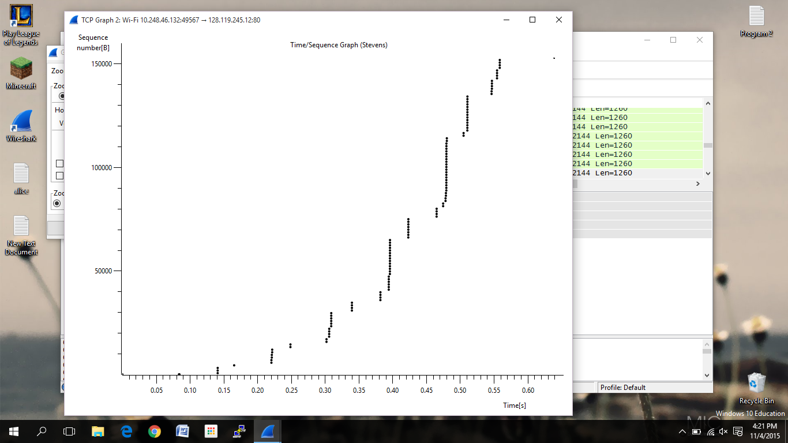

**Lab 4:**

**1.** Select the first ICMP Echo Request message sent by your computer, and expand the Internet Protocol part of the packet in the packet details window. What is the IP address of your computer?

The IP address of my computer is 172.16.0.17

**2.** Within the IP packet header, what is the value in the upper layer protocol field?

The value in the upper layer protocol field is ICMP (1).

**3.** How many bytes are in the IP header? How many bytes are in the payload of the IP datagram? Explain how you determined the number of payload bytes.

a. IP header: 20 bytes

b. Payload of IP datagram: 36 bytes

The previous was calculated by taking the packet header size, which is 20 bytes, and subtracting it from the the full length of the package, which is 56 bytes.

**4.** Has this IP datagram been fragmented? Explain how you determined whether or not the datagram has been fragmented.

The IP datagram has not been fragmented. This was determined by checking the more fragments field in the datagram. In this case, the bit was set to zero.

**5.** Which fields in the IP datagram always change from one datagram to the next within this series of ICMP messages sent by your computer?

The fields that always change are Identification, TTL and header checksum.

**6.** Which fields stay constant? Which of the fields must stay constant? Which fields must change? Why?

**Fields that stay constant:**

a. Version – same IPv4 version

b. header length – all have the same header, meaning same length

c. source IP – sending from same source

d. destination IP – sending to same destination

e. Differentiated Services – all user same Type of Service class

f. Upper Layer Protocol – since they are all ICMP packets

**Fields that must stay constant**

a. Version – same IPv4 version

b. header length – all have the same header, meaning same length

c. source IP – sending from same source

d. destination IP – sending to same destination

e. Differentiated Services – all user same Type of Service class

f. Upper Layer Protocol – since they are all ICMP packets

**Fields that must change:**

a. Identification Number

b. TTL (Time To Live)

c. Header checksum

**7.** Describe the pattern you see in the values in the Identification field of the IP datagram.

The ID field of the IP datagram is incremented with each ICMP Echo request.

**8.** What is the value in the Identification field and the TTL field?

ID field value: 55559

TTL field value: 64

**9.** Do these values remain unchanged for all of the ICMP TTL-exceeded replies sent to your computer by the nearest (first hop) router? Why?

The ID field changes for all of the ICMP TTL-exceeded replies sent to my computer. This is because the ID field is unique. If there are more than one packets with the same ID number, it means that they have been fragmented from one larger IP datagram. The TTL does not change, because the first hop router TTL is always the same.

**10.** Find the first ICMP Echo Request message that was sent by your computer after you changed the Packet Size in pingplotter to be 2000. Has that message been fragmented across more than one IP datagram?

*[Note: if you find your packet has not been fragmented, you should download the zip file*

*http://gaia.cs.umass.edu/wireshark-labs/wireshark-traces.zip and extract the ipethereal-trace-1packet trace. If your computer has an Ethernet interface, a packet size of 2000 should cause fragmentation.3]*

Yes, this packet has been fragmented into more than one IP datagram.

**11.** Print out the first fragment of the fragmented IP datagram. What information in the IP header indicates that the datagram been fragmented? What information in the IP header indicates whether this is the first fragment versus a latter fragment? How long is this IP datagram?

The part of the IP header that indicates that the datagram has been fragmented is the more fragments flag, which is set to true. The fragment offset flag is set to zero, meaning this is the first fragment in the sequence. This datagram is 1500 bytes long, including the header.

**12.** Print out the second fragment of the fragmented IP datagram. What information in the IP header indicates that this is not the first datagram fragment? Are the more fragments? How can you tell?

The fragment offset is set to 185, meaning this is the second packet after the first, which was 1480 bytes long. The more fragments flag is not set, meaning there are no more fragments coming.

**13.** What fields change in the IP header between the first and second fragment?

a. total length

b. flags

c. fragment offset

d. checksum

**14.** How many fragments were created from the original datagram?

There are three packets created from the original datagram.

**15.** What fields change in the IP header among the fragments?

a. The IP header fields that change between all packets are fragment offset and checksum.

b. First two packets have a length of 1500, while the last packet only has a length of 540.

c. First two packets have the more fragments bit set to 1, while the last packet is set to 0.

**Lab 5:**

**1.** What is the 48-bit Ethernet address of your computer?

The 48-bit Ethernet address of my computer is f4:b7:e2:59:a7:73.

**2.** What is the 48-bit destination address in the Ethernet frame? Is this the Ethernet address of

gaia.cs.umass.edu? (Hint: the answer is no). What device has this as its Ethernet address? [Note: this is an important question, and one that students sometimes get wrong. Re-read pages 468-469 in the text and make sure you understand the answer here.]

The 48-bit Ethernet destination address is e8:fc:af:83:5d:e4. This is not the address of gaia.cs.umass.edu, but it is the address of my Netgear router. The reason that its Ethernet address is shown is because that is the link between the subnet and the rest of the internet. My computer does not know the destination Ethernet address.

**3.** Give the hexadecimal value for the two-byte Frame type field. What upper layer protocol does this correspond to?

The hexadecimal value for the Frame type field is 0x0800. This corresponds to the Internet Protocol, meaning the frame contains an IP datagram.

**4.** How many bytes from the very start of the Ethernet frame does the ASCII “G” in “GET” appear in the Ethernet frame?

There are 54 bytes between the start of the Ethernet frame and the ASCII value that represents the letter “G”. The reason it appears 54 bytes into the Ethernet frame is because there are 14 Bytes for the Ethernet frame, 20 Bytes for the IP header, and 20 Bytes for the TCP header.

**5.** What is the value of the Ethernet source address? Is this the address of your computer, or of gaia.cs.umass.edu (Hint: the answer is no). What device has this as its Ethernet address?

The value of the Ethernet source address is e8:fc:af:83:5d:e4. This Ethernet source address is neither that of my computer nor that of gaia.cs.umass.edu; this is the Ethernet address of my router. This is because only the address of the next hop is given, which, in this case, it happens to be my router.

**6.** What is the destination address in the Ethernet frame? Is this the Ethernet address of your computer?

The destination address in this Ethernet frame is f4:b7:e2:59:a7:73. This is the Ethernet address of my computer.

**7.** Give the hexadecimal value for the two-byte Frame type field. What upper layer protocol does this correspond to?

The hexadecimal value for the Frame type field is 0x0800. This corresponds to the Internet Protocol, meaning the frame contains an IP datagram.

**8.** How many bytes from the very start of the Ethernet frame does the ASCII “O” in “OK” (i.e., the HTTP response code) appear in the Ethernet frame?

There are 54 bytes between the start of the Ethernet frame and the ASCII value that represents the letter “O”. The reason it appears 54 bytes into the Ethernet frame is because there are 14 Bytes for the Ethernet frame, 20 Bytes for the IP header, and 20 Bytes for the TCP header.

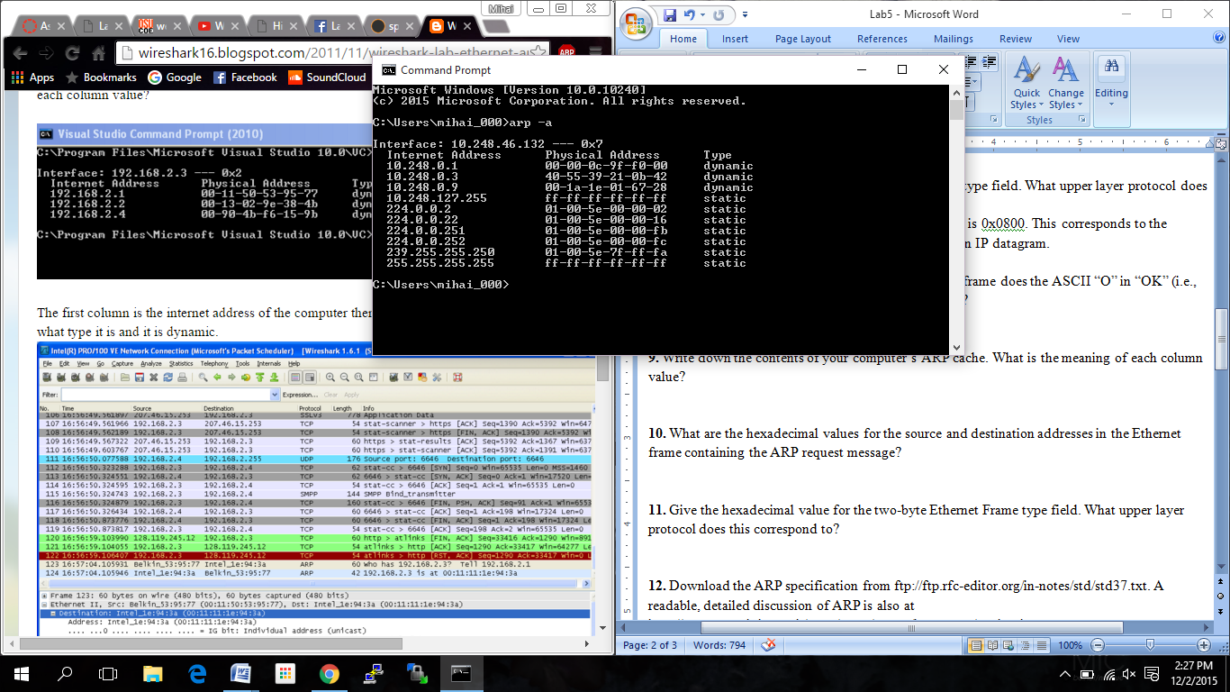**9.** Write down the contents of your computer’s ARP cache. What is the meaning of each column value?

I. Internet Address column contains the IPv4 addresses.

II. The Physical Address column contains the MAC addresses.

III. The type column shows whether the IPv4 address is static or dynamic.

**10.** What are the hexadecimal values for the source and destination addresses in the Ethernet frame containing the ARP request message?

The source address found in this Ethernet frame is the Ethernet address of my computer, which is f4:b7:e2:59:a7:73, while the destination address is the Ethernet Broadcast address, which is ff-ff-ff-ff-ff-ff.

**11.** Give the hexadecimal value for the two-byte Ethernet Frame type field. What upper layer protocol does this correspond to?

The hexadecimal value for the Ethernet Frame type field is 0x0806. This two-byte value corresponds to ARP.

**12.** Download the ARP specification from ftp://ftp.rfc-editor.org/in-notes/std/std37.txt. A readable, detailed discussion of ARP is also at http://www.erg.abdn.ac.uk/users/gorry/course/inet-pages/arp.html.

a) How many bytes from the very beginning of the Ethernet frame does the ARP opcode field begin?

The ARP opcode field appears 20 Bytes in to the Ethernet frame.

b) What is the value of the opcode field within the ARP-payload part of the Ethernet frame in which an ARP request is made?

The hex value found for the opcode field within the ARP-payload of the request is 0x0001, which means request.

c) Does the ARP message contain the IP address of the sender?

Yes, the ARP message contains the IP address of the sender.

d) Where in the ARP request does the “question” appear – the Ethernet address of the machine whose corresponding IP address is being queried?

The MAC address 00:00:00:00:00:00 is set in the Target MAC Address Field to “question” the IP address that is being queried.

**13.** Now find the ARP reply that was sent in response to the ARP request.

a) How many bytes from the very beginning of the Ethernet frame does the ARP opcode field begin?

The ARP opcode field begins 20 Bytes from the beginning of the Ethernet Frame.

b) What is the value of the opcode field within the ARP-payload part of the Ethernet frame in which an ARP response is made?

The hex value found for the opcode field within the ARP-payload of the request is 0x0002, which means reply.

c) Where in the ARP message does the “answer” to the earlier ARP request appear – the IP address of the machine having the Ethernet address whose corresponding IP address is being queried?

The ARP message contains a Sender MAC Address Field that contains the address e8:fc:af:83:5d:e4. This MAC address corresponds to the IP address of my router, which is 192.168.1.1

**14.** What are the hexadecimal values for the source and destination addresses in the Ethernet frame containing the ARP reply message?

The hex value for the source address is e8:fc:af:83:5d:e4, which is correspondent to my router. The hex value for the destination address is f4:b7:e2:59:a7:73, which is correspondent to my computer.

**15.** Open the ethernet-ethereal-trace-1 trace file in <http://gaia.cs.umass.edu/wireshark-labs/wireshark-traces.zip>. The first and second ARP packets in this trace correspond to an ARP request sent by the computer running Wireshark, and the ARP reply sent to the computer running Wireshark by the computer with the ARPrequested Ethernet address. But there is yet another computer on this network, as indicated by packet 6 – another ARP request. Why is there no ARP reply (sent in response to the ARP request in packet 6) in the packet trace?

The reason that there is no reply message is because my computer is not the machine that sent the request. The ARP request is broadcast, and the ARP reply is sent directly back to the sender’s Ethernet address. Since my machine is not the source of the request, it will not get an ARP reply sent.